**Maze worksheet - maze signs**

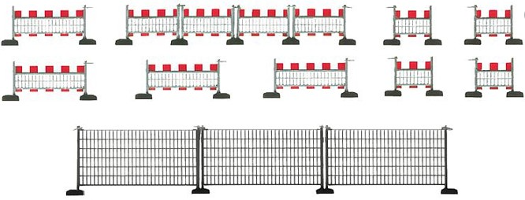**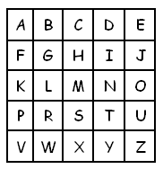List of signs:**

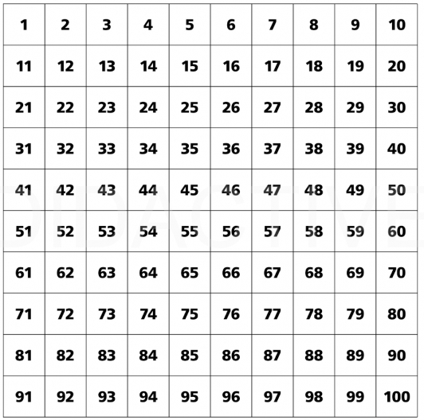

Maximum speed

Go straight ahead

No entry

No left turn

Turn left ahead

Turn right ahead

Stop, give way

