Worksheet – pictures
Specification: The first player selects one of the pictures. He/she enters the picture in the table using commands. The second player follows the commands and draws the picture in the prepared grid.
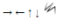
Player 1: Select one of the pictures below and enter it in the table using the commands.
Use the following symbols: Always start at the top left.
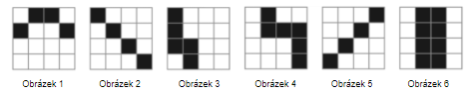
 | First game | Second game
1
2
3
4
5
6
7
8
9
10
11
12
13
14
15

Player 2: Draw a picture according to the table completed by player one. The start is at the top left (the star symbol).
