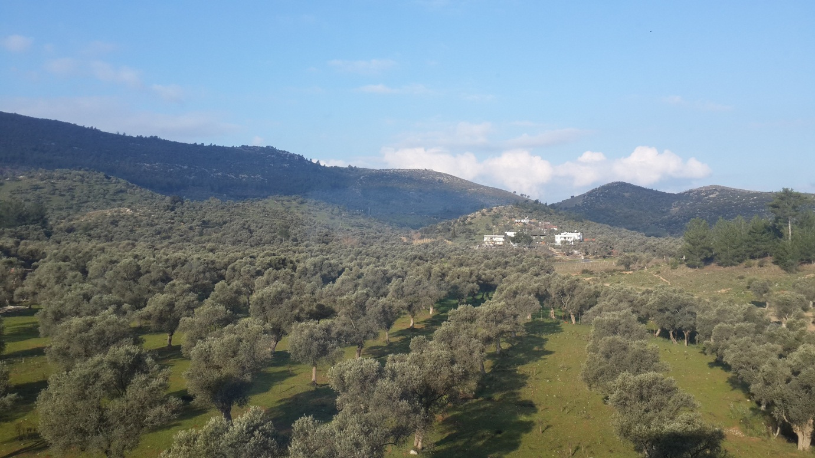
Olive trees

Mountains

From a window of the school (from a class which is located on the backside of school) we can really see this view! As our school is on the outskirts of the town, there are lots of olive trees and fields next to our backyard. Olives are very famous in our city. Behind the trees there are mountains. The weather is usually hot and sunny here.

