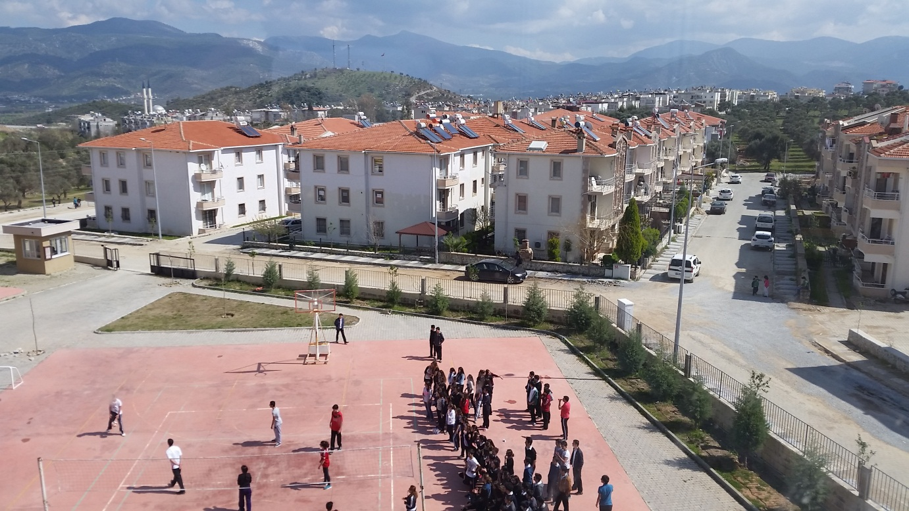
Houses privately owned
street
Our volleyball and basketball courts

From the window of our school we can see our basketball and volleyball courts. At the moment the picture was taken, the students are having a match. It’s a tournament. Some students are watching the volleyball match.
Outside the school there are houses privately owned and streets.

