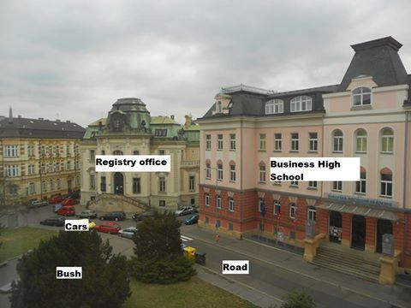
Statue of Jan Ámos Komenský –behind the bush
Labour office

This the view from one of our windows, in the front. The sky is quite nice, still better than sunny weather where you can’t see anything. The photo has been taken from our classroom V4.A on the second floor. In the photo there is one pink building. It's the Business High School (Academy). It was founded in 1945. Next to the Business High School there is the Labour Office, it's the place where you go when you're looking for a job. Next to the Labour Office is the road which leads to the main bus stop which is used by a lot of people not just students but also old people and working people.

