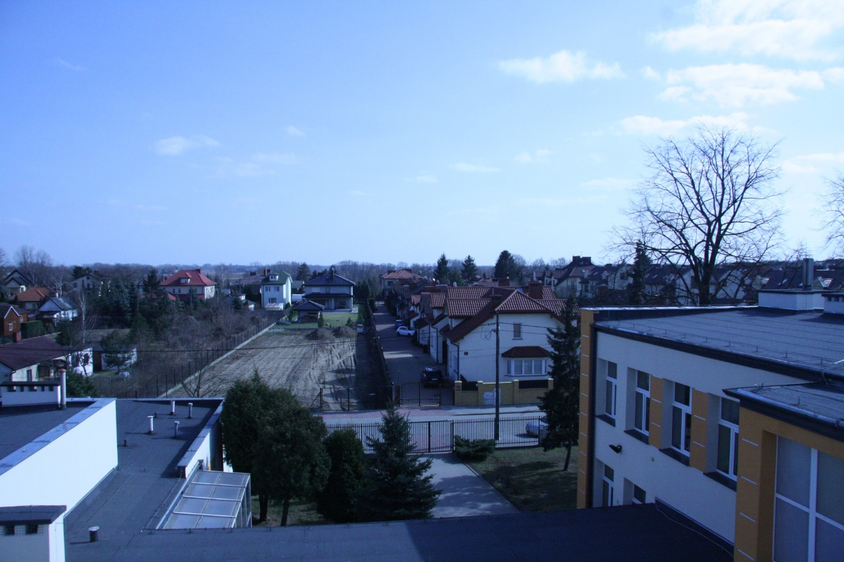
Subdivison
field
Primary school
Roof

In this picture you can see an entrance to primary school. The primary school was built in 1960s.
Later the secondary school was built and is connected to primary school. Behind the school area there are family houses.

