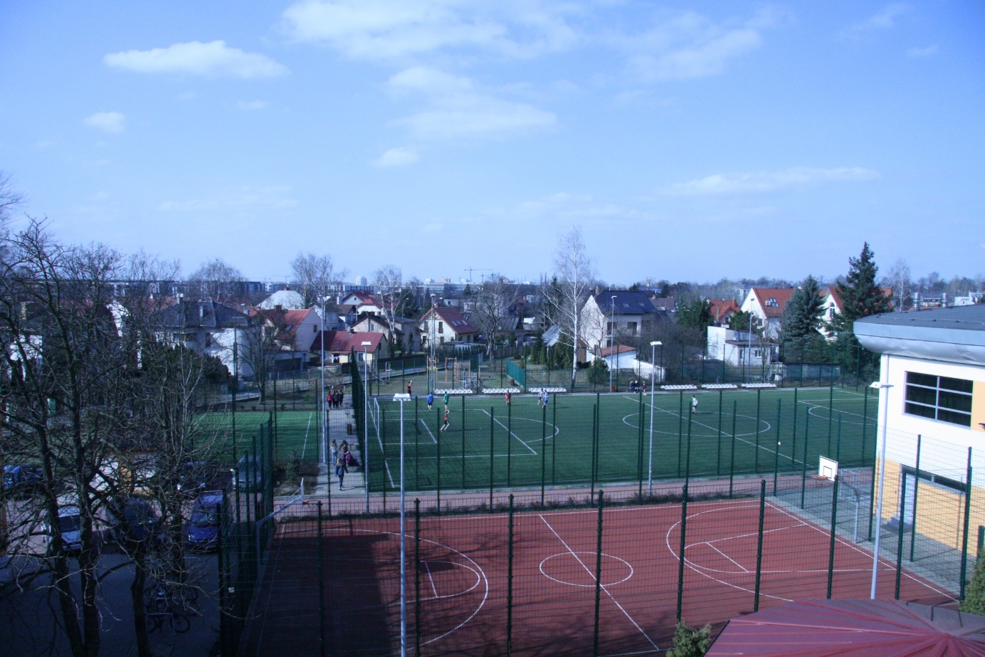

Sports Hall
Gym

Pitch
Parking

Our school has some sports fields. One of them is a football pitch that is used for frequent soccer duels between classes. We have also basketball and volleyball courts. Behind the football pitch there is an outdoor gym. The school is surrounded by family houses.

