Playing Field
Sandpit
Brich
Subdivision
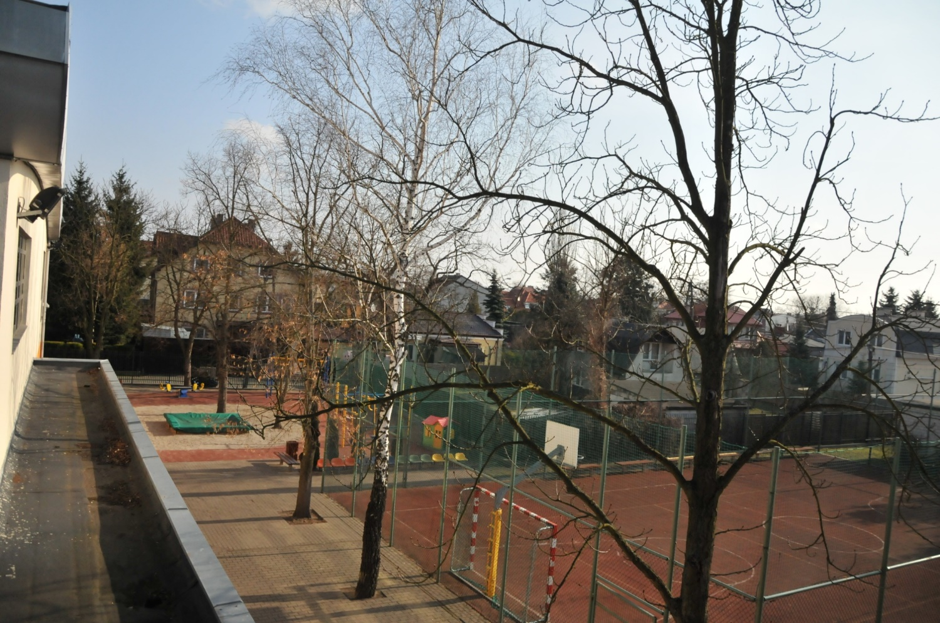
This view shows primary school playground and their sports field. In the playground there are : a sandpit, colourful swings and ladders. On the left side behind the sports hall there is the second part of the playground. Behind the fence there is a little frequented small road used in PE lessons as a track.

