CROATIA, Ličko - senjska and Zadarska county

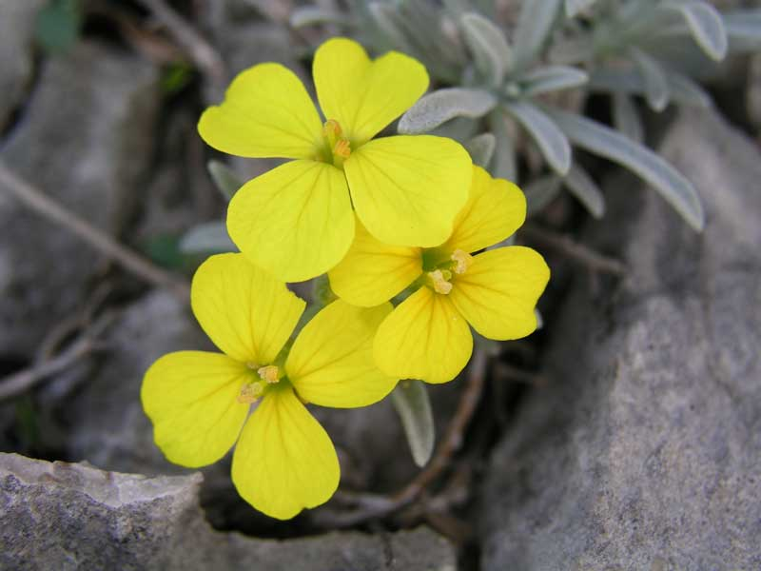

THE DEGENIA VELEBITICA

The Degenia Velebitica (Croatian: velebitska degenija) is

yellow-flowered plant endemic to Velebit and Kapela mountain ranges

in Croatia, and has become a symbol of the region.

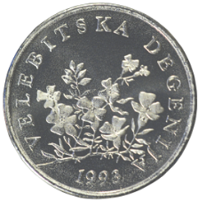It was discovered by Dr. Árpád Degen on 17 July 1917.

The Degenia Velebitica is depicted on the

reverse of the Croatian 50 lipa coin,

minted since 1993.

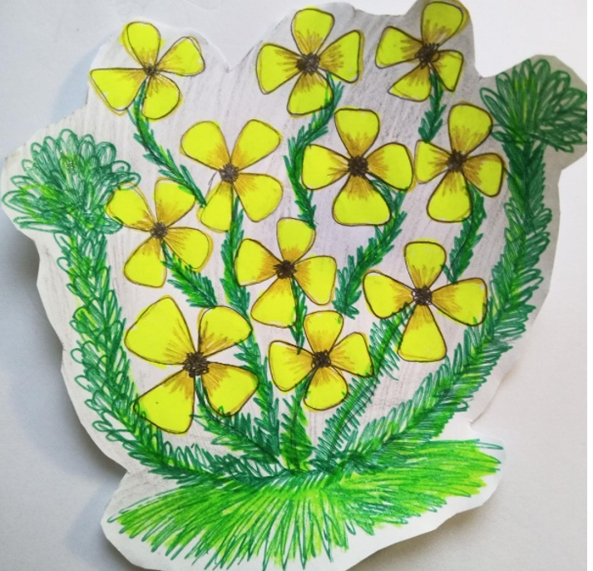

Hana (12)