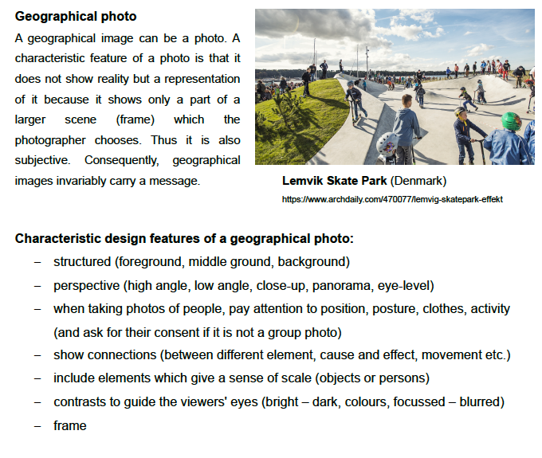
Tasks:
Take photos of main features of your public space, mainly of those elements that catch your interest. It can be features you would like to keep because you like them or also elements which you consider worth changing.

Remember not to take photos of individuals because you need their consent. You may take photos of groups.

