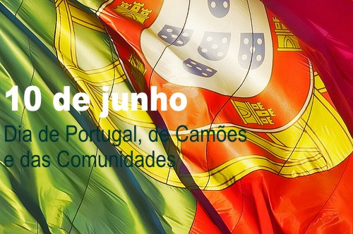
NATIONAL PORTUGUESE DAY
When is Portugal Day?
Portugal Day, officially known as Dia de Camões, de Portugal e das Comunidades Portuguesas ('Day of Camões, Portugal, and the Portuguese Communities'), commemorates the death of Luís de Camões on June 10th, 1580. It is Portugal's National Day.
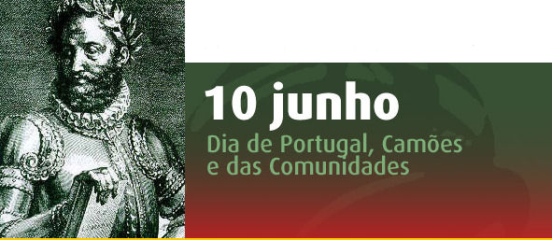
History of Portugal Day
Camões wrote Os Lusíadas, Portugal's national epic celebrating the country's history and achievements. While it is only officially celebrated in Portugal, Portuguese descendants across the world may also celebrate the holiday.
Os Lusíadas focuses on the Portuguese explorations in the 16th century, which greatly expanded the influence of Portugal. The poem is considered to be the most important piece of Portuguese literature, and has become a symbol for the glory of the Portuguese nation.
Camões was a colorful character. He lost one eye fighting and was shipwrecked off the coast of present-day Vietnam. According to legend, during the shipwrecking, he kept his epic poem dry by swimming with one arm and keeping the other arm above water.
In the year that Camões died, Portugal lost its independence to Spain and began a period of rule by three generations of Spanish kings. It was over 60 years before the country regained its independence.
For such national days, it is common practice to use a date of birth to mark the national day, but since Camões' date of birth was not known, the date of his death is celebrated instead.
During the rule of the Portuguese authoritarian regime up to 1974, Camões was used as a symbol for the Portuguese 'race' by the nationalists. Because of that, the June 10 celebrations were officially suspended during the Carnation Revolution in 1974, resuming as a more inclusive celebration including commerating Portuguese communities around the world.

Portugal Day Celebrations
The awards and recognitions bestowed on various achievers form the crux of Portugal Day celebrations. The President also inspects the troops and praises their contribution to national issues. Military parades, orchestras and fireworks mark the celebrations.
On this day people remember their roots by indulging in various patriotic activities such as reading Os Lusiadas, the national epic poem of Portugal, and listening to Portuguese music. Open-air parties and get-togethers are also organized. In case nothing special is happening, people spend the day eating, singing, drinking, and taking part in fun sports.
The event is also celebrated by the Portuguese diaspora in other nations. It is celebrated with great pomp in Toronto, Canada, where the indigenous Portuguese organize a number of events. The festivities last for a week and end with the Portugal Day Parades at Dundas Street. The Parades normally conclude close to Trinity Bellwoods Park where concerts and various other cultural events take place. The Portugal Day Parade is among the top three street festivals in Toronto.
The Portuguese diaspora in the UK also celebrate the day in a grand manner. Weeklong meetings are held along with art exhibitions, special breakfasts, folk festivals, sports tournaments and similar events.
In Newark, New Jersey in the United States, for example, the Portugal Day Festival draws in thousands of people, requiring months of planning in advance. Festivities in Macau are still vivid despite the area being handed over to China by Portugal in 1999. Celebrations in Brazil, Canada, and other parts of the world remind people of the Portuguese people and their culture.
Personal View
It makes us proud, knowing that a Portuguese man had and has such an impact on global literature and that he is a symbol for the glory of the Portuguese nation. So it’s important to celebrate and remember all the great things our ancestors did and honor the identity of our nation.

Work done by:
António Madalena, Lídia Rebelo and Tiago Santos

