AGRUPAMENTO DE ESCOLAS DO FUNDÃO

WORKSHEET

MATHEMATICS
TOPIC: Volumes and Surface Areas of Solids

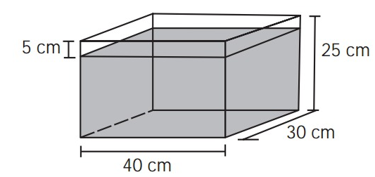
1. Some objects, during their manufacture, need to undergo a cooling process. For this to occur, a plant uses a cooling tank as shown in the figure.

1.1. What would happen to the water level if we put an object with a volume of 2 400 cm³ in the tank? Was the object completely submerged ? (Tick the correct option).
A) The level would rise 0.2 cm, making the water 20.2 cm high
B) The level would rise by 1 cm, making the water 21 cm high.
C) The level would rise 2 cm, making the water stay 22 cm high
D) The level would rise 8 cm, causing the water to overflow
E) The level would rise 20 cm, causing the water to overflow.
2. A wooden pencil holder was constructed in cubic format, following the model illustrated below. The inside cube is empty. The edge of the larger cube measures 12 cm and that of the smaller cube, which is internal, measures 8 cm.
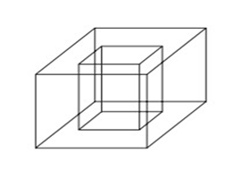
2.1. The volume of wood used in making this object was:
A) 12 ${cm}^{3}$
B) 64 ${cm}^{3}$
C) 96 ${cm}^{3}$
D) 1216 ${cm}^{3}$
E) 1728 ${cm}^{3}$
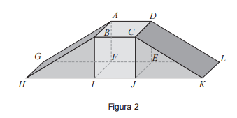
- Figure 2 represents a geometric model of a skateboard ramp. The model is not drawn to scale.

This model is a solid that can be decomposed into the cube [ABCDEFIJ] and the right triangular prisms [BHIFAG] and [CKJEDL], geometrically the same. The bases of the prisms are rectangular triangles.
It is also known that:
• $\overset{´}{HI}$ = 5m
• I$\hat{H}$B = 32º
3.1. Determine the volume of the solid shown in Figure 2. Display the result in cubic meters, rounded to units.

National Exam of Mathematics 9th year- 2nd Call 2012

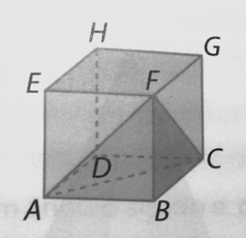
4. The following figure shows a cube [ABCDEFGH] and a triangular pyramid [ABCF].
It is known that $\overset{´}{AC}$=$3\sqrt{2}cm$.

  - Show that the ratio between the volume of the triangular pyramid [ABCF] and the volume of the cube [ABCDEFGH] is equal to 1/6.
  - Admit that the volume of the cube is equal to 252 ${cm}^{3}$. Determine the volume of the solid [ACDEFGH]. Display the requested value in ${mm}^{3}$.

