AGRUPAMENTO DE ESCOLAS DO FUNDÃO
WORKSHEET
PHYSICS AND CHEMISTRY

1. Complete the following sentences correctly:
A - Any force can be represented by a ______________. The length of the segment indicates the ________________ of the force and the ________________ indicates the direction.
B - The SI unit of force intensity is ________ and symbolized by _________.
C – The apparatus that measures the strength of forces is called _______________.
D - Two vertical forces have the same ______________ and two forces of 5N have the same _________.

- Consider the following vectors, which represent forces and complete the table.

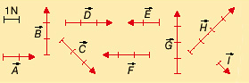

Force | Direction | Magnitude
A
B
C
D
E
F
G
H
I

1. Look closely at figures 1 and 2 and answer:
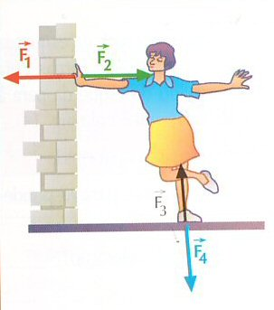
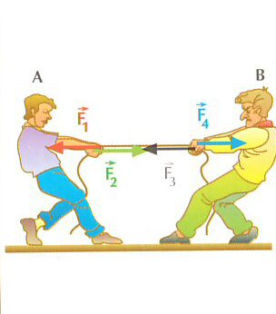

A. The force exerted by the wall on the girl's hand

B. The force exerted on the ground by the girl's foot

C. The force exerted by the boy A on the cord.

D. The force exerted by the cord in the hand of the boy B

E. Two action-reaction pairs

- Two forces F ⃗ 1 and F ⃗ 2 of horizontal direction and opposite magnitude act on the same body.
The force F ⃗_1 is directed to the right and has intensity 6N.
The force F ⃗_2 is directed to the left and its intensity is 4N.

- Determine the resulting force:

b) Characterize the resulting force:

