History Worksheet
9th grade
Decreased demand
(more offer than demand)
Document 1
Question: What do you think about the economic and financial situation in the US? Some think that the aparently brilliant present situation, with constant development of production shown in most statistics and the continuous rise of the price of shares in Wall Street will not last for long and a huge crisis will soon break up.
Answer: It won’t be a violent crisis (...) however, I think a crisis is starting to appear in the US. Some sources of wealth are exhausted. Farmers are complaining, textiles are in a difficult situation. There is over production in the automobile industry, stocks accumulate due to lack of market and a slowdown in automotive production will directly affect the metallurgical industries, basic industries. On the other hand, the constant rise in the value of shares developed specutation: some Americans borrowed money at 9% to buy shares that only earn 2%, which they hope to sell with profit. Retreats as the ones that have been produced in recent days on Wall Street should not be overlooked. They are a kind of warning signs.
Paul Reynaud’s interview (French politician ) to Le Temps Newspaper, October 1929

Accumulation of stocks
Document 2

Decreasing buying power

Deflation
≠
Inflation

Unemployment

Decrease in profits
Companies bankruptcy

Document 2

1. In Document 1, there are three main causes for the stock exchange crash. Which are they?
2. The economical wealth in the US was solid or just apparent?
3. Write a sentence from the text in order to justify your answer.
4. Write a title for Document 1.
5. Identify the causes for the stock exchange crash in Document 2.
6. Produce a text by which you can explain the contents of the diagram in Document 2.
Title:________________________________________________________
The Wall Street Crash was the most important isolated economic event between the two wars. It precipitated the Depression of the 30’s which affected all major world economies. Millions of peolpe, both in industrialized and developing countries, lost their jobs, as companies were forced to contract, therefore making a large part of the work force redoundant. Many companies went bankrupt and the demand for raw materials fell drastically.
The People’s Century (1918-1930), Vol. 8

Document 3

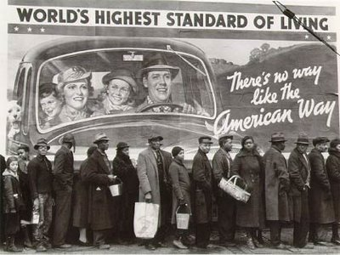
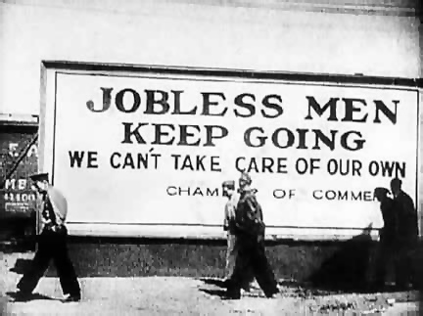

Doc. 5 – “Unemployed have hope ”
Doc. 4 – Queuing for soup

Roosevelt’s program
We have to face our common difficulties (...) a crowd of unemployed does not know how to solve the terrible problem of survival and a large number of people suffer hardships in exchange for a salary of misery (...).
Abundance is on our doorstep, but consumption has weakened relative to production (...). Our biggest task, the first task, is to get people back to work (...)This can be done through the creation of jobs directly by the government, while at the same time doing the work necessary to reuse our natural resources (...). Efforts must also be made to raise prices for agricultural products and purchasing power, which will absorb production. We must act and act fast.

Roosevelt’s speech, March 1933

Document 6 – Roosevelt’s program to solve the cises

7. There are three consequences of the stock exchange crash in document 6. What are they?
8. Did the crisis affect only the US?
9. Write a sentence from the document that may justify your answer.
10. Describe what you can understand from document 4.
11. Compare the outdoor panel to the people who are in the queue in the document 4.
12. Identify the causes for the stock exchange crash in Document 5.
13. What was the name of the Roosevelt social and economic program?
14. Write the measures taken by president Roosevelt suggested in document 6.

