AGRUPAMENTO DE ESCOLAS DO FUNDÃO
HISTORY WORKSHEET
9th GRADE

Name: Date: / /2016 Class: Number:

The First Republic
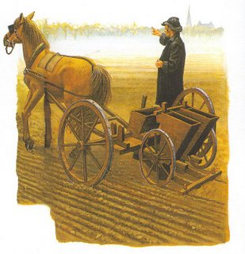

Document 1 – Agriculture in Portugal, 19th Century

- Look to the document 1.
1.1 Write a characterization of the agriculture in Portugal by the end of the 19th century and place it towards the economic situation of the country.
- Write, in one word, the key feature of the Portuguese trade balance during the 19th century.

- Remember what you have studied about the Portuguese Republican Party.

  - Indicate its main aim and explain how the Party could achieve so many supporters.

- Put a chronological order to the following events by numbering them from 1 to 5.
EVENT | ORDER
Regicide
First attempt to overthrow the Monarchy in Oporto.
1911 Constitution
Republican Revolution – October 5th
João Franco rules the country in dictatorship

- Indicate the measures taken during the First Republic in the educational field.

- As you know, the measures placed by the Republican governments weren’t very well accepted by the Portuguese people, especially the ones regarding the State secularization.

  - Indicate 3 of the most disputed aspects by the Portuguese population.

- The Portuguese participation in World War I was another event that affected the population and made the living conditions worse. Then, a man with some supporters, implanted a dictatorship.

  - Identify the name of the man and state the measures taken.

- State the event that happened in May 28th 1926.

Gonçalo Canavilhas, nº12, 9ºB

