FUTSAL (ADF)

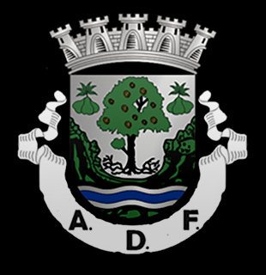Team history
Founded on April 23, 1955; AD Fundão was born from the fusion of Sporting, Benfica of Fundão and Hockey Club Fundão. However, futsal modality was only introduced in this association in 1997.
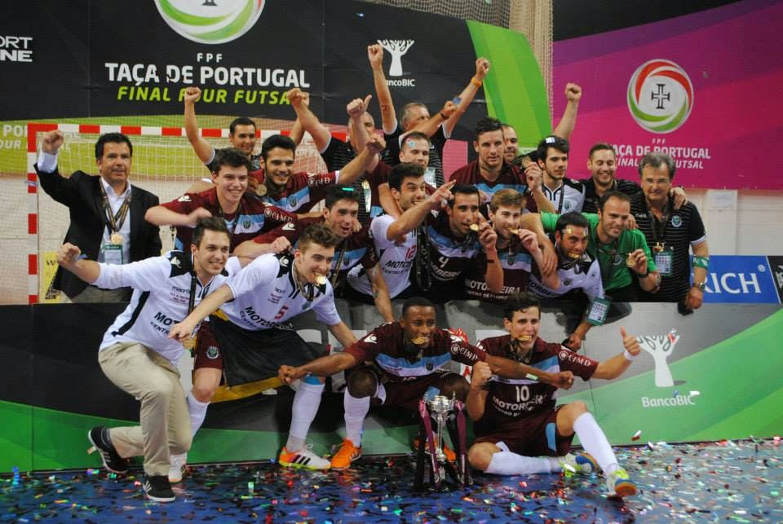
What is futsal?
Futsal is a sport played in teams of five players in a covered field. It demands a big physical effort since there are no periods of time where a player isn’t running. This sport also demands a great capacity of focus because it is practiced in a small area where one little mistake can be crucial to the entire game.
Nowadays, ADF is the most important team representing Beira Interior in the national futsal championship.
This is the result of the hard work and effort of all the directors, team players and other entities associated.

The Rising of ADF
The futsal team has been evolving and winning plenty of supporters and favoritism through the years. In 2013/2014 the team won the Portugal cup. A big accomplishment for ADF and a motive for everyone in Fundão to be extremely proud.

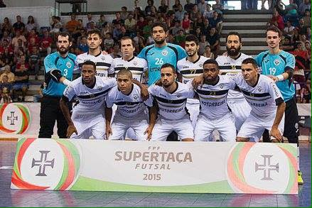Jéssica Almeida

FOOTBALL (MOURINHO)

Mourinho was born in Setúbal on 26 January 1963. He is the son of a former football coach named Félix Mourinho.
Football player career
Mourinho made his career playing in Portugal: Belenses, Rio Ave, GD Sesimbra and “Comércio e Indústria”. He ended his football career at the age of 34.

Coaching Career
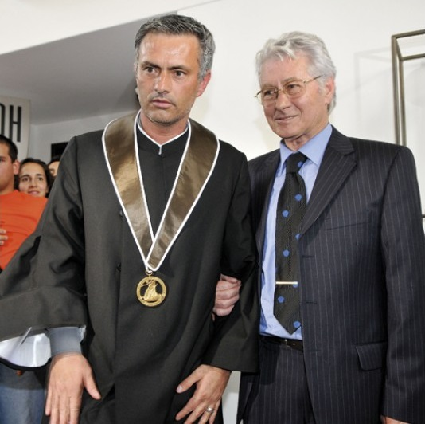Mourinho began coaching in the city where he was born: Setúbal. After that, he signed for Estrela da Amadora and then Bobby Robson took him to FC Porto as assistant coach for 2 years. He won many titles, including two Portuguese football leagues. Bobby Robson went to Barcelona and took Mourinho with him, again as an assistant coach. One year later, Bobby Robson left the Catalonian club but Mourinho stayed as assistant of Louis van Gaal.
In the year 2000, Mourinho came back to Portugal. His coach career in a professional team starts in Benfica where he replaced the german Jupp Heynckes. He didn’t get success and he left the club too early because of several arguments with the Club administration. União de Leiria was the next club he coached. Here Mourinho got good results, but he left the club before the end of the season.
Mourinho was also the coach of Futebol Clube do Porto and, abroad, of Chelsea FC, Football Club Internazionale Milano and Real Madrid FC where he always got the best results.

Eduardo Baptista, Gonçalo Canavilhas and João Pedro Simão

FOOTBALL (FIGO)

Short biography of Luís Figo
Luís Filipe Madeira Caeiro Figo was born on November 4, 1972 in Lisbon, Portugal.
He is a former Portuguese footballer with a 20 years long career in clubs in Portugal, Spain and Italy.
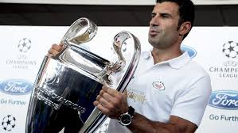
He represented the Portuguese Football selection 127 times, what makes him the record holder of appearances for the national team.
Figo won the Ballon d'Or in 2000, was the best FIFA World Player in 2001 and is included in the FIFA 100.
Figo is one of the few footballers that played in both Barcelona and Real Madrid, two Spanish football clubs. He also played in Sporting and Inter Milan.

He has won several championships and trophies as the Cup of Portugal, four Spanish Football Championships, one UEFA Champions League, one Cup Winners' Cup, one European Super Cup, one Intercontinental Cup, four Italian Championships, one Coppa Italia, and three Italian Super Cups.

Luís Figo career (teams)
Luís Figo began his career at Union Football Club "Os Pastilhas", a neighborhood club in Cova da Piedade, Almada, before being transferred to Sporting Clube de Portugal. He started his senior career at Sporting Clube de Portugal. He won a Portugal Cup serving Sporting and in this club he spent six of his 20 years career, from 1989 to 1995, until he was transferred to FC Barcelona.
In 1995, he announced his transfer to a European giant club, but a dispute between two Italian clubs, Juventus and Parma, after Figo has signed by the two clubs, resulted in the fact that Figo was forbidden to move to an Italian club for 2 years. This situation was resolved after his transfer to the Spanish club, Barcelona. In 2000 he was transferred, with a lot of controversy, from Barcelona to Real Madrid for 60 million euros, a value record in those times. Many fans of Barcelona felt betrayed by this transfer as Figo became a favorite over the years. Three seasons later, in a match against Barcelona in 2003, Figo got a very hostile reception from the public and he was thrown some objects. As a result, FIFA applied a fine on Barcelona.
Figo left Real Madrid to join Inter Milan in 2005 after his contract with the Merengues expired. In the summer of 2008 his compatriot Jose Mourinho was announced as the new coach of Inter, making Figo finish his career alongside Portuguese colleagues.
On May 16 2009, Figo announced the end of his career, in the same day Inter Milan became the Italian champion of Serie A. His last game was on May 31, 2009 against the Atalanta at the San Siro stadium. In this match Javier Zanetti gave Figo the captain's armband.

National team
Figo won the Under-20 Championship by the Portuguese National Team in 1991 along with Rui Costa and Joao Vieira Pinto. In this the year he also had his debut for the National Team A against Luxembourg in a friendly match that got a result 1-1. He represented the Portuguese National Team of “Quinas” in the Euro 1996, Euro 2000, the 2002 World Cup, the Euro 2004 and World 2006 Championship. Figo announced the end of his international career after the Portuguese defeat by Greece in the final of Euro 2004 by 1-0, with 117 internationalizations and 31 goals. However, in June 2005, he reversed his decision and returned to the National Team in order to qualify to the FIFA World Cup 2006, playing towards Slovakia and Estonia national teams.

Personal life
Luis Figo is married since 2001 with the Swedish model Helen Svedin. The couple has three daughters: Daniela (29 March 1999), Martina (23 February 2002) and Stella (9 December 2004).
In 2015 Luis Figo applied to the Presidency of FIFA.
Alexandre Creado, Daniel Silva and Sofia Bento

SURF (in Portugal)
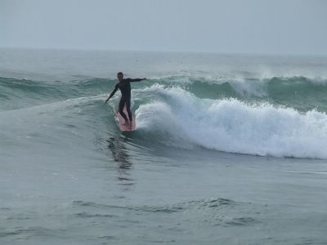What is surf?
Surfing is a water sport that consists of sliding on the waves with a surfboard, running simultaneously several maneuvers with varying degrees of difficulty. It relieves stress, helps to forget about problems and it’s considered by many of its practitioners as a philosophy of life.

Who practices surf?
Most practitioners are young teenagers but there is increasingly greater interest in children for surfing.

The world best surfer
The world best surfer is Kelly Slater who is considered The Legend.
Robert Kelly Slater is the most professional surfer in history, 11 times world surf champion. He is a 43 year old North American.
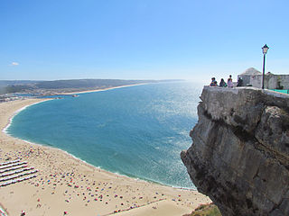
Famous Portuguese surfers
Vasco Ribeiro
Frederico Morais “Kikas
Francisca Pereira
Joana Rocha

Where to go surfing in Portugal?
Portugal has a temperate climate with a lot of sun. Although the water is cold, the waves are regular along the coast throughout the year. The combination of an irregular coastline with the flow of the Atlantic swell results in long coast line with more than 800 km, which is worth exploring.

Best beaches surf in Portugal
Cabedelo, Supertubos, Praia Grande, Praia do Guincho, Nazaré, Carcavelos, Ribeira d’Ilhas, Fonte da Telha

Surf origins in Portugal
Surfer Pedro Lima.
The surf with a standing surfboard in Portugal started in the early 60s. The pioneer, seen as the father of Portuguese surfing, is the surfer Pedro Lima. He lived at the time a real adventure because there were no surfers and virtually no documented material on surf in Portugal which forced him to be self-taught.
After the revolution of April 25, surf was gaining fans and in the 80s surfing took a huge leap in the practitioner’s number. Today it is a very popular sport that has been gaining a considerable number of fans every year. In 1988 Portuguese Surf Federation was created.

CURIOSITIES - Do you know the world’s largest wave?
In November 2011 Portugal came into the Guinness Book of Records. In Praia Norte, Nazaré, the American/Hawaiian surfer Garrett McNamara reached the Guinness World Record of the largest wave ever surfed. This was an event which gained great disclosure worldwide about Surf in Portugal.

Cátia Santos, Carlota Rosa and Catarina Rocha

