Daniela Ruah
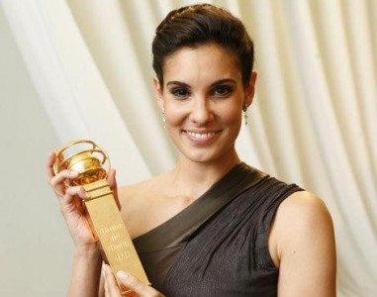

Family
Daniela Sofia Korn Ruah was born on 2 December, 1983 in Boston, Massachusetts, in the United States of America. She is an actress married with David Paul Olsen. They have a two year old son called River Isaac. Her parents are Portuguese citizens. Moisés Carlos Bentes Ruah, an otolaryngologist in a Portuguese clinic, and Katharina Lia Azancor Korn. They got divorced when Daniela was only 5 years old. Her father comes from a prominent Portuguese Sephardic Jewish family.
School and early career
She studied at the American School Foundation of Lisbon. Her career began at the age of 16, in the role of Sara in the Portuguese soap-opera Jardins Proibidos (“Forbidden Gardens”). At 18 years old, Daniela Ruah left Lisbon to begin her Bachelor of Theatre Arts at London Metropolitan University. She returned to Portugal with the aim of developing her career, especially in leading roles on TV shows, movies and plays. In 2007 she went to New York in order to study and start an international career. As her first job in the United States, Daniela Ruah starred in the spin-off series of NCIS and accompanies the show NCIS: Los Angeles as one of the co-protagonists.
Achievements and awards
She was nominated for a Teen Choice Award and for an Emmy Award, in 2010, for best actress due to her performance on the TV show. She was considered one of the sexiest women in the world by US magazine Esquire, one of the most worldwide prestigious magazines in its category. In 2010, she won a Portuguese Golden Globe for best new actress.

Inês Opinião, Pedro Soares and Rita Salvado
Gisela João
Gisela João is a young very well known Portuguese singer. She was born in Barcelos, in 1983. She lived for many years in Oporto, but in 2000 her passion for music made her move to Lisbon. In 2009, Gisela participated in Fernando Alvim’s disc “Fados e as Canções do Alvim”. In 2012 she was considered one of the greatest female revelations of Portuguese fado (typical song), in the latest years.
In 2013, Gisela produced her first album which was considered the best national album of that year and that made her win the prize Revelação Amália.
In May 2014, she won a Globo de Ouro in the category of Best Individual Interpreter, in the TV channel SIC Caras ceremony. She was also awarded the prize José Afonso 2014, in which the jury considered that Gisela is “the best voice that has appeared after Amália”, the most important voice of Portuguese fado.
In July 2015, Gisela was invited to participate in the tribute album to Amália Rodrigues, “Amália: as Vozes do Fado”, with the participation of some of the most iconic artists of Portuguese music.
Also in 2015, Gisela performed on stages in France, USA, England, Belgium, Spain, Switzerland, Slovenia and Germany. Gisela continues to sing and charm Portugal and the world.
Some of her songs are part of soundtracks of Portuguese films and soap-operas. Some exemples are: Coração d’Ouro, Casa de Mariquinhas, Meu amigo está Longe, Madrugada sem Sono. You can listen to a sample of her music here:
https://www.youtube.com/watch?v=87LugsyPhq8&list=PLlGRIXRQqzbzhdP6cDKMCGK0p1Xhk1-47

Rita Almeida e Sara Salvado
Richie Campbell

Important facts:
He was born in Lisbon, Portugal in November 25, 1986.
Full name: Ricardo Ventura da Costa.
Profession: singer.
Music style: Reggae.
Early career:
Campbell started his career at the age of 24 in a band called Stepacid. He also played in a musical project called “No joke sound”. He abandoned, however, both projects in 2010 to focus himself in a solo career.
His first album, My Pathm was released with the disc Focused and he got a great success especially by the track "That's How We Roll". This music was nominated to the Portuguese awards “Globos de Ouro” in 2013.
Here are some of his best well known songs:
https://www.youtube.com/watch?v=eeqi2Jo-ftc | https://www.youtube.com/watch?v=iOwdVdHxRtE

Márcia Nogueira and Maria Quintela

Shawn Mendes

Personal details: Shawn Peter Raúl Mendes, born on August 8, 1998 (17 years old). He is a Canadian citizen although his father is Portuguese and his mother is English.
Why did we choose to search about him? He is a great singer and he has Portuguese origins.
Early Career:
He became known in the app “Vine” where he published some videos and music. So, in January 2014, Andrew Gertler found his work and believed he could become a great artist. He participated in the MagCon Tour (before he signed the contract). In June 2014 he released the music Life of The Party. He did the openings in “Live on Tour” of Austin Mahone from July to September 2014.
Albums:
July 2014 - The Shawn Mendes Extended Plays.
Record label: Island Records (5th position in the Billboard chart of the USA and Canada).
April 2015 - Handwritten.
Record label: Island Records (1st position in Canada).
Most successful tracks: Life of The Party. Something Big. Stitches. I Know What You Did Last. Summer (https://www.youtube.com/watch?v=VbfpW0pbvaU)
Awards: 6 platinum disks, 2 double platinum disk and 2 gold disks.
Teen Choice Awards: Choice Webstar Music.
Teen Video Awards: Best Newcommer In Video (Something Big).
MTV Europe Music Awards: Best New Artist Best New Act.
Teen World Awards: Best New Artist, Best Crush Artist, Best Canadian Artist.
Teen Music Awards: Best New Artist.
Canadian Music Awards: Best New Artist, Best Pop Artist, Best Pop Album (Handwritten), Best Pop Song (Stitches).

Bruna Garcia, Joana Teófilo, Luana Azevedo and Nádia Mesquita

Dulce Félix
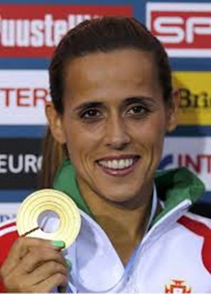

Full name: Ana Dulce Félix.
Birthday: October 23, 1983.
Sport categories: 1000 meters, marathon, cross-country.
Career:
She started her career at just 12 in a local sports club. In 1999 she was transferred to Vizela's sports club. Here she had to work as a normal everyday worker and also practice sports. Obviously she started to get very bad sport results.
In 2007, she joined Sporting de Braga football club and she decided she had to dedicate herself just to the sport practice or she wouldn't get better results.
In 2013 she was transferred to Maratona Clube de Portugal, where she is at present.

Participation in sport events and medals won:
2012 - Olympic Games - 21st position.
2009 - World Championship - 13th position.
2011 - World Championship - 8th position.
2010 - Europe Championship - 8th position.
2012 - Europe Championship - Gold Medal.
2008 - World Cross Country Championship - 72nd position.
2009 - World Cross Country Championship - 15th position.
2008 - Europe Cross Country Championship - 17th position.
2009 - Europe Cross Country Championship - 6th position.
2010 - Europe Cross Country Championship - Bronze Medal.
2011 & 2012 - Europe Cross Country Championships - Silver Medal.

Ana Silva, Beatriz Martins and Maria Gonçalves

