15/5/2021, Neapolis Crete

My dear friend Paul,

I'm sending you this letter to describe how I spent Easter in my small town, Neapolis.
As soon as the schools closed for the Easter holidays, we left right away for my mum's village. It is a quiet place in the mountains, in the north-eastern part of Crete. People there keep their customs and traditions through time. You feel like you're getting into a time machine.
My first walk started as soon as I set foot there. The journey to tradition had just begun! The main feature of this city is that it has many churches. People have a strong religious feeling and they have identified its way of life with the religious tradition, especially during the Easter period.

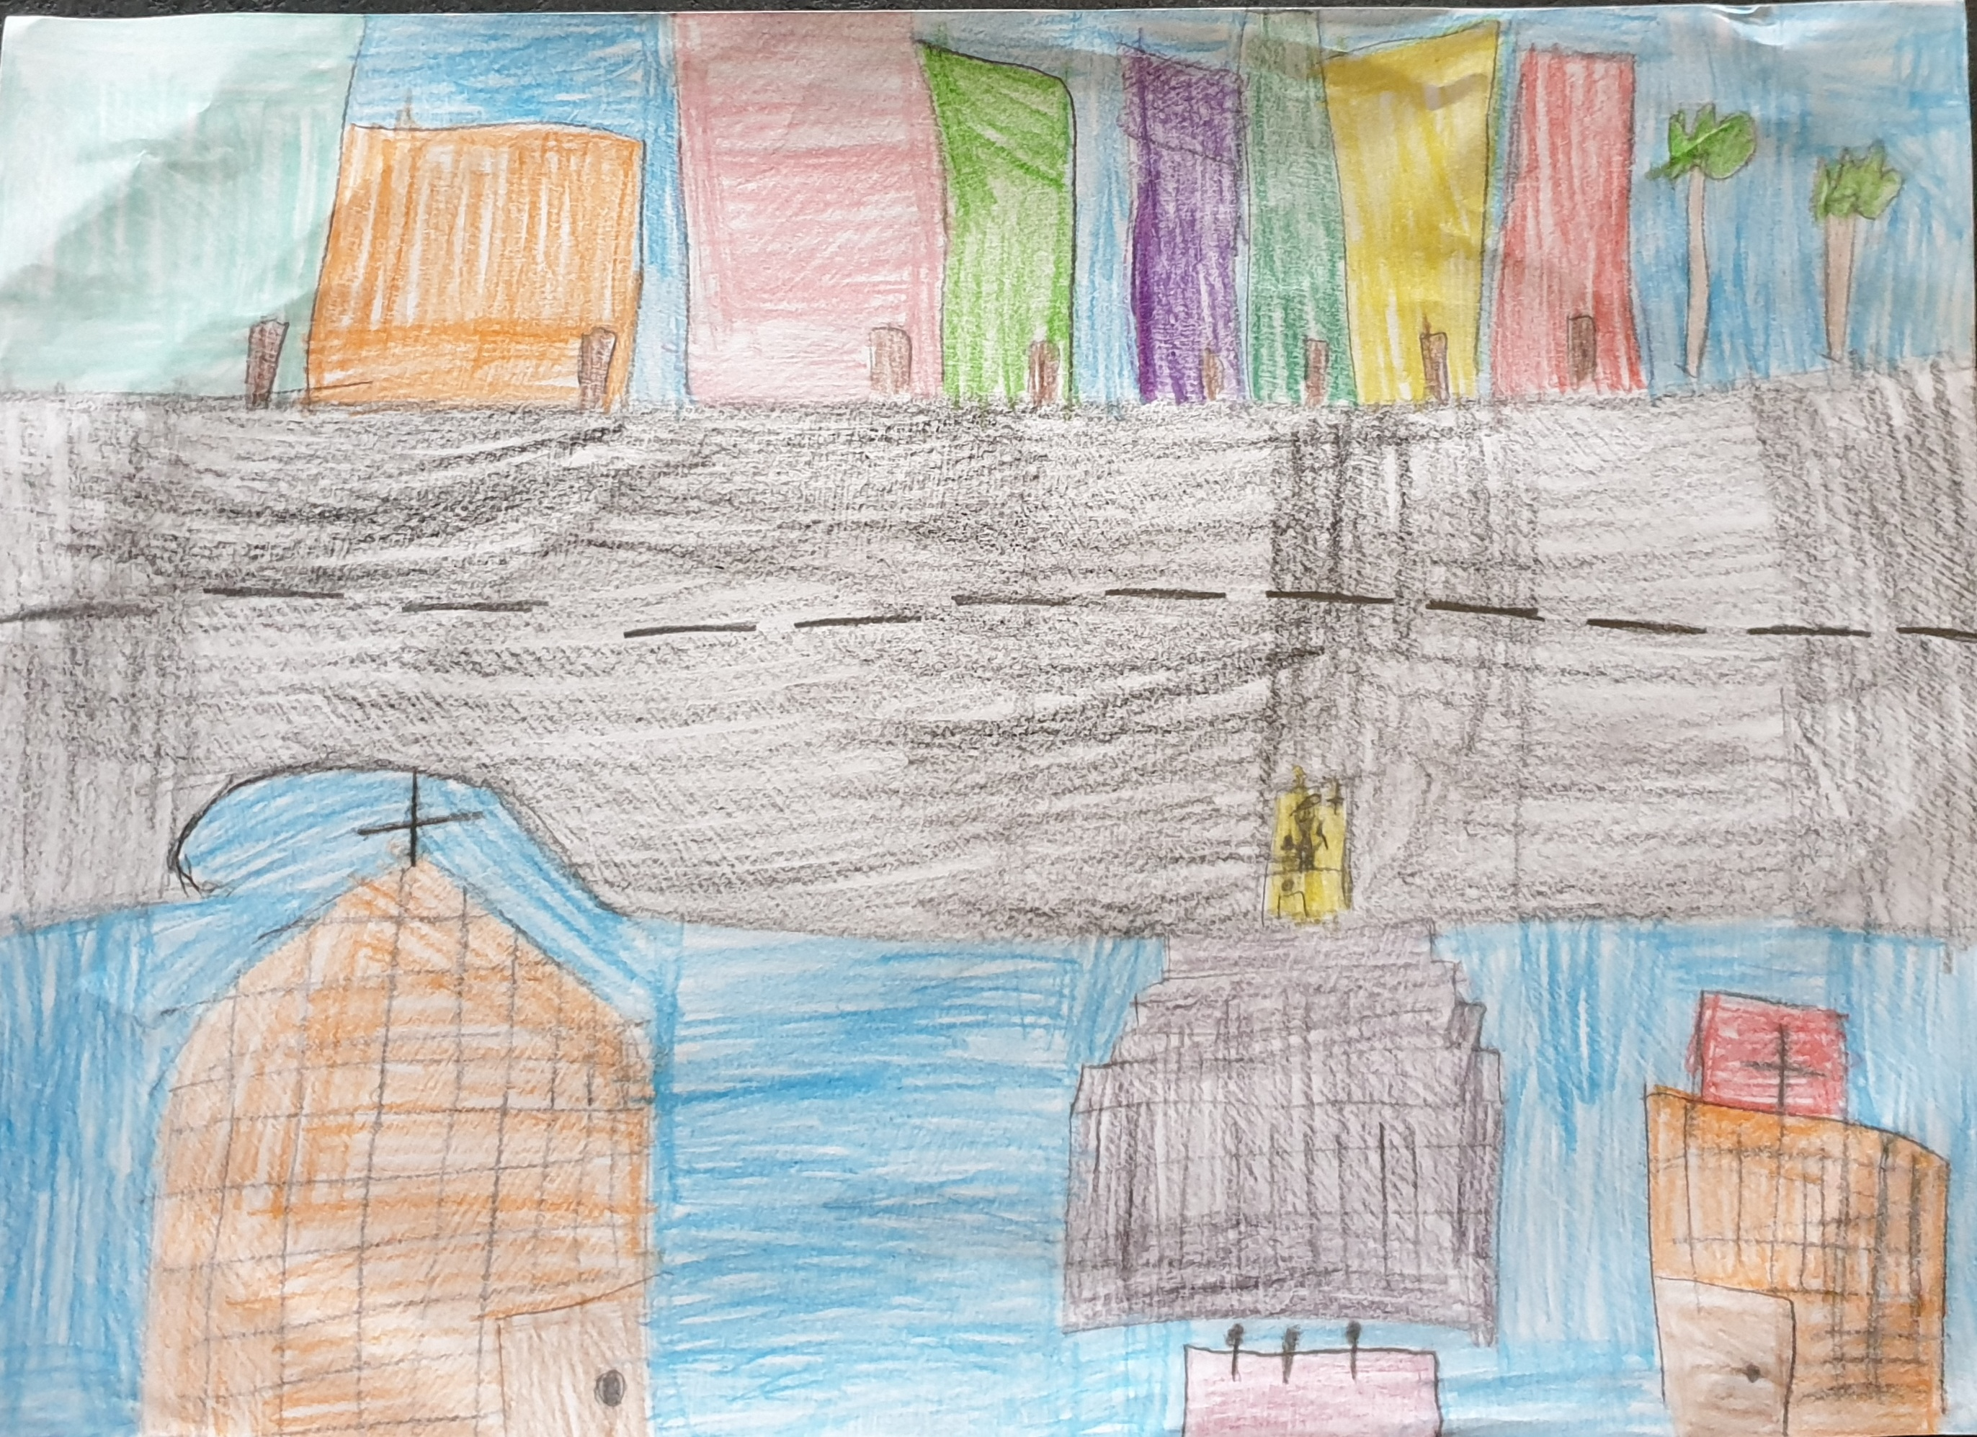

As soon as my grandmother saw me, she said, "The priest needs help, you're just in time!". As you can see, I had to take over my ‘duty’ – once again. The next day, that is called “Kiriaki ton Baion” (Palm Sunday), I found myself at the church of “Megali Panagia” at the first ringing of the bells. My first job was to wear my religious outfit and begin to help the priest. At the end of the Divine Liturgy I helped him to offer the faithful crosses made of palm leaves to the people.
The week of Passions began on Sunday afternoon, with the exit of “Nymphios” (Jesus Christ). At noon I went out with my friends in the fields to collect flowers. According to the custom, the young children throw flowers as soon as the icon of “Nymphios” comes out. So, on Holy Monday, Holy Tuesday and Holy Wednesday, we praised devotional “Nymphios”.
In the afternoon of Holy Wednesday, there is a custom of the locals going to the church to be ‘crucified’ by the priest with holy oil on their forehead, a ritual that is accompanied with wishes of forgiveness by the priest.
On Holy Thursday morning, I didn't go to church since I had to help my family paint the eggs. That afternoon was very tiring for me. My feet hurt because I was standing for hours to listen to the twelve gospels at the church! Christ’s “body” was put on the Holy Cross and people decorated him with garlands of lemon blossoms.
On Holy Friday morning, I went to the church to help the priest take the body of Christ down from the Cross and place it on the Epitaph. According to this custom, in the evening of Holy Thursday, women decorate the tomb of Christ (Epitaphios). As soon as the body was placed in there, the bells started ringing in mourning.

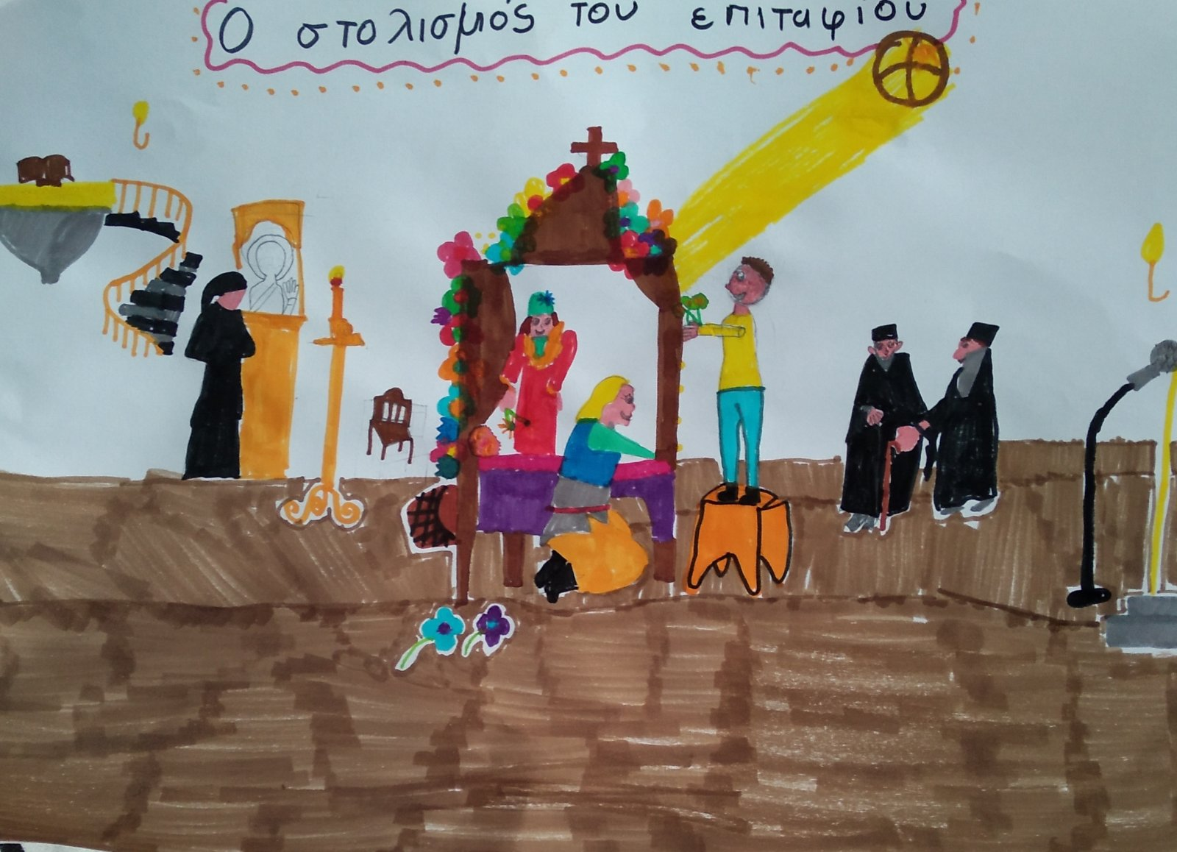

I came home thinking it was a day of mourning, because our Christ was in the tomb. Even Nature seemed to regret with its cloudy sky on that day. We all ate together simple and oil-free food, boiled lentils with plenty of vinegar in memory of the fact that Christ was watered with vinegar by the soldier while he was on the Cross.
In the afternoon, I went for a long walk in Neapolis to see the various Epitaphs, each church decorating its own. At first, I visited “Agios Georgios”, the church that was closest to me and which is the 2nd largest in Neapolis. Then I went to “Megali Panagia”. I walked under the Epitaph for three times, expecting good luck.
Next stop was the church of “Agios Syllas”. It is a small but very important church of the history of Neapolis. There is a well with water, which is miraculous, but also holy, because it gushes under the church. We washed with that Holy Water. It has healed a lot of people after all!
In the evening, at half past seven, I went to “Megali Panagia” in my best clothes. I sang the “Egomia” (lamentations) expressing the mourning words of Virgin Mary before the Holy Sepulcher.
Then my family and I followed the procession of the Epitaph. There were a lot of people holding a candle. We could all hear the bells ringing in mourning. When we arrived at the church we passed under the Epitaph once again, lit a candle and left...
It finally dawned Holy Saturday. At home, a lot of preparations were made for the dinner after the Resurrection. But duty called me. First, I had to help the priest to throw laurels to the crowd, representing the first Resurrection. Then I wanted to help the children find wood and branches for the bonfire where an effigy of Judas would be burnt. I was very lucky to experience both!
The night finally came. We dressed in our formal clothes and when the bells rang, we went to the church to get the Holy Light. We arrived at the moment when the priest had turned off the lights of the church and came out from the “Orea Pili” with a lit candle, giving the fire of his candle to the faithful crowd. Then people came out of the church and headed to the main square of Neapolis to sing "Christos Anesti" (Jesus resurrected).
We were all looking forward to hearing the priest singing "Christos Anesti", especially the children that were holding fireworks. Their thought was to light the fire that would burn “Judas” at the first words of "Christos Anesti". The priest started and the night became day! We couldn't hear him at all because of the noise. Then we returned to the church for the Βlessed Resurrected. We finished at three in the morning and gladly returned home for the festive table, with the well-known “Magiritsa”. As soon as we finished dinner, we fell asleep very quickly.
It was Easter Sunday and the preparations for the Easter table started very early. Dad lit the charcoals and put the lamb on the spit, while Mum and Grandma were in the kitchen preparing the rest of dishes. “Tsourekia”, “Kaltsounia” and red eggs have their honor. We ate a lot of food. I felt like a king, but my thought suddenly turned to our return. The next day we'd go home because Dad was going to start work again. In the evening, we loaded the car and took the way back home...
As I’m writing this letter to you, my feelings are mixed. Joy for what I experienced in the village and sadness as we had to return so soon. It was certainly an experience that I'll never forget. I’m closing this letter with a wish that next Easter you will be able to come to Greece and that we will spend Easter holidays together!

Good-bye,
Your friend,
John

