Easter stories
EASTER SURPRISE
Chapter 1
A busy Easter Bunny
Thiis year children are very sad cause Corona Virus,
The Easter Bunny want to paint Easter eggs for the children.
Easter Bunny goes to the market to buy some eggs.
He paints them with fantastic color:
He paint a egg like a sky!
He paints two yellow egg like a sun!
He paints three green egg like a tree!
He paints four orange egg like an orange!
He paint five red eggs like a cherry!
How many eggs he has?
What will he do?

Chapter 2
Let’s hide the Easter eggs
It's Easter eve! Friends, lets help Miss Bunny to hide all the Easter eggs.
Where are all the Easter eggs?
Miss Bunny hides an Easter egg on top of the table! Do you see it?
Miss Bunny hides an Easter egg at the bottom of the chair! Do you see it?
Miss Bunny hides the eggs in the cupboard! Do you see it?
Miss Bunny hides an Easter egg in the basket! Do you see it?
Miss Bunny hides an egg out of the basket! Do you see it?
Well done! Miss Bunny is very happy to hides all the Easter eggs.
What will children do?
They will find all the Easter Eggs! They will be happy!
﻿Thank you friends, for helping me to hide my Easter eggs!﻿
Chapter 3
Easter day surprise
It is time for the Easter egg to find in the garden and inside the house.
All the children come to look for eggs!
Mary is happy, she is very good to find eggs!
She find a blue egg like a sky!
She find two yellow egg like a sun!
She find there green egg like a tree!
She find four orange egg like an orange!
She find five red eggs like a cherry!
How many eggs she has?
A lot eggs! What will do?
Mary shares the eggs with her 5 friends.
All the kids open the eggs. What is inside?
A cards with a sentence:
"Happy Easter and remember that everything will be fine!"
Children say thank you to Easter Bunny with a basket full of carrots.
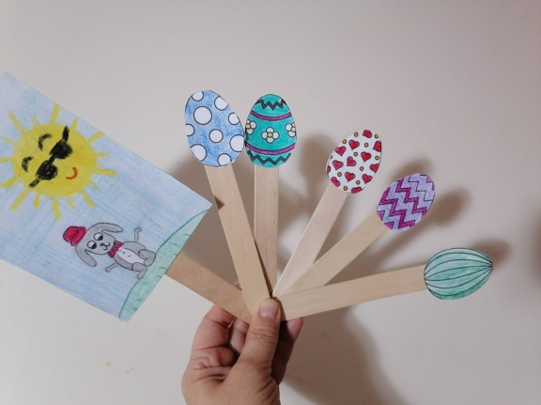
Share is the best way to make friends, no matter what!

