The Christmas’s segret

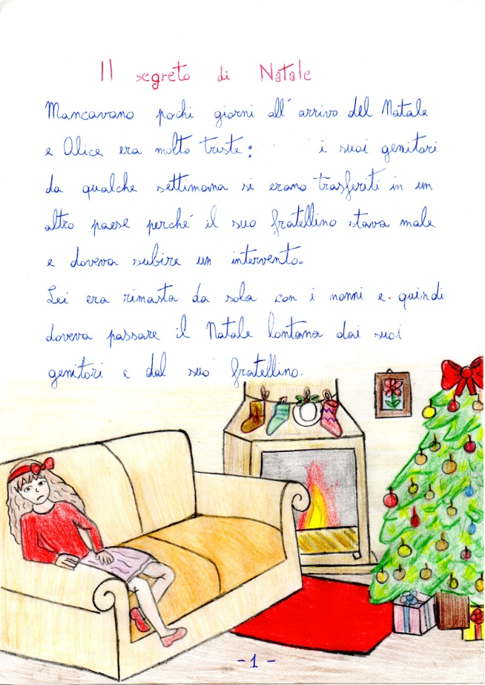

Alice is very sad, her brother is in hospital.

He is very sick.

Alice is at home with her grandma, she is on the sofà and she is thinking his brother. Christmas is near and she miss her parents.

Her grandma says: “Alice, please write a letter to Father Chrismas and ask some presents that make you happy. And Alice answer: I don't believe in Santa Claus”.

Her grandmam said: when I was a child I did not believe in father Christmas, but one day I saw him in my kitchen.

He gave me a beautiful present”, but father Christmas said to me: “shuu, it’s a secret! Don’t tell anyone to see me:”

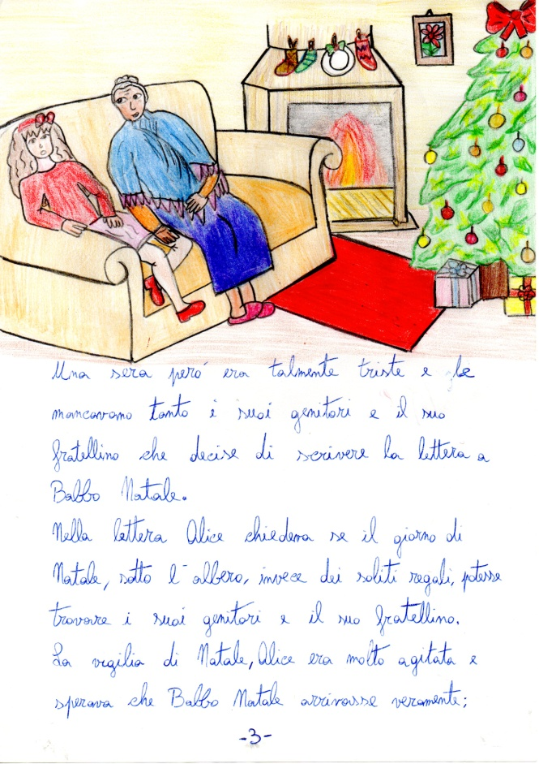



Christmas Eve, the girl is very sad.

She miss her mother and her little brother. She decided to write a letter to Father Christmas.

She write: Dear father Christmas, please let my little brother come back home, on Christmas day.

On Christmas Eve Alice can’t sleep, she wait Santa Claus.

During the night she hear a noisy, she goes in the livingroom and see Santa Claus. Father Christmas invite Alice to go with him, to live a wonderfull night with him but he says: “you don’t tell anyone. It is a secret”!

Alice is surprice to see Santa Claus. She goes on the sleighwith him.

They travell all the night to give some gift to all the children.

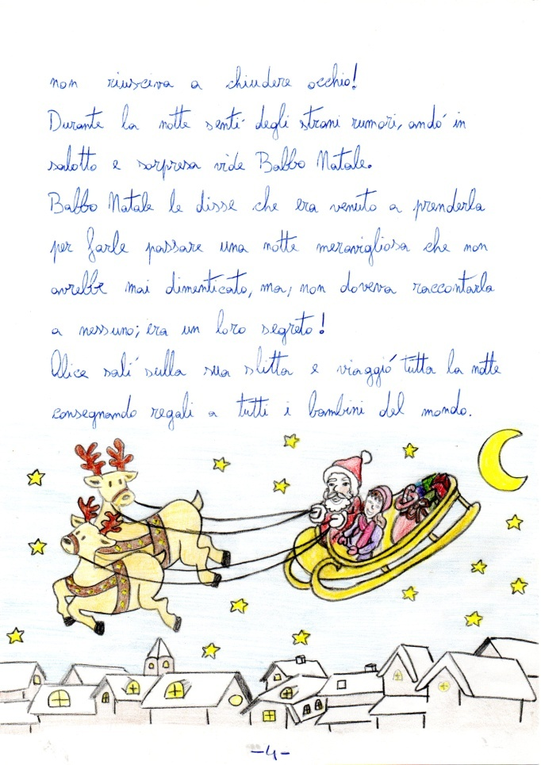

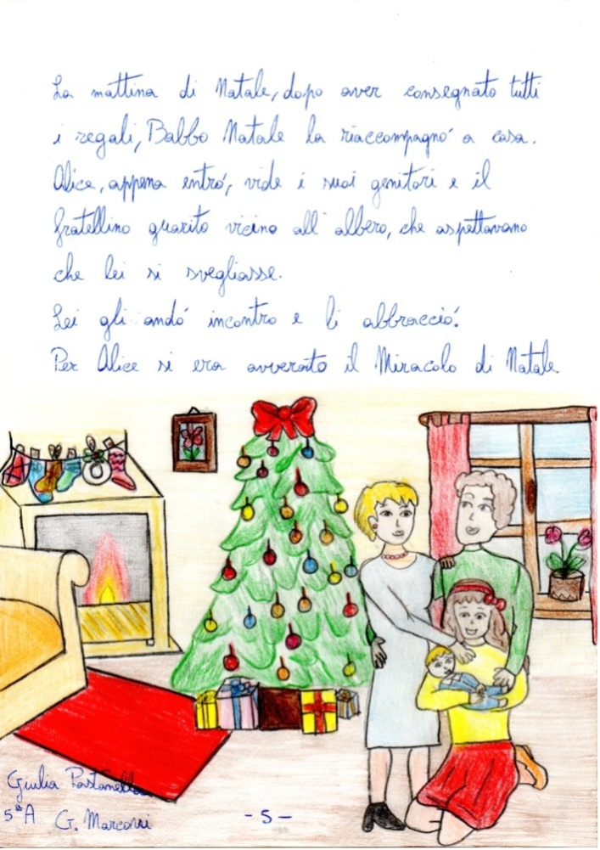

On Christmas Day, Alice recived a special present. When she wakes up,

her little brother and her mum are near the Christmas Tree. They come back home. Alice hug is brother and say: “this is a dream.

Dear brother and mum, you are the best present that I recived for Christmas.

