Lesson Plan

Title of the Unit: Industry
Subject: Iron Industry in Romania
Students’level: 7th, 8th graders

INTRODUCTION: This lesson has as a main aim studying the most important aspects about steel industry in Romania. Students will learn related phrases / expressions of this field, they will contemplate the impact of steel industry on environment.

Learning outcomes:
- Defining industry;
- Identifying the factors which leaded to the appearance of industry;
- Awarness of the impact of industry on humanity;
- Defining steel industry;
- Identifying the factors which leaded to the appearance of steel industry in Romania;
- Identifying the main steel cities in România;
- Specifying the advantages and desadvantages of steel industry;

Subject content:
- Industry: definition, period of appearance, factors which leaded to its appearance, impact on humanity;
- Steel industry in Romania: definition of siderurgy, steel works, mill; factors of steel industry appearance in Romania, the main steel companies in Romania;
- The story of steel industry development in Călăraşi, Martifer - the metalic constructions factory.

Language objectives:
- knowledge and comprehension of scientific terms: iron ores, coke, cast iron, steel, steelworks, blast furnace, rollingmill, galvanisation;

Task:
A presentation about advantages and disadvantages of steel industry, a bunch of specific expressions of iron industry.
Activities:
Students will read texts about industry;
Students will watch a presentation about industry; they will watch a video about the appearance and development of industry;
Students will watch a presentation about steel industry in Romania;
Students will practise specific vocabulary;
Students will make a scheme of steel industry advantages and disadvantages;
Online tests.

Session :

- Motivating video: https://www.youtube.com/watch?v=9l7JqonyoKA
- Brainstorming - students watch a video “STEEL: From the Begining to the End”
- Identifying key terms reffering to steel industry - these are sticked by the students on a flipchart paper. Students read the word definition.
https://docs.google.com/document/d/1u8GklswR6zBvDsDSEVqwaqt8nbIv4pUAxhiaUzaRypY/edit?usp=sharing
KEYWORDS

IRON ORES - are rocks and minerals out of which metallic iron can be extracted.

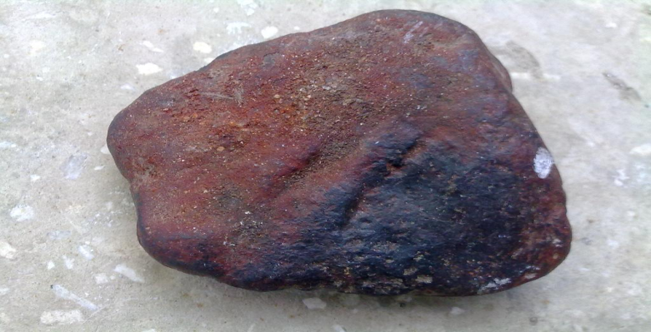

COKE - is a material obtained by thermal processing of coal.

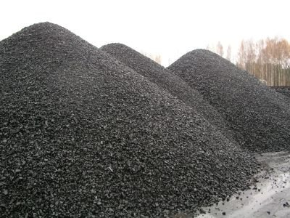

CAST IRON - is a group of iron-carbon alloys with a carbon content higher than 2%.

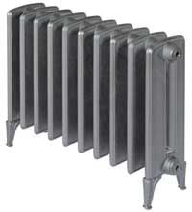

STEEL - is an alloy of iron and other elements, primarily carbon; the carbon content of steel is between 0.002% and 2.1% .

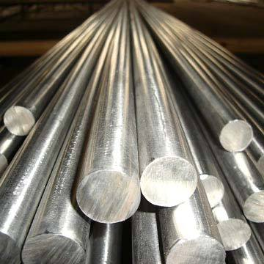

STEELWORKS - is an industrial plant for the manufacture of steel.

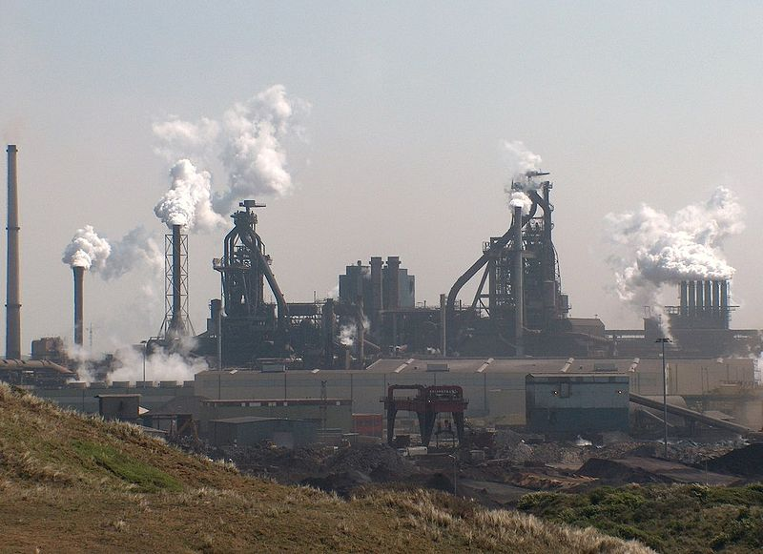

BLAST FURNACE - is a type of metallurgical furnace used for smelting to produce industrial metals, generally iron.
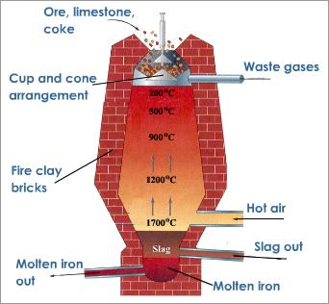
ROLLINGMILL - is a metal forming process in which metal stock is passed through one or more pairs of rolls to reduce the thickness and to make it uniform.

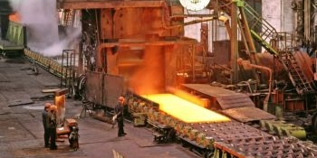

GALVANISATION - is the process of applying a protective zinc coating to steel or iron, to prevent rusting.

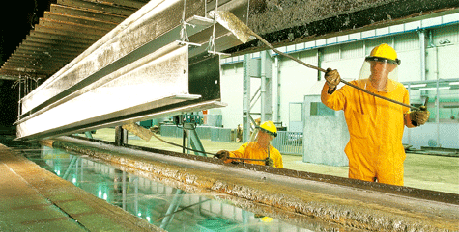

- Presenting a PowerPoint material about Steel Industry in Romania: explaining/defining words like: siderurgy, steel works, mill; presenting the main steel centers in Romania.
https://docs.google.com/presentation/d/1SYf-LQYWOr7vEthBm57FGeu_Y63kudK4FCQ8ffW-7kI/edit?usp=sharing
- Students answer to questions in an online test.
https://docs.google.com/forms/d/1so3byITElSn2si4gW4p192IHHBxgls0PlJ-NZgMuyFg/viewform

IRON INDUSTRY IN ROMANIA
Top of Form
What does the iron industry produce?
  - fonte and steel
  - furniture
  - food
  - cars
What city in Romania hosts the oldest steeI mill?
  - Hunedoara
  - Reşiţa
  - Călăraşi
  - Galaţi
What company is the leader in all major global steel markets?
  - Nestle
  - Continental Automotive
  - ArcelorMittal
  - Alro Slatina
Where is the largest integrated steel plant in Romania?
  - Reşiţa
  - Galaţi
  - Hunedoara
  - Călăraşi
Steel is 100% recyclable!
  - Yes
  - No
The main chemical elements in steel composition are:
  - Copper and Aluminium
  - Silver and Carbon
  - Iron and Carbon
  - Copper and Iron
Coke, used in iron industry, is obtained of:
  - Iron ore
  - Copper
  - Coal
  - Other Minerals
The plant where the steel is produced is called:
  - textile factory
  - steelworks
  - fertilizer plant
  - automobile factory
Which is the mother country of Martifer Company?
  - Germany
  - Romania
  - Spain
  - Portugal
Galvanisation prevents:
  - breaking
  - rusting
  - sticking
  - bending
Bottom of Form

Assessment:
- Students are divided into four groups; the first three groups get a thematic text:
https://docs.google.com/document/d/1-CO6Oz8u-7YE7iGth1IqogtmHKGnXWfvqPbq4luhV9s/edit?usp=sharing
Steel is today one of the best sold materials in the world; it is used to produce everything: automobiles, railways, buildings. Iron (steel and fonte) is a "green" product. It is also energetically efficient. Any excess material is 100% recyclable. Steel does not easily warp, buckle, twist or bend, and is therefore easy to modify and offers design flexibility. Iron (steel and fonte) allows improving the quality of construction and less maintenance, while offering improved safety and resistance.
Heavy and thus expensive to transport, susceptible to corrosion - steel bridges must be painted continuously, particularly in a salty environment. When metal is extracted from the ground, it creates a lot of negative impact to the environment. Metal extraction can drastically affect the quality of air in the surrounding areas, with the high levels of dust and gas in the area. There’s also the noise pollution that it creates, which affects the natural habitat of animals. Last, metal extraction disfigures the landscape. Now, if companies continue extracting metal, the land will be disfigured forever, causing flooding and soil erosion in the area.
  - students in the first group will specify advantages of iron industry;
  - students in the second group will identify iron industry negative impact on environment;
  - students in the third group will identify disadvantages of iron industry;
  - students in the fourth group will complete a crossword puzzle about iron industry;
https://docs.google.com/spreadsheets/d/128apooBRZLw-QEk2bbhdbYNFjtAYUCBZjmRvwDGpDl0/edit?ts=564c2a6f#gid=0
 |  |  |  | 1 | E | N | V | I | R | O | N | M | E | N | T
 |  |  |  | 2 | S | T | E | E | L
 |  |  | 3 | R | O | L | L | I | N | G | - | M | I | L | L
 |  |  |  |  |  | 4 | I | R | O | N
 |  |  |  | 5 | F | O | N | T | E
 |  |  |  |  |  | 6 | G | A | L | V | A | N | I | Z | A | T | I | O | N
 |  |  |  | 7 | C | A | R | B | O | N
8 | R | E | C | Y | C | L | A | B | L | E
 |  |  | 9 | W | I | N | D
 |  |  |  |  |  |  | B
 | 1. The Industry must protect........
 | 2. Iron alloy with < 2,11% carbon
 | 3. Process in which the metal is transformed into sheets
 | 4. The metal used to produce steel is ...
 | 5. Other alloys of iron
 | 6. The process of appling a protection zinc coating to steel or iron to prevent rusting
 | 7. Chemical element that form alloys with iron
 | 8. Which can be recycled
 | 9. The steel is used in the construction of ... turbines
At the end all students will present their worksheets.
Resources:
- Motivation Video: https://www.youtube.com/watch?v=9l7JqonyoKA
- Google Presentation
- Google Form
- Google My Maps
- Google Docs

