Lesson Plan

Title of the unit: Natural and cultural heritage
Lesson: Ecotourism and sustainable tourism in Europe
Group Age: 13 - 15 years old
Group Size: 25 students
Timing: 55 minutes
Place: Computer Lab

Introduction: The lesson has as a main purpose discovering and studying the most important aspects about ecotourism and sustainable tourism and their benefits and characteristics.
Students will learn related phrases/ expressions of the topic, they will consider the impact of ecotourism and sustainable tourism on environment and people’s lives, also tourists around the world.

Learning outcomes:

- Understanding of ecotourism and sustainable tourism meanings;
- Awareness of ecotourism and sustainable tourism benefits and characteristics;
- Acknowledge the impact on the environment and people;
- Experimenting an interdisciplinar lesson.

Subject content:

- What is ecotourism? - motivating video;
- Ecotourism - definition and benefits;
- Sustainable tourism - definition, characteristics;
- The most famous ecotouristic areas;
- Ecotourism in our countries.

Language objectives:

- Acquiring new specific vocabulary related to tourism;
- Using the achieved knowledge in different contexts.
- Developing skills as: reading, listening, speaking and writing;

Students will be divided into 5 groups.

Session: Ecotourism and sustainable tourism in Europe
Activities:

- Introduction of the topic - motivating video https://www.youtube.com/watch?v=RDIfFTs9V1A;

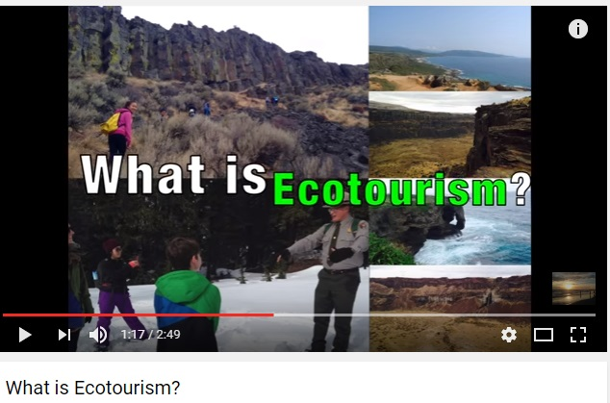

Procedure: Teachers will start the lesson with a short introduction of the topic and continue by presenting students an interesting video;
Timing: 5 minutes

- Brainstorming;

Procedure: Teachers ask students their opinion about the meaning of ecotourism and sustainable tourism.
Students will answer the question.
Timing: 5 minutes

- Identifying keywords - filling in a crossword puzzle based on definitions;

Procedure: The crossword will be posted on a flipchart in front of the classroom.
Students, divided into groups, will get worksheets with the crossword and definitions.
They need to identify the words, according to the definitions.
These are the keywords of the lesson.
After identifying the first word, each group will write the word on a piece of paper and show it to each other; they will continue until all the words are discovered.
Timing: 10 minutes
WORKSHEET
A
B

1. To show regard or consideration for something/someone that is good, valuable, important;
2. Act or process of sharing/acquiring general knowledge or skills; result of study, instruction;
3. To keep something/someone from being hurt;
4. Able to last or continue for a long time, involving methods that don’t completely use up or destroy natural resources;
5. To traverse or range over a region/area for the purpose of discovery, to study/ analize/ learn about something, by trying it;
6. A particular form or stage of civilization, as that of certain period, development or improvement of the mind by education or training;
7. The third planet in order from the sun, habitation of humans; soil; dry land;
8. Animals and plants that grow independently of people, usually in natural conditions;
9. An expanse of scenery, seen in a single view; area or land with particular appearance;
10. The air, water and land in which people, animals and plants live.

 |  |  |  |  |  |  |  |  | R | E | S | P | E | C |  | T
 |  |  |  |  |  | E |  | D | U | C | A | T | I | O |  | N
 |  |  |  |  |  |  |  | P | R | O | T | E | C | T
 |  |  |  |  |  |  | S | U | S | T | A | I | N | A |  | B | L |  |  | E
 |  |  |  | E |  |  | X | P | L | O | R | E
 |  |  |  |  |  |  |  |  | C | U | L | T | U |  | R | E
 |  |  |  |  |  |  |  | E | A | R | T | H
 |  | W |  | I | L |  |  | D | L | I | F | E
 |  |  |  | L | A |  |  | N | D | S | C | A | P | E
E | N |  | V | I | R |  |  | O | N | M | E | N | T

- Presenting the material https://docs.google.com/presentation/d/1bkQ825sV5PEvlrys5rCMwZZlVAzAytiy4WgELkHuUUY/edit?ts=57db9e0b#slide=id.g1718c89673_0_0;

Procedure: Teachers will present the material - google presentation - about ecotourism and sustainable tourism, their benefits and the most famous ecotouristic European areas.
Timing: 10 minutes

- Identifying the areas from our countries;
Procedure: Students are challenged to identify ecotouristic areas from their own countries.
Some pictures will be displayed on the video projector.
Timing: 5 minutes
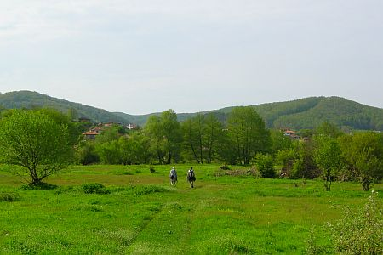
Source: visitstrandja.com
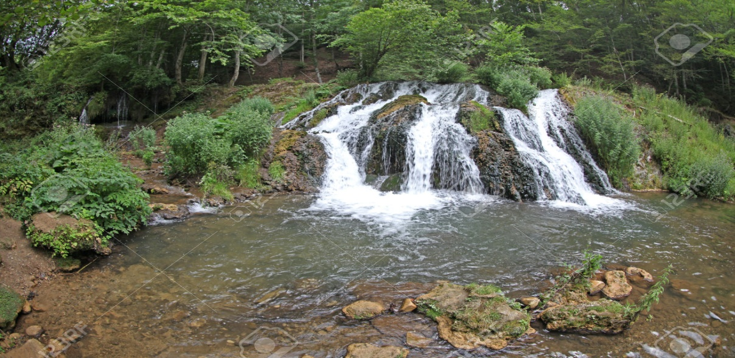
Source: http://www.123rf.com
( images from Bulgaria)

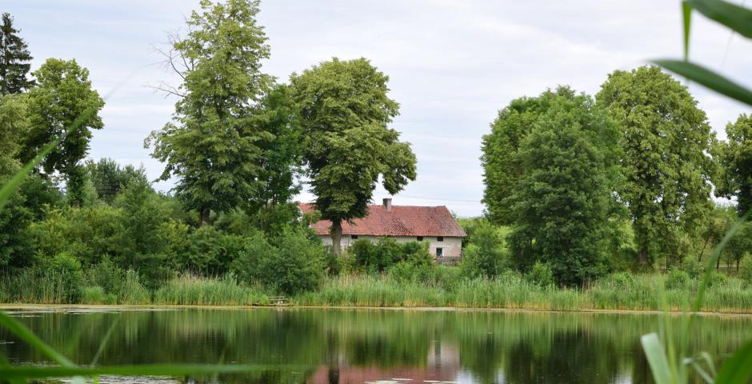
Source: mynatour.org
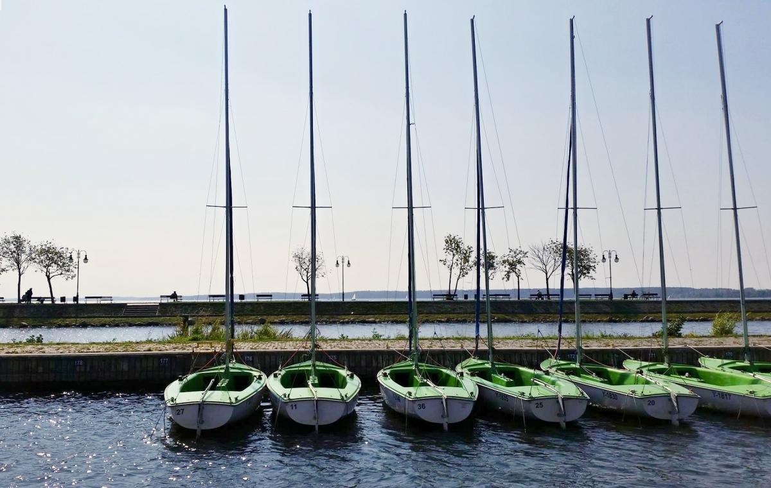
Source: mynatour.org

(images from Poland)
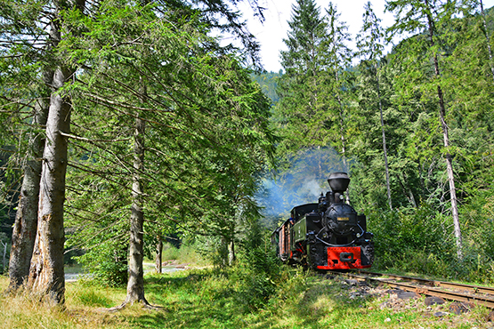
Source: http://www.cffviseu.ro
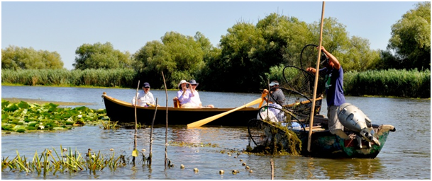
Source: http://www.agerpres.ro
(images from Romania)

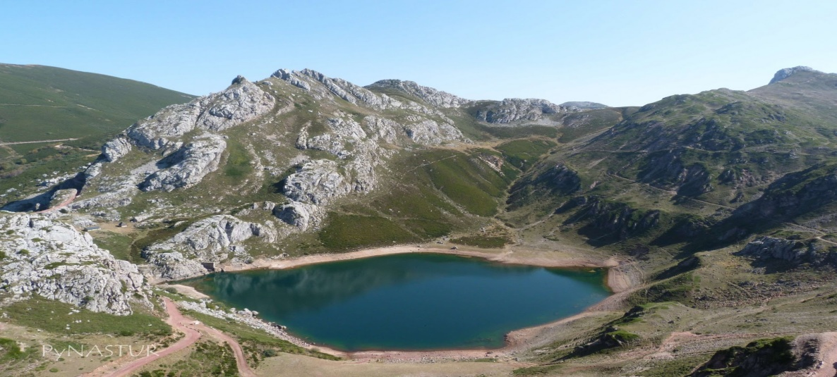
Source: hikingasturias.blogspot.com
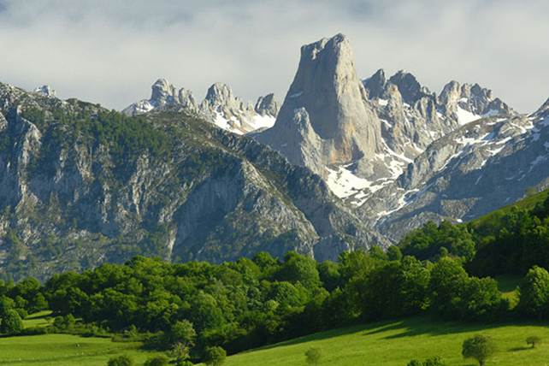
Source: gallerily.com
(images from Spain)

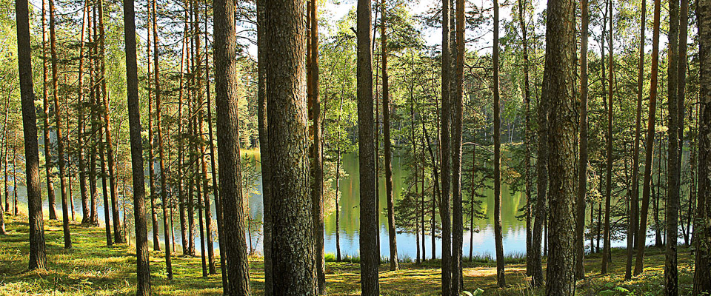
Source: http://www.discoverlithuania.biz
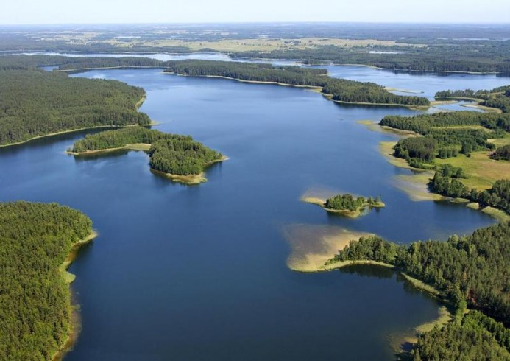
Source: http://www.visitlithuania.net
(images from Lithuania)

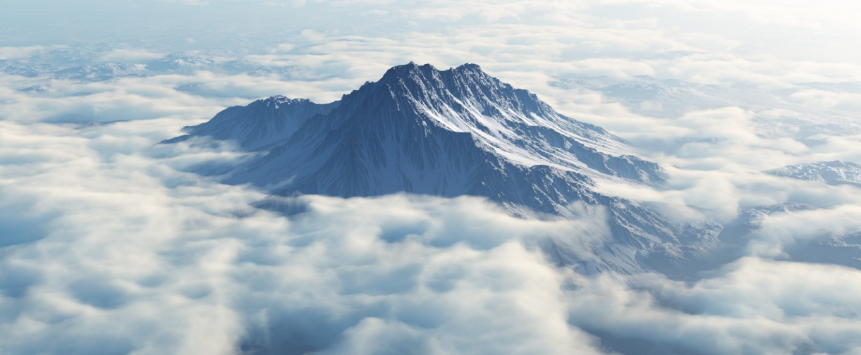
Source: http://www.greeceturkeytours.com

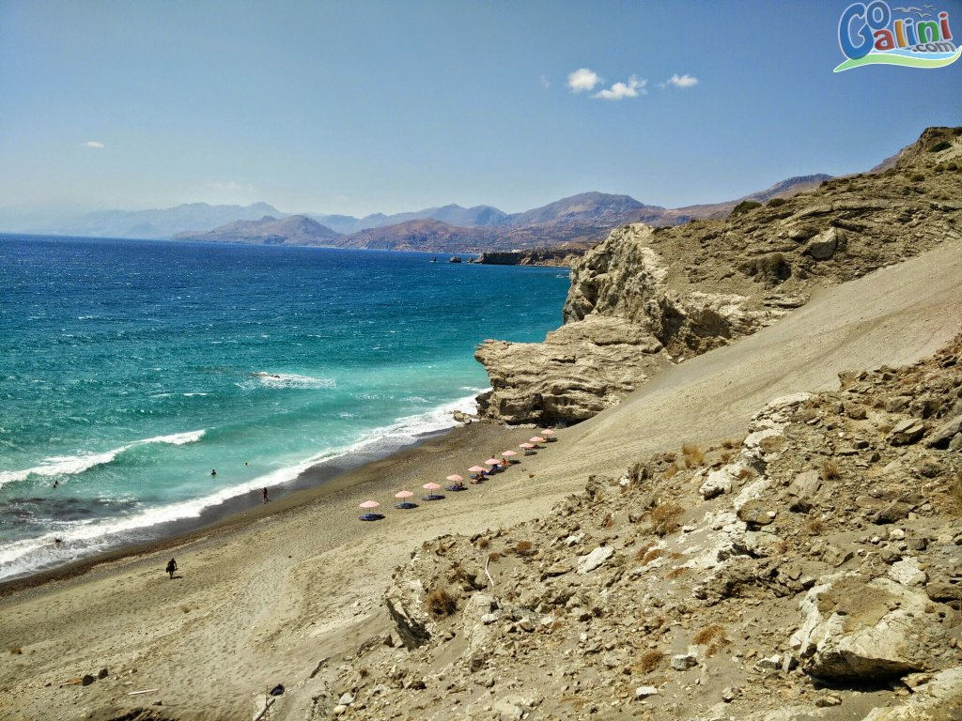
Source: gogalini.com
(images from Greece)

Assessment:

Task 1: Building up dialogues (role playing);

Procedure:
Students, divided in groups will get a short text related to the topic, with the necessary pieces of information.
Each group should provide a dialogue, according to the task.
Then, they will have to choose two members to perform it for the other groups.

Timing: 10 minutes
Worksheet - Group 1

Read the following text:

Strandzha Nature Park is located in the southeastern part of country, its southern border coincides with the Bulgarian sovereign border with Turkey, and it spreads as far as the Black Sea Coast to the east. The Nature Park lies on the territory of Strandzha Mountain which spreads in both Bulgaria and Turkey.

Tasks:
1. Using the pieces of information in the text and your imagination, build-up a short dialogue between a tourist and a pension/ guest house owner. (maximum 10 sentences)
2. Act it out for the other students in different groups.
Timing: 7 minutes; 3 minutes.

Good luck!:)

Worksheet - Group 2

Read the following text:

The Masurian Lake District in the north-east of Poland is the most sought-after destination in this part of Europe for lake lovers, nature lovers and sailors. Fans of ecotourism and green travel will find themselves in paradise!
The region has over 2000 lakes of different sizes, most of which are connected by canals and waterways. If you wish to explore the region properly you will need to dedicate several months of full-time travel!
Tasks:
1. Using the pieces of information in the text and your imagination, build-up a short dialogue between a tourist and a local resident. (maximum 10 sentences)
2. Act it out for the other students in different groups.
Timing: 7 minutes; 3 minutes.

Good luck!:)

Worksheet - Group 3
Read the following text:

...An increasing number of areas are now developing into eco-tourist destinations in Romania, offering sound services network and specific tourist infrastructure - places as Tara Dornelor, Tusnad Resort, Tara Hategului - the Retezat Massif, Padurea Craiului in the Apuseni Mountains, the Danube Delta and Hartibaciu Plateau.The Danube Delta is perhaps the most important wildlife area in Europe. This 564,000 ha major wetland area encompasses a diversity of species and habitats and lies at the crossroads of several major bird migration routes.
Tasks:
1. Using the pieces of information in the text and your imagination, build-up a short dialogue between a tourist and a travel agency. (maximum 10 sentences)
2. Act it out for the other students in different groups.
Timing: 7 minutes; 3 minutes.

Good luck!:)
Worksheet - Group 4
Read the following text:

The Ebro Delta is the largest wetland in Catalonia and the main aquatic habitat in the western Mediterranean after the Camargue regional nature park in France and the second-largest in Spain after Doñana National Park.
The Delta plays an important biological role, its interior containing large rice and vegetable fields and fruit orchards, whilst the coast is formed by one of the most attractive lakeland landscapes in the Mediterranean, with large, biologically rich lagoons.The Delta periphery is made up of large salt marshes and long, unspoilt sandy beaches with dunes.

Tasks:
1. Using the pieces of information in the text and your imagination, build-up a short dialogue between a tourist and a guide. (maximum 10 sentences)
2. Act it out for the other students in different groups.
Timing: 7 minutes; 3 minutes.

Good luck!:)
Worksheet - Group 5
Read the following text:

There are fifteen areas in Greece listed as Preserved Natural Monuments. These include the Cedar forest in Kynouria, the primeval forest in central Rodopi, the aquatic plant forest in Evia, the petrified forest of Lesvos, the broadleaf evergreen forest on the Island of Sapientza in Messinia.Preserved Natural Monuments in Greece also include the large national parks and “aesthetic forests”- natural forests of great significance and biodiversity, such as Mount Olympus, Samaria Gorge, Mount Parnassos, the suburban forest in Ioannina and numerous other unspoilt locations.
Tasks:
1. Using the pieces of information in the text and your imagination, build-up a short dialogue between a student and a teacher. (maximum 10 sentences)
2. Act it out for the other students in different groups.
Timing: 7 minutes; 3 minutes.

Good luck!:)
Task 2: Thematic painting competition.

Procedure:
Students will be challenged to practise and share their painting skills.
Students will pick a little note with a task( different for each group) and try their best to transpose their task into a gorgeous painting.
After the painting is accomplished, they will share it with the other groups and vote the one they like the best.
The best painting will be appreciated and rewarded.

Timing: 10 minutes

Task 2: Painting competition;

Procedure: Students will be challenged to be creative, original and show their ability of painting.
Each group will get a note with a task – painting a different scenery.
They have to collaborate and do their best.
Then, the best painting will be voted and rewarded.
Timing: 10 minutes

Painting Competition - Notes

Note 1

Imagine you are in an ecotouristic area, in the mountains, during a lovely warm spring day.
Everything is green, there is dew on the grass, the mountains are high and you can see others even more higher in the distance, the sky is cloudless, the weather is great…
Imagine the view and paint it. You will do a great job! Have fun!
Timing: (10 minutes)

Note 2

Imagine you are in an ecotouristic area, near the sea, during a hot summer day.
You are on the coast line, you can see the sea from a high point… seagulls are flying in the sky, the wind is blowing, there are big waves, the sea is agitated.
Imagine the wild scenery and paint it. You will be great! Have fun!
Timing: (10 minutes)

Note 3

Imagine you are in an ecotouristic area, on a lake, during a cool but pleasant autumn day with blue sky. The lake is quiet and the water is so clean that you can see fish and other small creature swimming under.
There are willow trees around it, yellow grass and carpets of leaves… autumn colours, from yellow to dark brown.
Imagine this dream landscape and paint it. You will do an amazing job! Have fun!
Timing: (10 minutes)

Note 4

Imagine you are in an ecotouristic area on an island, during a marvelous summer day.
The sun is bright, coconut palms are all around you, white sand, quiet waves and coloured birds...
Imagine this exotic view and paint it. You will do a wonderful job! Have fun!
Timing: (10 minutes)

Note 5

Imagine you are in an ecotouristic area on the top of the mountains and you are looking around you. Everything is white...you can only see a few green fir branches and a little village, in the distance.
It’s a cold but cloudless day of winter. The wind doesn’t blow and everything is quiet, covered by the white shining carpet.
Imagine this frosty scenery and paint it. You will do a shining job! Have fun!
Timing: (10 minutes)

Resources:

Motivating video https://www.youtube.com/watch?v=RDIfFTs9V1A
Google presentation https://docs.google.com/presentation/d/1bkQ825sV5PEvlrys5rCMwZZlVAzAytiy4WgELkHuUUY/edit?ts=57db9e0b#slide=id.g1718c89673_0_0;
Crossword
Worksheet
Notes

