CLIL LESSON

ARTIFICIAL INTELLIGENCE

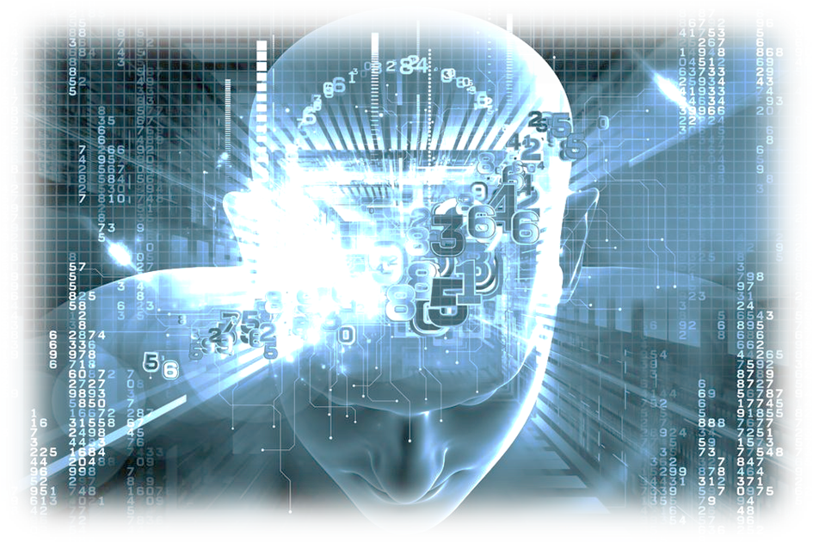

Subject: Social science
Title: Artificial intelligence
Level: B 1. 2.
Age: 14-17

Content aims:

-learn about robotics and its highest level of development- artificial intelligence

-get students familiar with the origin of the word “robot”

- learn about various characteristics of artificial intelligence

-learn about the use of AI as integral part in marketing

Language aims:
Reading comprehension – read and find the answer to questions in a text on robotics
Speaking – describe, discuss and express opinion on controversial issues
Grammar – Past Simple tense forms of the verbs, Comparatives, Present Perfect tense

First five minutes: refresh the vocabulary on robotics and provoke students’ interest about artificial intelligence

Advance organizer: present the tasks for the lesson to get them ready and familiar with the topic

Goal: Learn about the evolution in the notion of artificial intelligence and discuss the importance and influence of it nowadays and in the future

Resources: .video you tube, Powerpoint presentation
Activities:
matching words and definitions
reading texts and answering questions
doing a quiz
watching a video and discussing the issue

Anticipated problems/solutions: Internet access- not available or other technical problems

Session 1:
Match the words and pictures:

 | Word |  | Picture
1 | robot - a machine capable of carrying out a complex series of actions automatically, especially one programmable by a computer. | A | 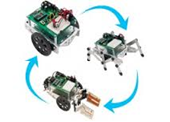
2 | android - a robot with a human appearance | B | 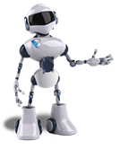
3 | mechanical doll - a child’s toy that is animated by winding it like a clock | C | 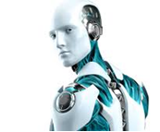
4 | unmanned factory - a factory not having or needing a crew or staff because the production is done by robots | D

Session 2:
Do you know where the word ” robot” comes from?
Read the text on the origin of this word and find it out.

The conventional view of robots visualizes them as mechanical figures made in the human image. These are the robots of science fiction and of popular films. They also recall the mechanical dolls, some of which appeared in Western Europe during the Middle Ages.
The 20th century brought with it more meaningful advances in the direction of today’s robots. It also introduced the word itself. Robot is derived from “robota”, the Czech word for serf of forced labour and it was introduced into English language as a result of a play by the Czech writer KarelChapek, published in 1920. the play was called “R.U.R.”, short for “Rossums Universal Robots”.
“R.U.R.” features a factory owner, Rossum, who turns out in his workshop android machines with a wonderful capacity for work. The machines usually sell well to the other manufacturers who put them to work in their own factories.
But this happy state of affairs does not last long. The robots become more advanced and even learn to think for themselves, though they remain devoid of emotions or a “soul”.
Eventually they rise up and overcome their human masters. In this way was established one of the characteristic traits of robots: they have a great desire to take it out on humans. One of the characters in the play sums up the useful points about robots: “ One robot can replace two and a half workmen. The human machine …….was terribly imperfect. It had to be removed sooner or later.”

What is your answer to the question about the origin of the word “robot” ?

And what are your answers to the other questions?

1. What is the conventional view of robots?
…………………………………………………………………………………………..
2. What does “robota” mean in Czech language?
………………………………………………………….………………………………..
3. What does Rossum produce in his factory?
…………………………………………………………………………………………..
4. In what way do the andrioid machines change when they become more advanced?
…………………………………………………………………………………..………
5. Why does one of the characters think “The human machine ………was terribly imperfect. It had to be removed sooner or later.”
……………………………………………………………….…………………………

Session 3:
Read the definition of artificial intelligence and decide what you understand about it.

Artificial Intelligence is the attempt of computers to mimic or outperform the human brain.
There are four requirements for a machine to be human-like. Match them with the explanations that follow:

Four requirements that differentiate humans from machines.
1- Human emotion.

2 - The ability to create its own data associations in order to make decisions and differentiate between true and false.
3 - Self-consciousness, which involves identity, a track of time, and a sense of the world around you. We have 5 senses and a sense of time, and a sense of who we think we are or might become.
4 - Creativity and imagination, something that will probably be the last thing to be implemented properly.

( ) Some people do not understand why we even have them; some even try to hide them most of the time. The reality is, it is an evolutionary trait that makes us have a purpose in life. Without it, we would not reproduce, complete our daily tasks, or interact with other humans. An artificially intelligent machine would still only be a simple calculator without it. Ability to Create Data Associations and Decide

( ) It is what's important with AI. Computer programs need to find ways to adapt and collect all data available to connect ideas. Most likely many of these things will be accomplished once natural language and communication is understood by AI developers.
( ) This is probably the hardest things to create. However, I think it is based on things we've already know and seen, then minor variations on those ideas, and since everything is very related anything is possible.

Answer key: Human emotion, the ability to create its own data association, creativity and imagination.

Session 4:
I. Watch the segment and discuss the questions:

- Describe the scene.

- Do you think robots will be so perfect in the future that they will become part of the family? Why?

- Will robots ever have emotions? Will they be able to fall in love, for example?

- What about people? Will they be able to fall in love with robots?

- What is the future of robots? How present will they be in our lives?

- What's your opinion about Artificial Intelligence?

Session 5
Do a survey on artificial intelligence in marketing
https://econsultancy.com/blog/67745-15-examples-of-artificial-intelligence-in-marketing/

Keys:
Task 1

1 - B | 2 - C | 3 - D | 4 - A

Word | Picture
robot -a machine capable of carrying out a complex series of actions automatically, especially one programmable by a computer.
android - a robot with a human appearance
mechanical doll- a child’s toy that is animated by winding it like a clock
unmanned factory- a factory not having or needing a crew or staff because the production is done by robots

