LESSON PLAN

Title of the unit: SCIENCE
Subject: AGRICULTURE AND INDUSTRIAL MACHINES
Group Age: 13 - 15 years old
Group Size: 25 students
Timing: 45 minutes per session
Place: Computer Lab

Introduction: The main aim of this lesson is to emphasize the most important issues related to agriculture and industrial machines.
During the lesson, students will acquire the specific terms of the topic and they’ll use them to make connections which emphasize the features and the importance of the agriculture worldwide, as well as in Romania.

Learning outcomes:
- To be aware of the agriculture role on humanity;
- To define cereals and vegetables;
- To specify types of cereals and vegetables;
- To be aware of the advantages of cultivating vegetables;
- To dicover the role of industrial machines in agriculture;
- To acknowledge the benefits of cereals;
- To identify the countries cultivating half of the land assigned for the vine, worldwide;
- To discover the 10 countries which provide the global wine production, also, the main cultivated vine varieties;
- To find out the place is Romania ranked in global and European wine and vegetables production;
- To identify the most cultivated areas with vegetables and vine in Romania;
- To acknowledge the impact of new technologies in agriculture development.

Subject content:
- Cultivation of cereals: defining cereals, types of cereals, agricultural machines, cereals benefits;
- Cultivation of vegetables:
- Cultivation of vine: cultivating countries, vine varieties, new technologies in vineyard and vinification.
Language objectives:
- Acquiring specific vocabulary regarding agriculture;
- Developing reading, listening and speaking skills;
- Improving oral and written expressing in English.
Students are divided into five groups.

Session 1: Cultivation of cereals
Each group will get a worksheet to fill in (along the activity), using the information which will be used in the assessment. https://docs.google.com/document/d/1k_EIKlnd-HkIgRW-JDPv9Be98AmkxdHmJ6iKjN_da30/edit
Worksheet
Agriculture and industrial machines
Cultivating cereals

- The types of grains are :
-
-
-
-
-
-
-
-
2. Uses of cereals:
-
-
-
-
-
-
3. Modern technology used in agriculture refers to:
-
-
-
-
-

4. The benefits of cereals are:
-
-
-
-
-
-
Motivating video: https://www.youtube.com/watch?v=Xt1gm3PtKFM
Brainstorming: - starting question: What is the importance of cereals in everyday life?
The vocabulary of the topic: https://docs.google.com/document/d/1QSVphXS9cBFxSbcqUqSj7ROM2CeKK0zHn80yC4yXXjw/edit
Vocabulary
Agriculture and industrial machines - Cultivating cereals

- Maize - a tall cereal plant, Zea mays, cultivated in many varieties, having a jointed, solid stem and bearing the grain, seeds, or kernels on large ears.

- Rice - the starchy seeds or grain of an annual marsh grass, Oryza sativa,cultivated in warm climates and used for food.

- Wheat - the grain of any cereal grass of the genus Triticum, used in the form of flour to make bread, cakes, etc., and for other culinary and nutritional purposes.

- Barley - the grain of this plant, used as food and to make beer, ale, and whiskey.

- Sorghum - a cereal grass, Sorghum bicolor, having broad, cornlikeleaves and a tall, pithy stem bearing the grain in a dense terminalcluster.

- Millet - a type of grass that is grown for its seeds which are used as food.

- Fertilizer - a substance (such as manure or a special chemical) that is added to soil to help the growth of plants.

- Irrigation - is the artificial application of water to the land or soil; It is used to assist in the growing of agricultural crops, maintenance of landscapes, and revegetation of disturbed soils in dry areas and during periods of inadequate rainfall.

- Genetic engineering - is the direct manipulation of an organism's genome using biotechnology. It is a set of technologies used to change the genetic makeup of cells, including the transfer of genes within and across species boundaries to produce improved or novel organisms.

- Crop - Cultivated plants or agricultural produce, such as grain, vegetables, or fruit, considered as a group.

Task: Acquiring and using spcific terms of the topic - “Cultivation of cereals”
Activities:
- Presenting a material about the cultivation of cereals and industrial machines; https://docs.google.com/presentation/d/16lHzeiD5coZ3AWrOD5JSnkVxwVd-gjRXRPhOZHDEeKE/edit#slide=id.p
- Playing a multiple choice game – Kahoot: Agriculture;
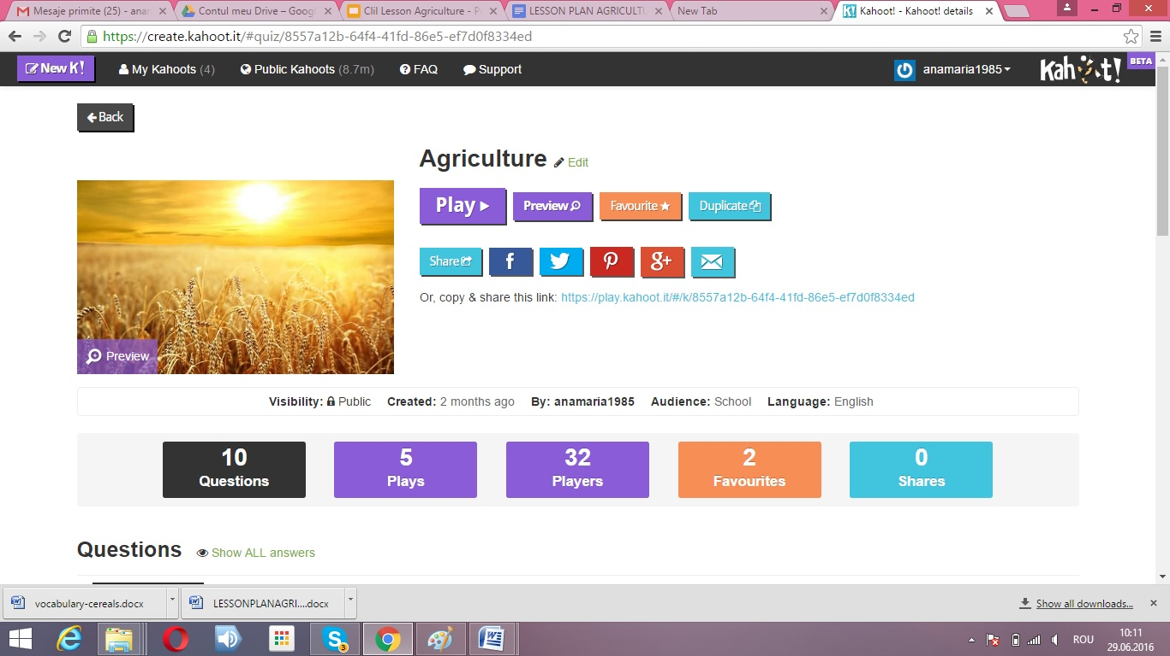
- Identifying the types of grains, using samples.
Assessment:
- Identifying keywords after watching a video and writing them on the worksheet;
- Using keywords in teaching game;
- Matching the cereals (grains) to their names.

At the end, students watch a video: “The farms of the future” https://www.youtube.com/watch?v=Xg27iMXwdV0

Session 2: Cultivation of vegetables

Brainstorming: - starting question: What vegetables do you know?
Using the information offered by students, there will be drown a bunch on the topic “The most important vegetables”, made on flipchart paper.
The vocabulary of the topic: https://docs.google.com/document/d/1n_0DNgjSBv0dHsitnRXmkXDRc3Yy9kZaWghbKxKTFTA/edit?ts=5717e47f .
Vocabulary
“Agriculture and industrial machines - Cultivating vegetables”

Vegetables are plants or parts of plants used as food, such as cabbages, potatoes, turnips, or beans.
Tomato is a glossy red, or occasionally yellow, pulpy edible fruit which is eaten as a vegetable or in salad.
Onion is a swollen edible bulb used as a vegetable, having a pungent taste and smell; it is composed of several concentric layers.
Carrot is a tapering orange-coloured root eaten as a vegetable.
Greenhouse is a glass building where plants that need protection from cold weather are grown.
Vegetable cultivation is the science which deals with studying vegetable plants, in terms of biological peculiarities, bio and ecosystem relationships that determine the most appropriate culture technologies in order to achieve higher yields, in terms of quality and quantity, in conditions of high economic efficiency.
Task: Acquiring and using the specific terms on the topic - “Cultivation of vegetables”
Activities:
- Presenting a material about the cultivation of vegetables legumelor and industrial machines - https://docs.google.com/presentation/d/1BgcwuJKNZ4DIW57LBn_ZhbBwQ9x-6rNHIm0PtYQLpl8/edit?ts=5717e4fc#slide=id.p
- Filling in a text;
Handout
Fill in the texts with the suitable vegetable:

Vegetables deliver ample amounts of vitamins, including folate, vitamin A, vitamin K and B6, as well as carotenoids like beta carotene from ..............................
............................ are high in vitamin C, a good source of fiber and add abundant flavor to a wide variety of food. Hint: it makes you cry!
.............................. belong to the same botanical family as melons and squashes, they are produced for fresh consumption or for eventual processing into pickles.
The ........................... is a starchy, tuberous crop – an essential crop in Europe and the fourth largest food crop in the world.
The ........................... is the edible, often redberry-type fruit of Solanum lycopersicum, being consumed in diverse ways, as an ingredient in many dishes, sauces, salads and drinks.
- Matching the word to the pictures; https://docs.google.com/document/d/1zikewHmOdQP0jdVf1a8BOAbIkfjtMShmTFp4yKWHcHc/edit
Worksheet

Match the words to the pictures.
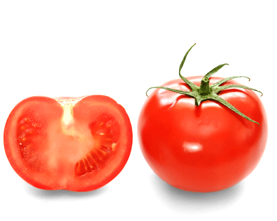 CUCUMBER

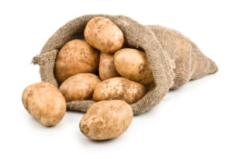 GREENHOUSE
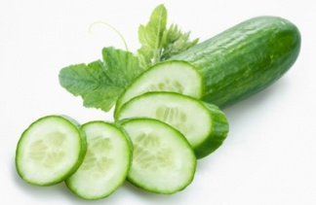 POTATOES
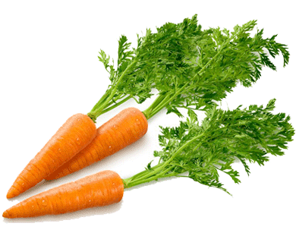 TOMATOES
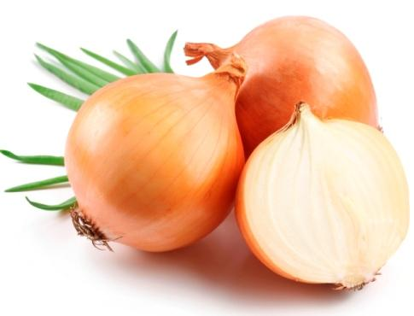 INDUSTRIAL MACHINES
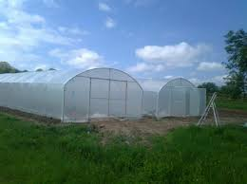 CARROTS 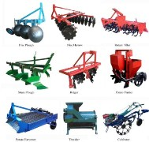 ONION

- Matching orally other two related words, starting from a keyword.
Assessment:
- Using keywords in completing a lacunar text;
- Matching the words to the pictures (each group gets a worksheet);
- Acquiring the specific vocabulary.

The activity will be ended by watching a video: https://www.youtube.com/watch?v=er34VcOUwLk

Session 3: Cultivation of vine/ Viticulture

Brainstorming: How much do you think the technology helped winemakers? You’ll discover the answer to this question here: https://www.youtube.com/watch?v=7Oq76Ls3lEY
The vocabulary of the topic: https://docs.google.com/document/d/1EK21kW7TYcrjoIsiPRpwlOwjVAKyKQnoKu-akUz-1pw/edit?ts=5715f299
Keywords

- Vineyard. A vineyard is a plantation of vines, grown mainly for winemaking, but also raisins, table grapes and non-alcoholic grape juice.

- Winemaking. Winemaking or vinification, is the production of wine, starting with the selection of grapes or other produce and ending with bottling the finished wine.

- Harvest. Harvest means the time of year when crops are ripe and ready to be gathered.

- Cellar. Cellar is a room, or set of rooms, for the storage of food, fuel, etc., wholly or partly underground and usually beneath a building. A winecellar - a cellar for the storage of wine.

- Oak barrels. Oak is used in winemaking to vary the color, flavor, tannin profile and texture of wine. It can be introduced in the form of a barrel during the fermentation or aging periods, or as free-floating chips or staves added to wine fermented in a vessel like stainless steel. Oak barrels can impart other qualities to wine through evaporation and low level exposure to oxygen.
Task: Acquiring and using the specific terms on the topic - “Viticulture”
Activities:
- Using a map of Europe, mark the top countries in vineyards and wine production: https://docs.google.com/document/d/1G0RbQWscSlDh3nlLRsO9hPg2URIitm8xXZ_mdIUPT0Y/edit
Vineyard in Europe

Using a map of Europe, mark the top countries in vineyards and wine production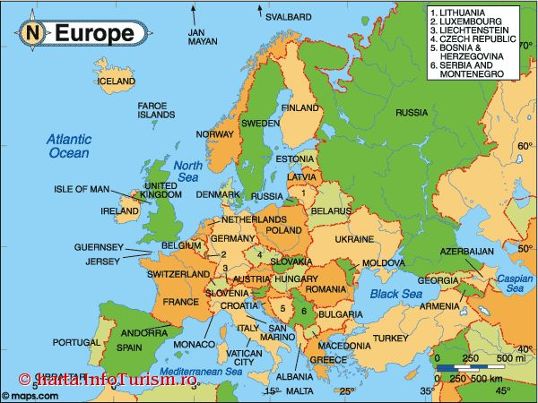

- Matching the pictures to the keywords
https://docs.google.com/document/d/1j9Chc0h9k2qlTLZGIzYSr5hYUI0uZS2mViRpXEl2CrA/edit?ts=57127c93
Worksheet

- Match the pictures with the keywords:

Winemaking 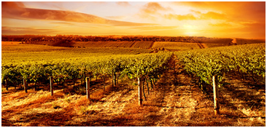

Oak barrels 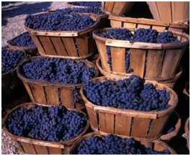

Vineyard 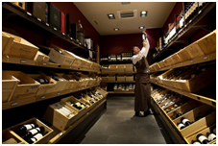

Harvest 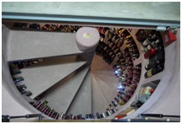

Cellar 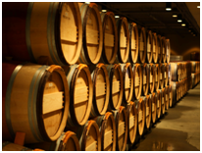

2. Build up sentences using the keywords.

- Building up sentences using the keywords.

Assessment:
- Each group gets a worksheet with a map of Europe. The task is to mark the main wine producing countries and also the main vine cultivator countries.
- Each group gets a worksheet with the same task, of matching words to pictures,
- Using keywords in building up sentences.

General activity (for all three sessions):
- Making posters.

Assessment:
Each group will perform a poster on a specific topic of Agriculture:
- the first group will receive an envelope which consists of plant images, seeds and uses ( students must match the three groups of elements);
Match the cereals to the seeds and their uses!!!
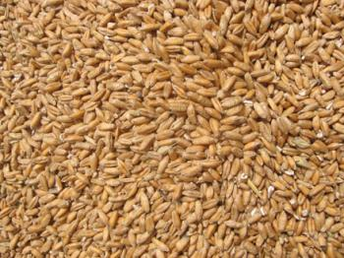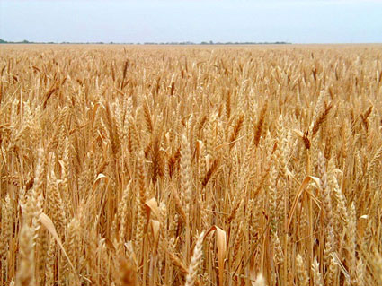

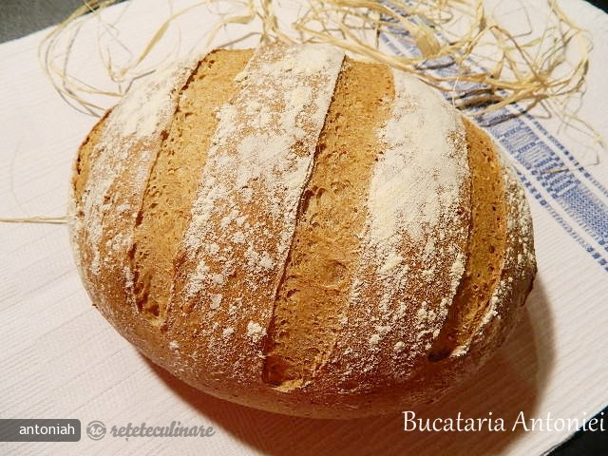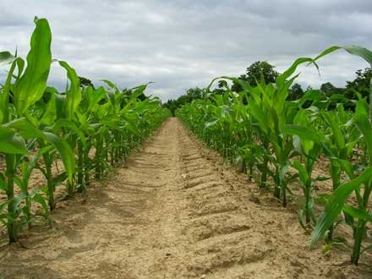
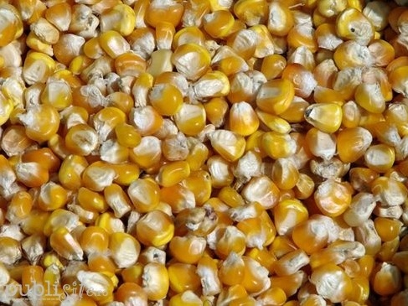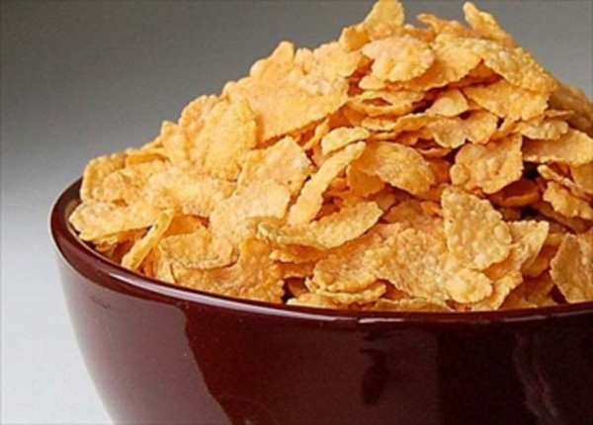

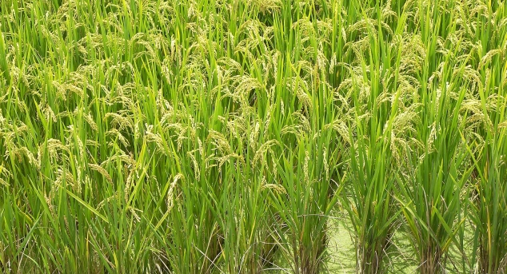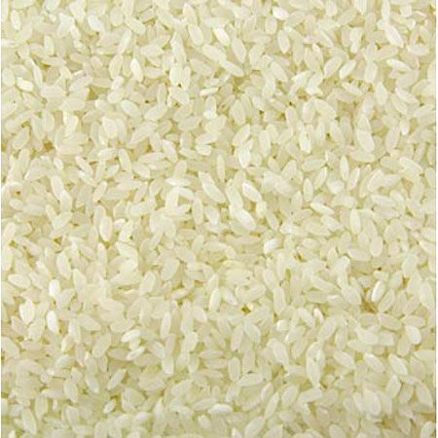

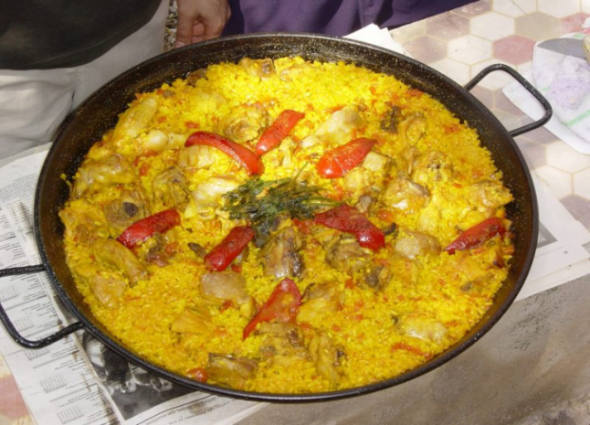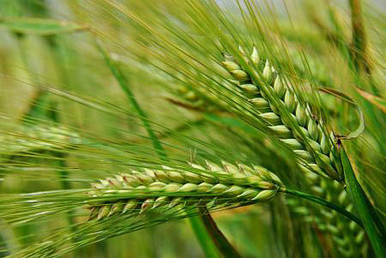

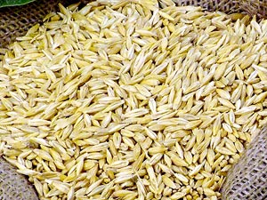
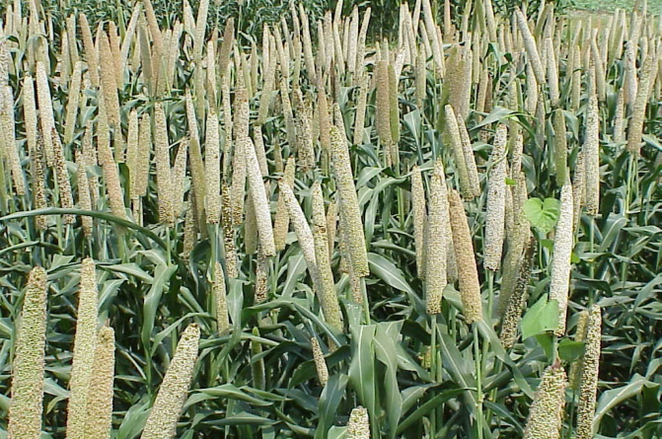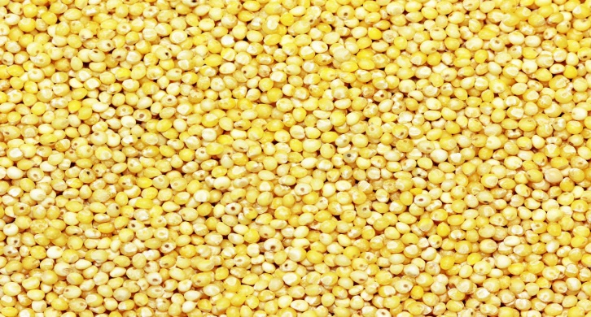

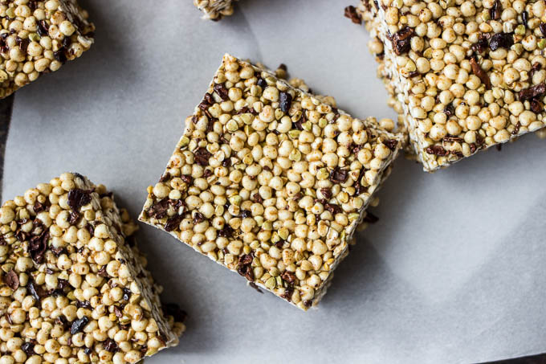

- the second group must match agricultural machines and technologies represented by images to their name;
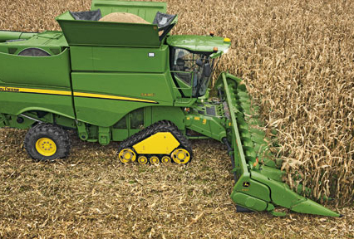 TRACTOR
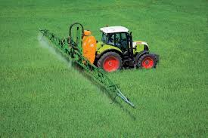 PLANTER
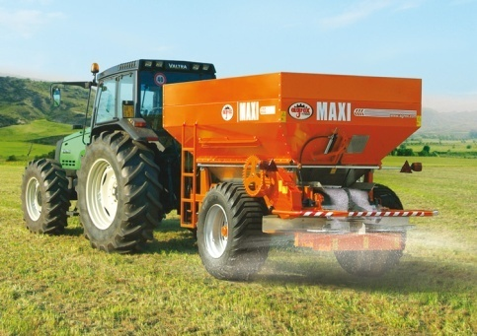 COMPUTER MONITORING SYSTEMS
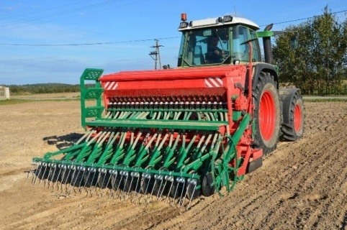 HERBICIDE
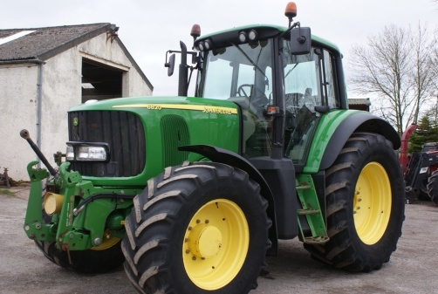 FERTILIZER
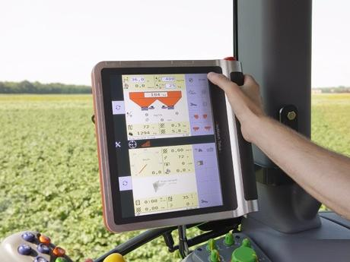 HARVESTER
- the third group must write the benefits of cereals;
- the fourth group will fill in a crossword about agriculture;
Complete the crossword puzzle, discovering the defined terms!
A
1.
 |  | 3.
 |  |  |  | 4.
 |  | 5.
6.
7.
 | 8.
 |  | 9. |  |  |  |  |  |  |  |  |  | 10
11.
B
Vertically (A-B), you will discover the branch of the material production which has as an object the culture of plants and animal breeding.

1. A tall annual cereal, cultivated for its yellow edible grains, which develop on a spike.
2. The artificial application of water to the land or soil.
3. It is a glass building where plants that need protection from cold weather are grown.
4. An alcoholic drink made of fermented grape juice.
5. The starchy seeds or grain of an annual marsh plant, Oryza sativa, cultivated in warm climates and used for food.
6. Long, green vegetables with watery consistency, usually eaten raw in salads or pickled.
7. The grains used for food, as: wheat, maize, or rye.
8. Plants or parts of plants used as food, such as cabbage, potatoes, carrots, or beans.
9. Cultivated land with a certain kind of plant.
10. A plantation of vines
11. Organ of the plant from which it can develop a new plant - grains or…

1. |  |  |  |  | M | A | I | Z | E
 |  | I | R | R | I | G | A | T | I | O | N
 |  | 3. |  |  | G | R | E | E | N | H | O | U | S | E
 |  |  |  | 4. | W | I | N | E
 |  | 5. |  | R | I | C | E
6. |  |  | C | U | C | U | M | B | E | R | S
7. | C | E | R | E | A | L | S
 | 8. | V | E | G | E | T | A | B | L | E | S
 |  | 9. |  |  | C | U | L | T | U | R | E | 10
V | I | N | E | Y | A | R | D
11. |  |  |  |  | S | E | E | D | S

- the fifth group must draw a bunch with the three branches of agriculture presented in the material (cultivation of cereals, cultivation of vegetables, viticulture) and match appropriate images to each agricultural branch.
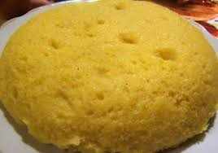

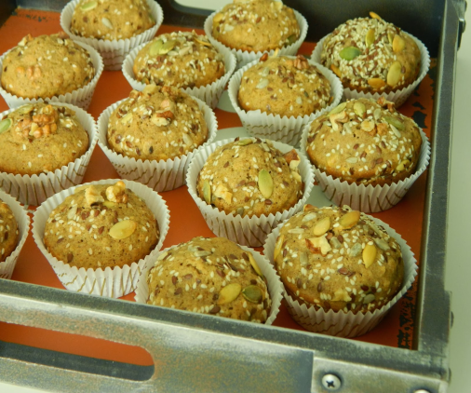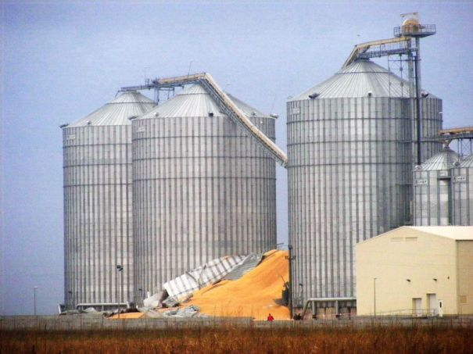

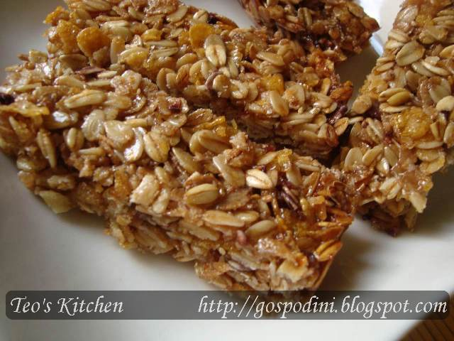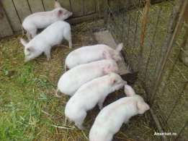

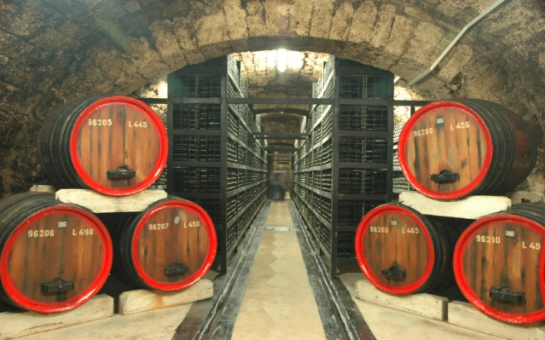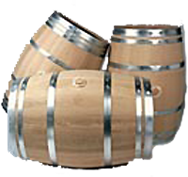
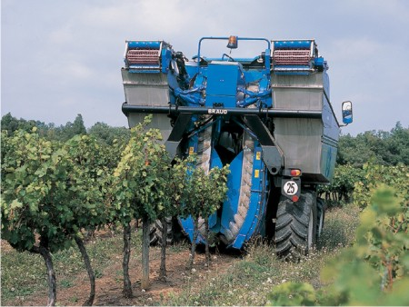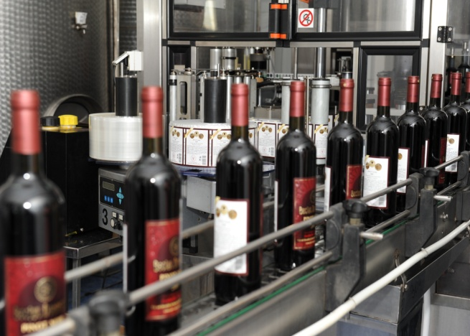

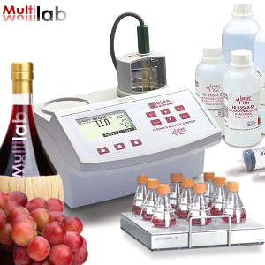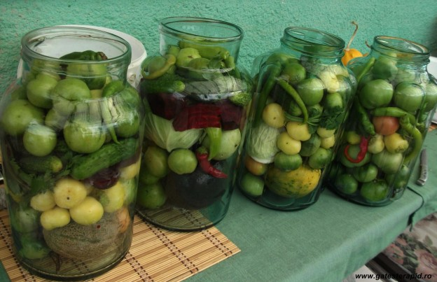

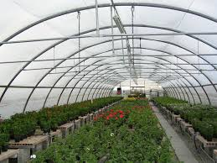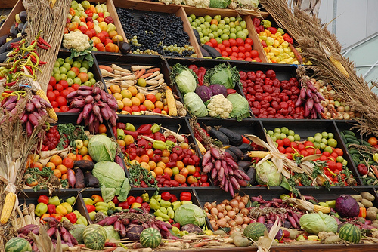
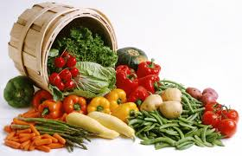
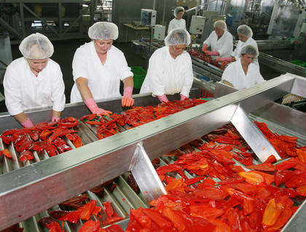

Resources:
Google Presentation: presentation cultivating cereals, informative material, winemaking industry
Google Docs: worksheet, Keywords-cereals, Vocabulary - Vegetables culture,
viticulture keywords, map of Europe, words and pictures, vegetables
Motivating video: https://www.youtube.com/watch?v=Xt1gm3PtKFM, https://www.youtube.com/watch?v=5YQ2EFta0sM
Concluding Video: https://www.youtube.com/watch?v=Xg27iMXwdV0, greenhouse vegetables
Kahoot.

