CLIL LESSON
- TITLE OF THE UNIT: NATURAL RESOURCES - MINERAL WATERS

- SUBJECTS: Geography, Chemistry, Biology, Natural Environment, ICT

- STUDENTS’ LEVEL /AGE: 14-16 years
- OBJECTIVES:
4.1. Content objectives:
- Identifying and classifying natural mineral water resources;
- Identifying the main composition of mineral waters;
- Awarness of the importance of mineral water for healty body;
- Developing personal skills to use maps, graphics and tables;
- Selecting jobs required on the labor market in mineral water;
- Getting familiar with websites for jobs in the field of mineral waters.
4.2. Language objectives:
- Acquiring specific vocabulary,
- Developing personal vocabulary,
- Developing reading and listeninig comprehension in English,
- Improving oral and written expression in English.
5. ACTIVITIES:
Activities are divided in 3 sessions, covering:
- vocabulary related to mineral waters as natural resources and their use in industry, medicine and spa, labor market in mineral water industry,
- written and oral expression,
- using ICT.
6. DETAILED SESSIONS
The main contents are based on the economic importance of the rational use of mineral water in food industry, medicine, spa.
The second session contains pieces of information about labor market in the mineral water industry and competencies that an employee must have in various trades.

The 3rd session approaches the topic concerning the use of mineral water in medicine and spa.
The sessions also contribute to developing students’ language competence through the use of English in a language integrated learning context.
SESSION 1
MINERAL WATERS - NATURAL RESOURCES
Time: 45-50 minutes
Activity 1
Brainstorming: What is mineral water? What is the composition of mineral waters?
You can find the answer watching this video:
https://www.youtube.com/watch?v=eJ2f4uRC5fg
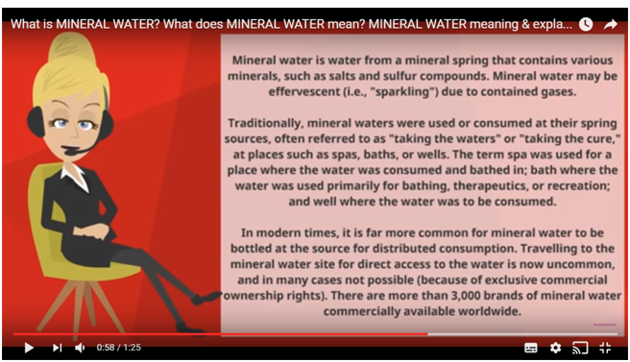
Activity 2
What is the composition of mineral waters?
https://docs.google.com/presentation/d/1GpoGJCQO4gjM9wihNHQBl5RYTouP53hs2kMh8YF40w8/edit#slide=id.g20a403d291_0_49

Read carefully the following text:
The chemical composition of mineral water resulted from the specific content of dissolved salts, represents one of its main characteristics that confers health benefits.
In the composition of water, mineral salts exist in the form of positive charge (cations) and negative charge ions (anions). The most present cations in the chemical composition of mineral water are: calcium (Ca2+), magnesium (Mg2+), sodium (Na+); the anions are: bicarbonate (HCO3 – ), chlorine (Cl– ).
Vocabulary:
Minerals, solid, crystallized natural substances which go into the composition of rocks, ores;
Ions, atoms or group of atoms with nonzero electric charge (positive or negative);
Cations, positive ions;
Anions, negative ions;
Calcium, Ca2+, positive ion, derived from the disposal of 2 electrons, from the calcium atom;
Magnesium, Mg2+, positive ion, derived from the disposal of 2 electrons, from the magnesium atom;
Sodium, Na+, positive ion, derived from the disposal of 1 electron, from the sodium atom;
Hydrogen carbonate, HCO3, negative ion, obtained from carbonic acid (anion).
Activity 3: Class management: Pair work
Task 1. Match the following words to the appropriate definition:
Minerals | positive ion derived from the disposal of 2 electrons from the calcium atom
Ions | negative ions
Cations | solid, crystallized natural substances which go into the composition of rocks, ores
Anions | negative ion, obtained from the carbonic acid
Calcium, Ca²⁺ | positive ions
Hydrogen carbonate, HCO₃⁻ | atoms or group of atoms with nonzero electric charge (positive or negative)

Task 2. You have 3 samples of mineral waters.
Fill in the following chart with the quantities of present anions and cations per liter of mineral water, using the different labels:
 | Sample 1 | Sample 2 | Sample 3
 | mg/l
Calcium, Ca²⁺
Magnesium, Mg²⁺
Sodium, Na⁺
Hydrogen carbonate, HCO₃⁻
https://docs.google.com/document/d/1Mrm_ux0mUgVRiftfoGym7sgRUg5OU93jvM2XCXr2z-I/edit
Activity 4. Discover the words through anagram, using the link below:
http://www.wordplays.com/anagrammer
1) lenimars
2) sinotac
3) krilsapng
4) nasoni
5) ratew

SESSION 2
MINERAL WATER MARKET FOR CONSUMPTION
JOBS ON THE MINERAL WATER MARKET
ENVIROMENTAL PROTECTION

Time 45-50 minutes
Class management: Group work (students are divided into 6 groups)

Activity 1 : Brainstorming:
Watching the following video you will discover the new contents about mineral water consumption, the bottling process and the importance of recycling and environment protection:
https://www.youtube.com/watch?v=DsKONprvKVc
Keywords
Let’s improve our vocabulary with the following expressions:
In order to find out the expressions of the vocabulary of the lessons, the following link will be available for the groups - http://www.wordplays.com/anagrammer and some cards which must be filled in with the missing words:

(SPONTI-POINTS, NLOTIGTB-BOTTLING, ESORCU-SOURCE, TEWRA-WATER, ELOCALGIGO-GEOLOGICAL, ASESL-SALES

EXTRACTION ……... | ………. PLANT | UNDERGROUND …………….. | …………. CATCHMENT | …………….. ENGINEER | MANAGER ……..
EXTRACTION POINTS | BOTTLING PLANT | UNDERGROUND SOURCE | WATER CATCHMENT | GEOLOGICAL ENGINEER | MANAGER SALES

Discovered expressions will be attached on the flipchart paper.

Activity 2: Presentation of contents:
https://docs.google.com/presentation/d/1CAFdHkOI-S-2tTr0dZlcQVrrtliuzU8Ep2pZqQJL3bQ/edit#slide=id.g1ba0357893_0_67

Activity 3:

The activities will be assigned to the groups, using a cube.
Each group will get an envelope with different tasks:

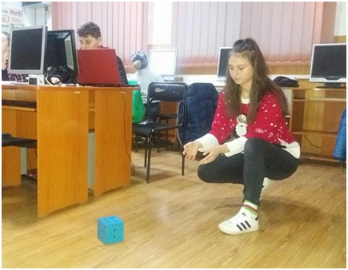

TASKS:
Group 1: Compare the production of bottled mineral water with the consumption per capita and achieve a table of values, following this model: (use http://www.efbw.org/index.php?id=90):

COUNTRY | SPAIN | GREECE | POLAND | LITHUANIA | BULGARIA | ROMANIA
PRODUCTION
OF NATURAL MINERAL WATER
PRODUCTION
OF SPRING WATER
CONSUMPTION PER CAPITA

Group 2: Match the producing country to the images of bottled mineral waters.

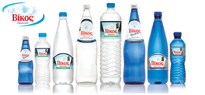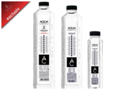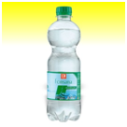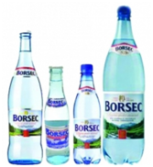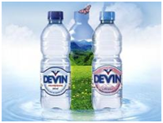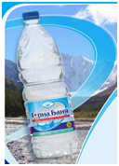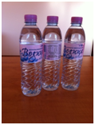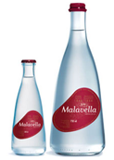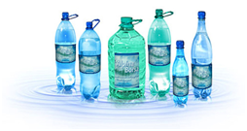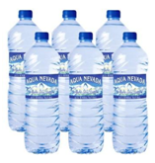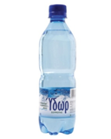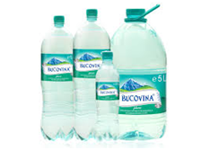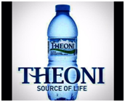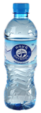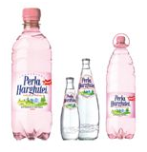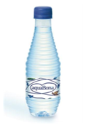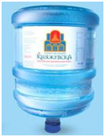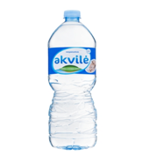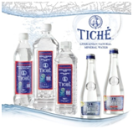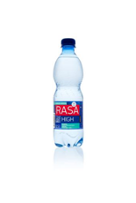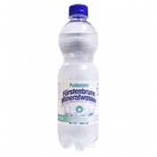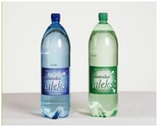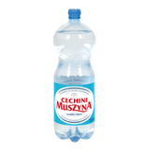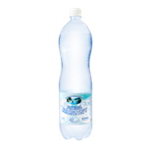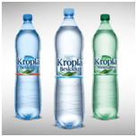

Group 3: Fill in the text using the following words/ expressions: bottling plant, geological engineer, spring waters, underground sources, water catchment, safeguard, sector’s, development

1. One of the responsibilities of a …………………. ……………… is achievement of geophysical measurements.
2. Natural mineral waters and …………... are a gift of nature and lie at the heart of the ………… activity.
3. Sustainable …………… is a fundamental objective to ………….. the future of the industry.
4. More checks are carried out at the …………….. ……………… where strict quality and safety measures are applied.
5. The drop of water that reached the ………………… …………….. is collected in the bottle of water you buy in the local shops.
6. The producers actively monitor and protect the ………….. …………... areas.

Group 4: Identify 3-5 benefits of the consumption of natural mineral waters, using the Internet.
Group 5: Imagine you are the marketing team of mineral water manufacturing company. Make an advertising spot or an advertisement convincing potential clients to buy the mineral water you commercialize.
Group 6: Provide an employment interview for the job of sales agent and then act out the role play.

SESSION 3
MINERAL WATER IN MEDICINE AND SPA

Activity 1: Brainstorming
Class management:
Time: 50 minutes
Keywords : spa, treatment of diseases, therapies, health benefits, mineral baths
https://docs.google.com/presentation/d/1plUd7ZYlMf8qhQ16k2JDahRDD1U1HXbos8dHghK8ZR8/edit#slide=id.p
Activity 2 : Questions with short answers related to the presentation - a bowl with little notes.
Each group assignes a leader to get a note with a question out of the bowl. The question is adressed only to that group. If the group does not provide the correct answer or does not answer at all, the chance will be offered to another group - the concerned group will decide which group may answer.
- What component of the mineral water has the most important therapeutic role?
- What is the effect of carbon dioxide on the body, with mineral water therapy?
- How much time is it recommended to take a bath with mineral water?
- What benefits have mineral baths on the body?
- What kind of diseases can be treated with carbonated mineral water baths?
- What therapeutic effects does mineral water have?
- List a few cities where there are spa's, regardless the origin of the country.
- What is the chemical formula of carbon dioxide?
The extraction is repeated until the questions are exhausted.
Activity 3 : Build up a "dumb"(mute) poster on the theme of the session. Peer!

Activity 4 : Circle the odd one out in the following series:
- medicine, spa, robots, health, diseases, mineral bath, benefits, carbon dioxide, therapeutic, water;
- mineral deficiency, lowering cardiovascular risk, alzheimer, digestive diseases, inflammation, urogenital, diuretic effect, masks and compresses with mineral water;

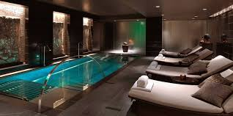
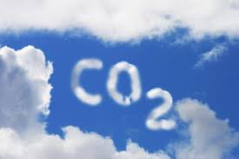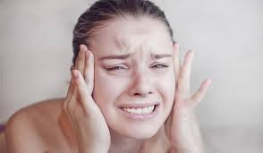

Activity 5: Fill in the bunch, properly, using these terms: mineral water, massage, compresses, digestive diseases, cardiovascular risk, diuretic effect, H₂O, CO₂, relaxation, 5-20 minutes, 40 ºC.
MINERAL WATER
diseases

composition

SPA

