LESSON PLAN

Title of the unit: New technologies
Subject: Communication
Group Age: 13 - 15 years old
Group Size: 25 students
Timing: 45 minutes per session
Place: Computer Lab

Introduction: This lesson has as a main aim studying the most important aspects about communication. Students will learn related phrases / expressions of this topic, they will contemplate the impact of the technology evolution on human being.

Learning outcomes:

- To be aware of the importance of communication;
- To identify all the types of communication;
- To improve their knowledge about the evolution of telephone, Internet and electronic mail;
- To discover the benefits and to use all these tools.

Subject content:
- Communication: definition, types of communication;
- Telephone: occurence, essential parts, evolution;
- Internet and electronic mail: occurence, evolution, benefits.

Language objectives:
- Acquiring specific vocabulary regarding communication;
- Using the new knowledge in practice;
- Developing reading, listening and speaking skills;
- Improving oral and written expressing in English.

Students are divided into five groups.

Session 1: Communication - introduction. Telephone

Motivating video: https://www.youtube.com/watch?v=-Vw_57-PHb0
Brainstorming: - starting question: What do you think about the evolution of telephone?
Reading a text related to the topic:
https://docs.google.com/document/d/1n6rL1k7vITUNZddjhV4GejBWJiKO9zd_PhZFsK1L5xc/edit
Read the text and fill in the appropriate word: ringer, dial, microphone, android, earphone, smartphone, iOS, touchscreen.

The essential elements of a telephone are a ……….. (transmitter) to speak into and an …………. (receiver) which reproduces the voice in a distant location. In addition, most telephones contain a ………... which produces a sound to announce an incoming telephone call, and a ……... or keypad used to enter a telephone number when initiating a call to another telephone. A ………... is a mobile phone with an advanced mobile operating system which combines features of a personal computer. Most smartphones can access the Internet, have a …………. user interface and have advanced operating systems like ………….. for Samsung, HTC, LG, Motorola or ……... developed exclusively by Apple Inc.

The vocabulary of the topic:
https://docs.google.com/document/d/1fyTgO__wHREAjOoaTI8ScNPaCJcBousKMX0sKUpV_NQ/edit
Vocabulary
Communication using telephone

- Microphone - transmitter; to speak to;

- Earphone - receiver which reproduces the voice from a distant location;

- Ringer - which produces a sound to announce an incoming telephone call;

- Dial - keypad used to enter a telephone number when initiating a call;

- Smartphone - A mobile phone that performs many of the functions of a computer, having a touchscreen interface, Internet access, and an operating system capable of running downloaded apps;

- Touchscreen - is an input device normally layered on the top of an electronic visual display of an information processing system;

- iOS - is a mobile operating system developed by Apple Inc. and distributed exclusively for Apple hardware;

- Android - is an open-source platform founded in October 2003 by Andy Rubin and backed by Google, along with major hardware and software developers.

Introducing keywords into sentences.
Using Google Apps.

Task: Working in Google Apps, using keywords.
Activities:
- Read the text and identify 8 keywords related to the topic;
- Using Google Play, download WhatsApp and send a message to the other groups.
- Using Facebook, post an appropriate photo of our current activity with an original message also, tag your friends.
Assessment:
- Use the keywords to build up sentences;
- Each group gets two stickers - one, to write two advantages and another, to write two disavantages of using the telephone.

Session 2: Communication - Internet

Motivating video: https://www.youtube.com/watch?v=XhXk3wzemR4
Brainstorming: - starting question: Why is so important the internet for us?
The vocabulary of the topic:
https://docs.google.com/document/d/1WN23SlAFw2tMBrwqEQgjKrQawiKMnuPhTctdDO9kQJ4/edit
Vocabulary
Communication using Internet

- Network - is a group of two or more computer systems linked together;

- Site - a set of ​pages with ​information on the internet about a ​particular ​subject, ​published by a ​ ​person or ​organization;

- World Wide Web - an ​information ​network of ​texts, ​pictures, and ​sounds where ​people have ​access to when they use the ​Internet;

- Google - a ​search ​engine; a ​program for ​finding ​information on the Internet;

- Electronic mail (Email, e-mail) is the transmission of messages (emails or email messages) to electronic networks like the Internet;

- Forum - is an online discussion site where people can hold conversations in the form of posted messages;

- Blog - is a discussion or informational site published on the World Wide Web consisting of discrete entries ("posts") typically displayed in reverse chronological order;

- Facebook - a ​website where you can publish and share ​information about yourself, and ​communicate with ​groups of ​friends;

- Twitter - a ​website where ​people or ​organizations can ​publish ​short​ remarks or ​pieces of ​information, and where you can ​see ​information ​published by ​people or ​organizations that you ​choose;

- Skype - a ​communicating ​application with other ​people on the Internet using ​video or ​voice ​calls.

Task: Practicing online programes on the Internet.

Activities:
- Identifying the keywords out of the multitude of words;
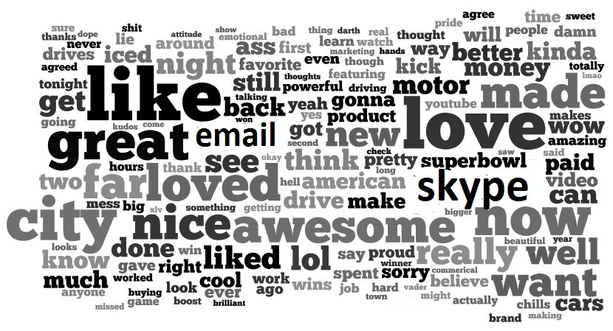

- Writing the most used five applications; bulding up a bunch;
- Playing a multiple choice game – Kahoot: Internet;
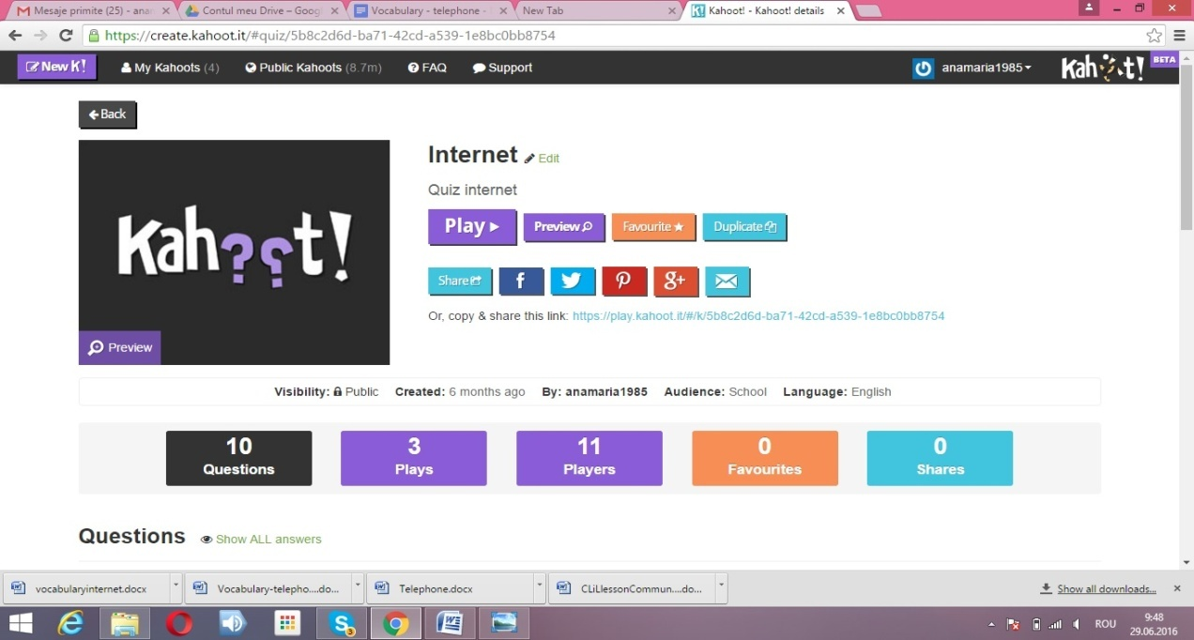

- Filling in a text – Kahoot: Communication;
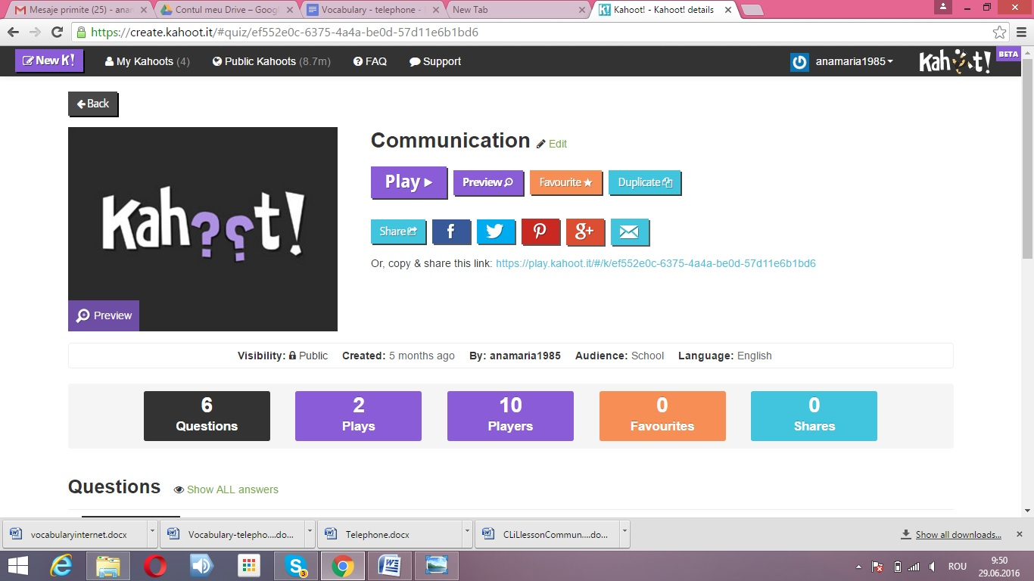
- Using Skype.

Assessment:
- Each group has to build up two sentences using the two keywords they identified;
- Each group gets two stickers - one, to write two advantages and another, to write two disavantages of using the Internet.

At the end, the students watch a video - New Communication Technologies
https://www.youtube.com/watch?v=qRToZ3HZsmY

Resources:
Google Presentation
https://docs.google.com/presentation/d/1b2g4AXsP9Vh250rJs2VRNlkopw3IAOW2Gs9LxsCb3xA/edit ;
Google Docs:
https://docs.google.com/document/d/1fyTgO__wHREAjOoaTI8ScNPaCJcBousKMX0sKUpV_NQ/edit; ;https://docs.google.com/document/d/1WN23SlAFw2tMBrwqEQgjKrQawiKMnuPhTctdDO9kQJ4/edit ;
Motivating video: https://www.youtube.com/watch?v=-Vw_57-PHb0; https://www.youtube.com/watch?v=XhXk3wzemR4
Concluding Video: https://www.youtube.com/watch?v=qRToZ3HZsmY
Kahoot: Internet, Communication;
Skype;
Google Play;
Facebook.

