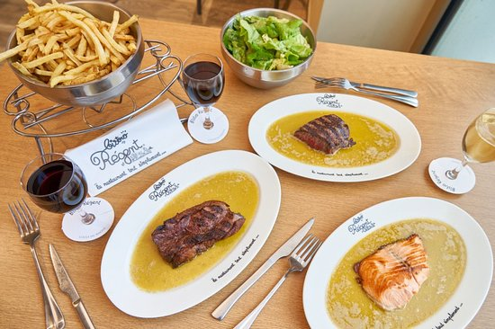

Simple meal, good value for money, fast service. All the staff are friendly. We recommend it as a couple or with friends. The French fries are so good that you want more.

***BISTRO REGENT***