Le Vesper

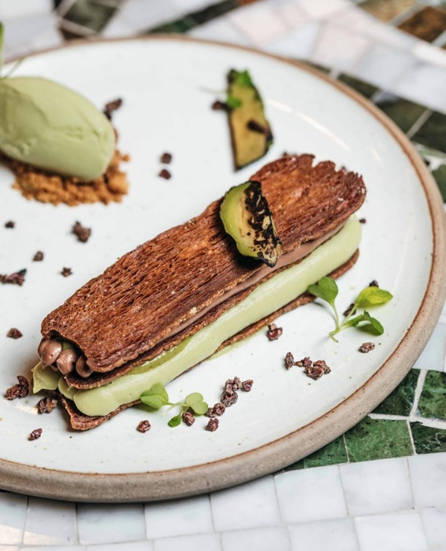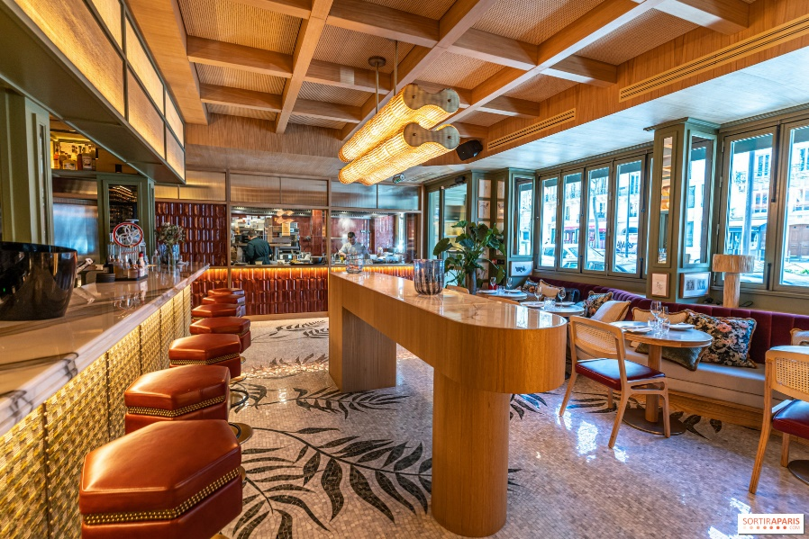

Le Vesper is a chic and warm restaurant located in the 7th arrondissement not far from the Eiffel Tower.

It is a mixture of Peruvian and Japanese flavors that will attract your taste buds. The decoration is very trendy and will take your breath away.

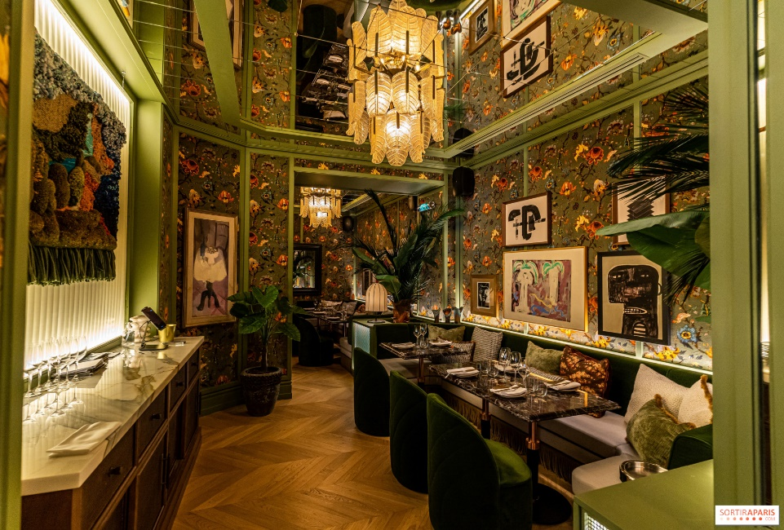

The food is delicious and the staff are very charming. The bar is very famous for its delicious cocktails and the atmosphere is really cool.

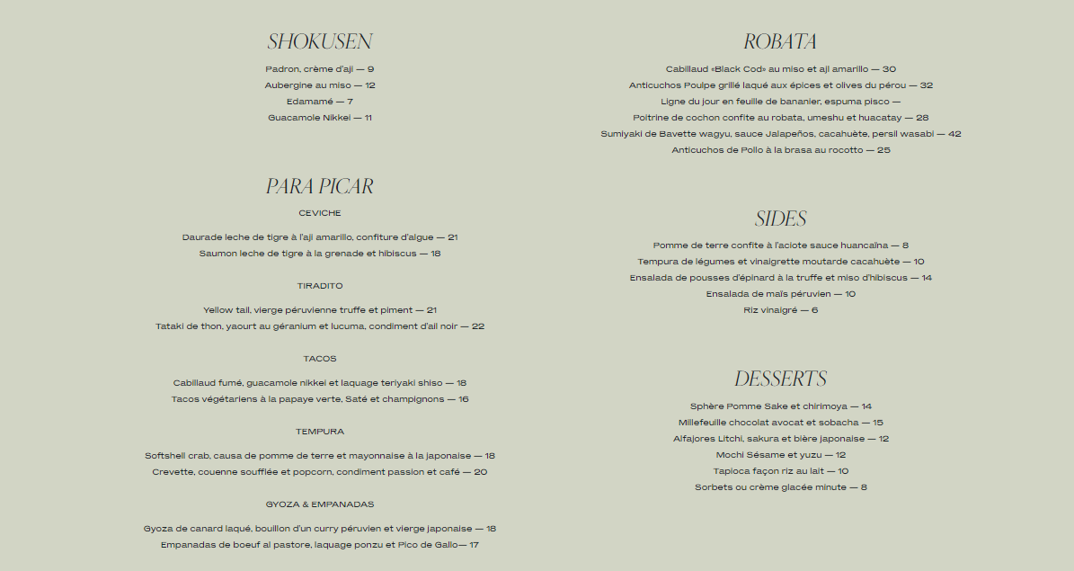

Certainly the dishes are a bit expensive and there is a lot of waiting so that's why you have to book in advance. But it is an experience to do because it is worth the cost.