DOMINIK & M.Oğuzhan

Poppy seed cake (MAKOWIEC in Polish)

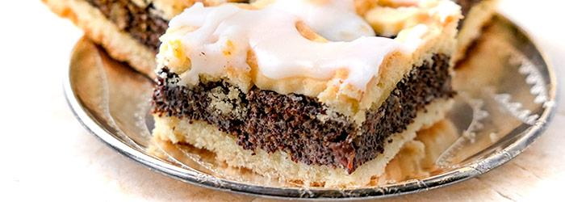

Ingredients:
- 300 g wheat flour
- 250 g butter (cold)
- 1 teaspoon of baking powder
- 70 g of icing sugar (powdered sugar)
- 1 tablespoon of vanilla sugar
- 3 eggs

Way to prepare:
- Add the cubed butter, baking powder, powdered sugar and vanilla sugar to the flour
- Chop the ingredients or crush with your hands or a fine crusher mixe
- Add egg yolks (keep egg whites to poppy seed mixture) and combine ingredients into a smooth dough, then put it in the fridge
- The dough can be kneaded in a bowl, on a table or in a planetary mixer
- Divide shortcrust pastry into two parts
- Put a half of the dough on the baking sheet (about 21 x 25 cm)
- Spread the poppy seed filling
- Roll out the rest of the dough and cut out the strips, put them on top of the poppy seed
- Put in the oven and bake at 180 degrees C for about 35 minutes until golden brown
ENJOY :)

M.Oğuzhan please prepare: butter, flour, eggs, icing (powdered) sugar
I will bring the rest of ingredients :)

