ANIA & ASYA

Polish Carpathian mountain cream cake (KARPATKA in Polish)

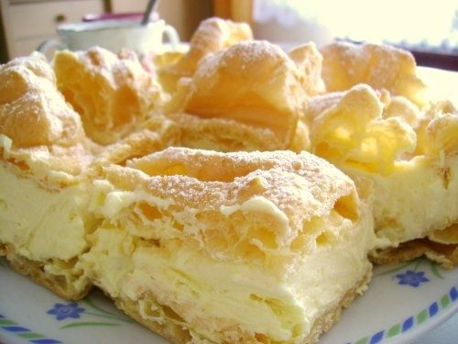

Ingredients:

- Dough:  - 250 ml water (1 glass)  - 125 g butter  - 5 eggs  - To decoration:  - 1 tablespoon powdered sugar | - Cream:  - 500 ml milk (2 glasses)  - 200 g butter

Way to prepare:

Cream:
- Mix the contents of the cream bag with 200 ml of milk
- Boil the remaining milk and pour the mixture into the boiling milk
- Cook for a while, energetically cream any lumps, then cool it off.
- Add butter to the cooked pudding and blend it until smooth

Dough:
- Apply little butter and flour on a baking sheet (about 25 x 30)
- Boil water with butter, add the contents of the bag with the dough and cook for a while creaming the mass, then cool it off
- Add eggs (one after the other) into the cool mixture and mix at high speed for 5 minutes
- Divide the dough into two parts
- Spread each part in a thin layer on the prepared baking sheet
- Put in the oven preheated to 220ºC and bake for 25-30 minutes until golden brown (first one layer then another) - it should look like mountains

Final activity
- Put the prepared cream on the bottom layer of cooled cake
- Cover with the top layer of cake
- Sprinkle the cake with powdered sugar.

ENJOY :)

Asya please prepare: butter, eggs, milk, icing (powdered) sugar
I will bring the rest of ingredients :)

