ANIA & ASYA

Apple pie (SZARLOTKA in polish)
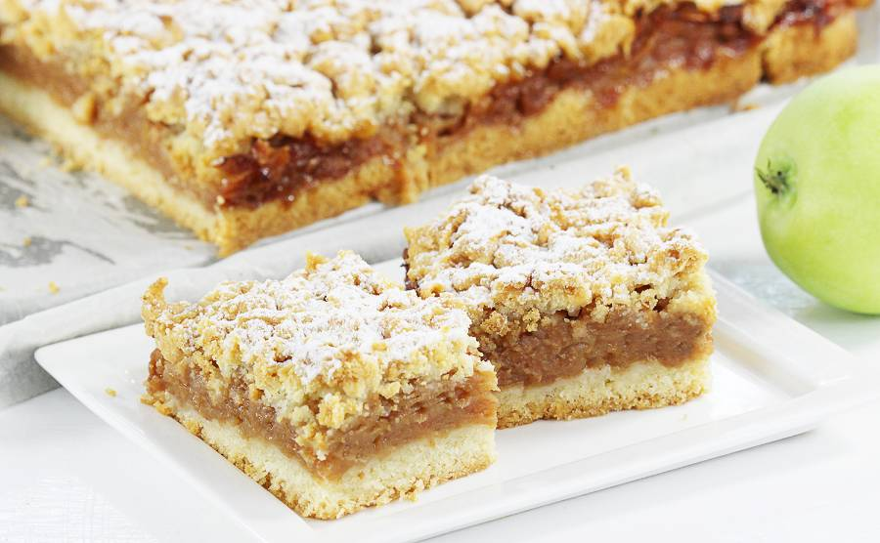

Ingredients:

- Dough:  - 3 cups of flour  - a block of butter  - 4 flat spoons of sugar  - 5 yolks  - 2 teaspoons of baking powder  - a packet of vanilla sugar | - Apple filling:  - 6 large apples  - 5 egg whites  - 3/4 cup of sugar  - a packet of fruit kissel  - cinnamon

Way to prepare:
- Knead the dough
- Put ⅔ of the dough on the baking sheet and freeze the rest ⅓ of the dough.
- Peel and grate apples.
- Before putting the apple filling on the dough, sprinkle the dough with bread crumbs.
- Sprinkle apples with cinnamon and sugar.
- Beat the egg whites with a blender, at the end of whipping add fruit kissel and sugar.
- Spread the beat egg whites over the apple filling.
- Grate the rest of the dough over the beat egg whites.
- Put into the oven. The oven does not have to be heated.
- Bake at 180 ° C for 45 minutes (until the crust is golden brown)
- Sprinkle the cake with icing (powdered) sugar
Enjoy :)

Asya please prepare: butter, flour, sugar, eggs, apples. I will bring the rest of ingredients :)

