PAWEŁ & Ömer

Our local gingerbread - ”Kętrzyn gingerbread”
(PIERNIK KĘTRZYŃSKI in Polish)

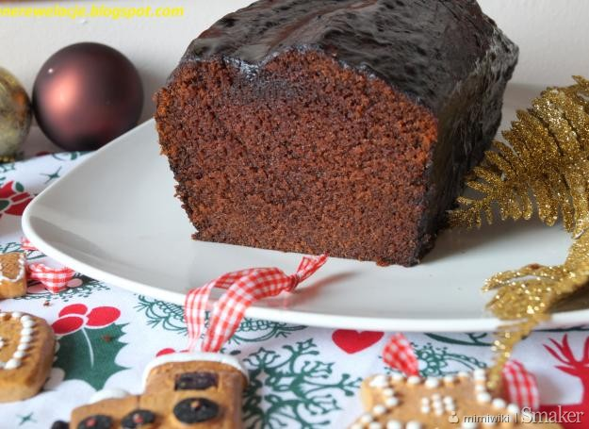

Ineredients:
- “Kętrzyn gingerbread” powder
- water - 1.5 cups (380ml)
- oil - 3/4 cup (170 ml)
- sour jam,
- chocolate (to melt for coating)

Way to prepare:
- Mix the contents of the package with water using a blender/mixer
- Add oil and mix carefully again
- Put the dough into a baking sheet previously greased with oil or butter and sprinkled with breadcrumbs, put aside for about 15 minutes
- Put the dough in a preheated oven (180 degrees C) and bake for about 45-60 minutes
- Cool the cake off and cut into halves
- Cover the first part of the cake with a layer of sour jam and cover with the second part of the cake, then top the cake with melted milk chocolate
Ömer please prepare: oil, sour jam, breadcrumbs
I will bring the rest of ingredients :)

