Content
Short Description Material: 1
Objectives Funding: 1
Target groups + possible uses: 2
Picture Example: 3
Sources: 4

Timetable - table cards

Short Description Material:
- symbol or pictogram represents compartment
- pictures are taken in the order of the timetable on the board
- arrow indicates current lesson

Objectives Funding:
- orientation in the course of the day and the hour
- ritualization of daily processes u. services (for example, daily schedule boss)
- creating language events

Target groups + possible uses:

material | class 1-2 | class 3-4 | Pupils with special needs | Own experiences
"Daily- and hours-cards " | - Installation of the cards in the daily routine  - Integration student service (1-2 students bring their own cards)  - Pictograms can be extended according to competence (eg replaced by words)  - Symbols can be used in the beginning time in the homework book | - extension of the board cards (reduction of image share)  - symbol of the stop + use of writing (word-phrase-phrase) promotion of reading competence  - learning words or technical terms can be installed in it (repetitive language structures) | Special need "language":  • ritualized speech ("In the first hour we have ..." etc.)  • Specification of language structures u. linguistic exercise elements → e.g. Past participle Past continuous "We read ...")  Special need "mental development / autism":  • internalization / ritualization of daily routines | - students enjoy accepting this language and are proud of their own verbal results  - students remember language structure and use these more independently  - great help for autistic and mentally disabled students  - can be adapted to their needs (eg by removable symbols for example by Velcro put in box with the label "Done")

Picture Example:
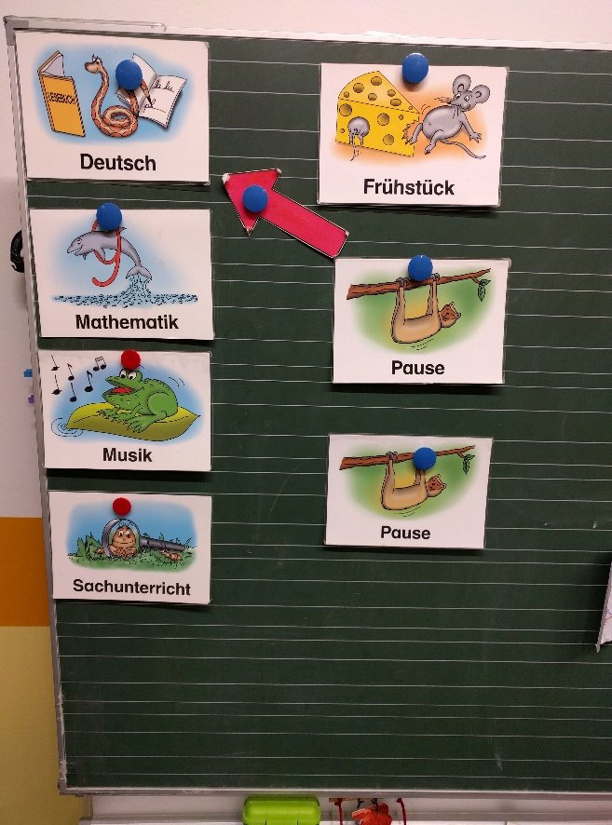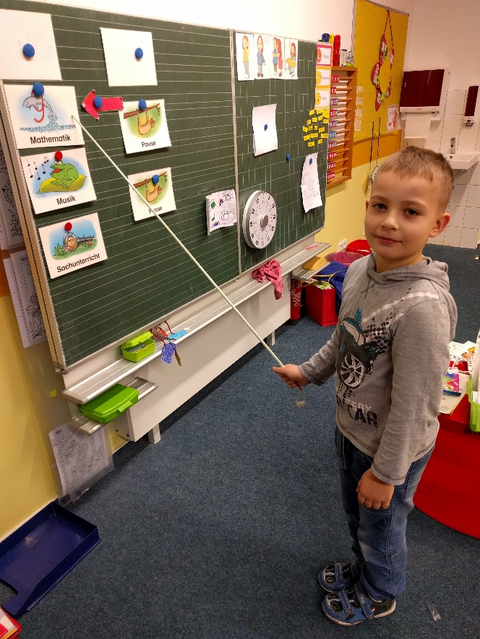
picture 1: Pictogram + word (1st-2nd class) picture 2: Student (1st class) shows the pictograms, speaks to it

Sources:

- idea by M. Graf (taken over by: Verlag an der Ruhr)

