Learning about Democracy
Name: __________________________________
Class: _____________
School: _________________________________
School year 2018-19

What do I know about democracy;
Discuss with the members of your team the meaning of the word democracy and write down your thoughts:
Democracy is… _________________________________________________________________________________________________________________________________________________________________________________________________________________________________________________________________________________________________________________________________________________________
Discussion in class usiing the phrases:
«I learned that…» , «I found out…», «I would like to discuss…», «I found interesting…»
DID YOU KNOW…
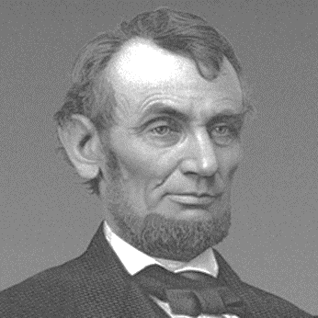
U.S. president Abraham Lincoln (1809-1865) defined democracy as: «Government of the people, by the people, for the people»
- Of: The government belongs to the people.
- By: The government is formed by the people.
- For: The government works for the people.
His definition of democracy suggests that a democratic government always functions for the welfare and progress of its people.

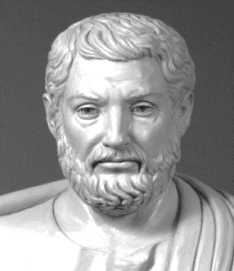
Greece: The country that gave birth to democracy
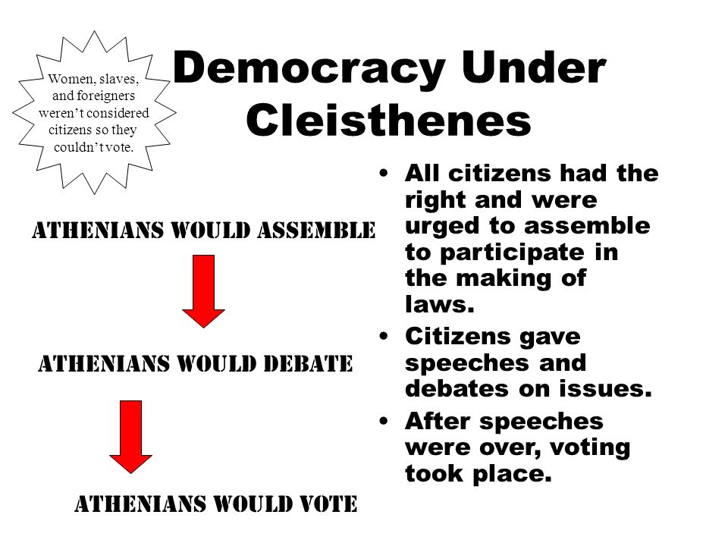
Ancient Athens is best remembered for giving birth to the first democracy in history, a course of action that took many years and several leaders to develop. One of the most prominent figures of that period is without a doubt Cleisthenes, also known as "the father of Athenian democracy."

Democracy is a Greek word. It comes from the words DEMOS (people) and CRATO (rule).

All people equal
Voting
Respect for Human Rights
Political parties
Majority
Dialogue, discussion, co-decisions
Laws, rules for everyone
Citizens taking part

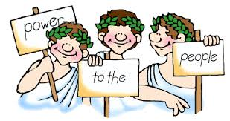

Democracy in school… Democracy in home..
Do you have democracy in your school or in your house? Could you write down three things that show that there is democracy in your…
SCHOOL | HOUSE

Working in groups:
Democracy is about dialogue, discussion and expression and sharing of ideas. It is about taking decisions about what is best for the group (a family, a class, a school, a country…).
Discuss in your group and think about how your school can be more democratic.
GROUP:___________________ __________________
1.
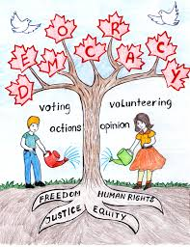
___________________________________________________________________________________________________________________________________________________________________________________________________
2.

_______________________________________________________________________________________________________________________________________________________________________________________________
We democratically set the rules of our class!
That’s right! Let’s think about the rights and duties we have in class.
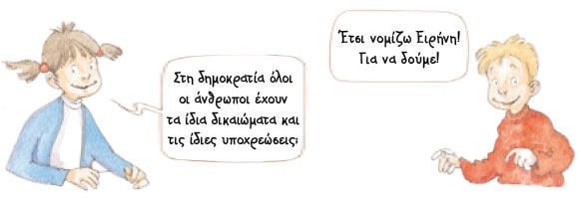
In democracy everyone has the same rights and duties.

GROUP WORK
Rights we have in class | Duties/responsibilities we have in relation to this right
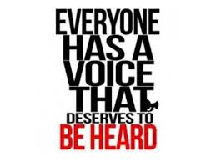
Attention: The rules should be concise, positively formulated (DO rather than DO NOT), describe the behavior required (for example, remain silent when others talk) and be posted at a prominent point in the classroom.

