WOMEN THAT CHANGED THE WORLD!

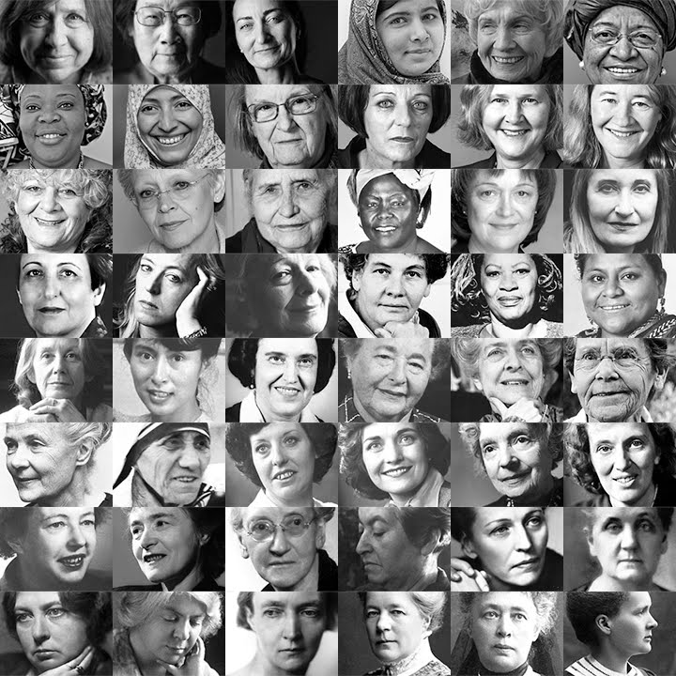

C’ Ayios Dometios Elementary School

6th Grade
Marie Curie (7 November 1867 - 4 July 1934)
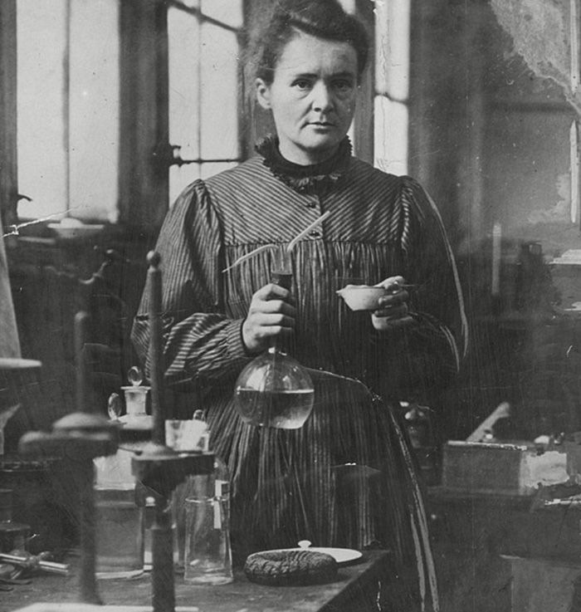

________________________________________________________________________________________________________________________________________________________________________________________________________________________________________________________________________________________________________________________________________________________________________________________________________________________________________________________________________________________________________________________________________________________________________________________________________________________
Rosa Parks (4 February 1913 - 24 October 2005)
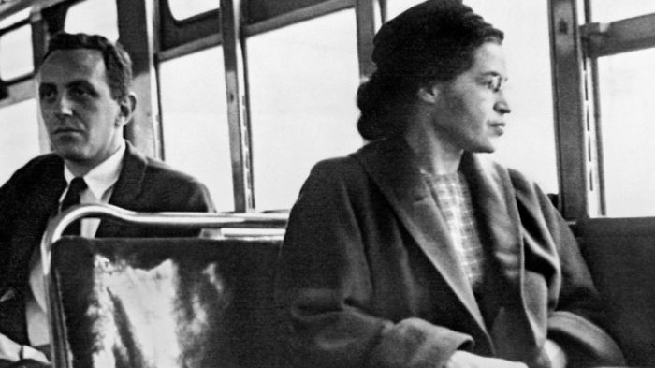

_______________________________________________________________________________________________________________________________________________________________________________________________________________________________________________________________________________________________________________________________________________________________________________________________________________________________________________________________________________________________________________________________________________________________________________________________________________________________________________________________________________________________________________________________________________________________________________________________________________________________________________________________________________________________________________________________________________________________________________________________________________
Bertha von Suttner (9 June 1843 - 21 June 1914)
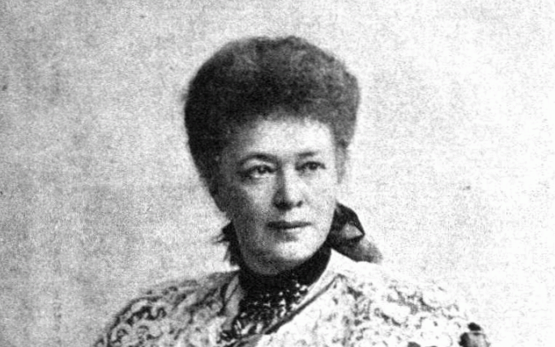

_________________________________________________________________________________________________________________________________________________________________________________________________________________________________________________________________________________________________________________________________________________________________________________________________________________________________________________________________________________________________________________________________________________________________________________________________________________________________________________________________________________________________________________________________________________________________________________________________________________________________________________________

Malala Yousafzai (12 July 1997)
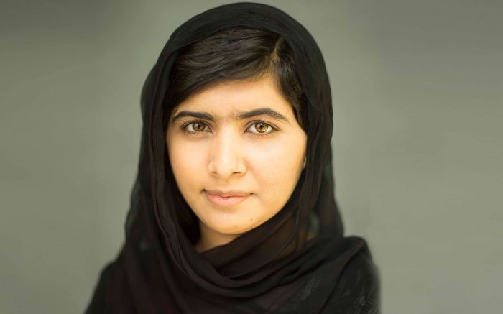

_________________________________________________________________________________________________________________________________________________________________________________________________________________________________________________________________________________________________________________________________________________________________________________________________________________________________________________________________________________________________________________________________________________________________________________________________________________________________________________________________________________________________________________________________________________________________________________________________________________________________________________________
Amelia Earhart (24 July 1897- 5 January 1939)
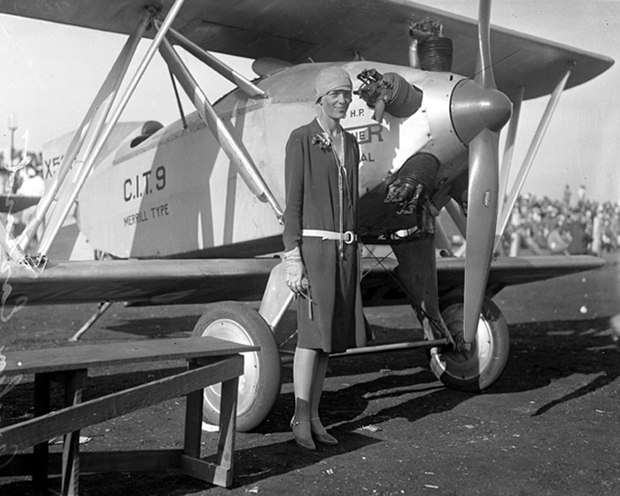

_________________________________________________________________________________________________________________________________________________________________________________________________________________________________________________________________________________________________________________________________________________________________________________________________________________________________________________________________________________________________________________________________________________________________________________________________________________________________________________________________________________________________________________________________________________________________________________________________________________________________________________________
Jane Goodall (3 April 1934)
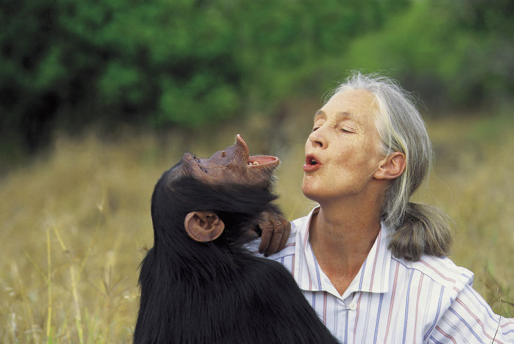

_______________________________________________________________________________________________________________________________________________________________________________________________________________________________________________________________________________________________________________________________________________________________________________________________________________________________________________________________________________________________________________________________________________________________________________________________________________________________________________________________________________________________________________________________________________________________________________________________________________________________________________________________________________________________________________________________________________________________________________________________________________
My Mother!

