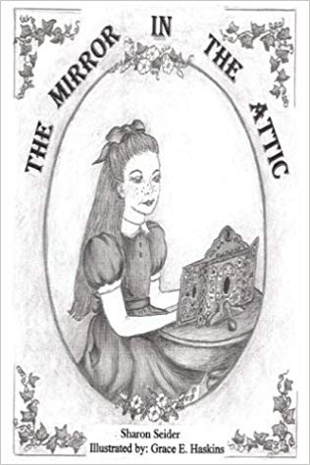
Guidelines for the Creation of the Story Book as Discussed in Germany on Thursday 27th September 2018

- The story book will be about a human hero decided in each country that will find a problem and try to solve it with a team of seven other friends/ human heroes from his/hers school/ surrounding
- The story starts when the hero finds on the attic a magic mirror. A part of the magic mirror is illuminated each time and a problem is shown. Every time a problem is solved and moving on to the next country a next part is shining and the mirror together with the heroes or some of them travel to the other country where there is another problem to be solved. At the end all the mirror is illuminated.
- The mirror is talking and is helping the heroes to solve the problems, however it does not give “ready solutions”. It just enables them. A slogan can be used such as: “Mirror Mirror on the Wall take me where I am needed more!”.
- In the story the competencies of an active citizen should be emphasized such as: co-operation, dialogue, self-confidence, expressing of opinion orally or in a written way, respecting duties and rights…
- The primary hero selected by each country should be different. We should have: boys and girls, students of different origin or personal appearance, students with special needs such as a student on a wheelchair. The problem in each country should also be different.
- The basic hero should be presented well each time. For example the hero in Cyprus at the beginning will be a girl and will be described like snow-white so as to have a connection to the story of snow-white.
- At the end when all the heroes are gathered together they are on top of a lake that acts as a big mirror. They form a big team in that way. When one throws a small rock in the lake then circles start to be formed. Then a hero says that to solve a problem in the world you have to see the whole picture, all the circles and not just the point where the first rock was thrown. Also one could say that when one acts as an active citizen (like the small rock that is thrown in the lake), many can follow (the circles that are consequently formed)
- Length: 7 pages with illustrations
- Each country sends his work to all the others upon completing of its part.
- First: Book in Cyprus, Then Germany, Greece and Finland (Is it correct?)
- The book is completed and an audio cd is produced in the last meeting in Germany
12. THE DEADLINES FOR THE STORYBOOK
19 NOVEMBER CYPRUS TO GERMANY
19 JANUARY GERMANY TO GREECE
16 MARCH GREECE TO FINLAND
27 APRIL FINLAND TO GERMANY
