MIRROR, MIRROR TO MY SCHOOL
What do I like in my school?
building, classrooms, colours, schoolyard, decorations, subjects, equipment, books, teachers, classmates, behaviour, activities, timetable, sports ????????

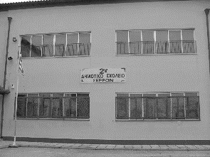

_______________________________________
____________________________________________
_______________________________________________
_______________________________________________
______________________________________________
____________________________________________
_________________________________________
_________________________________
______________________

What is it that I don’t like in my school?

We form groups of 3-4
We discuss, find the 3 most positive things in our school about the building, classrooms, schoolyard, subjects, teachers, activities, outings, games etc. and write them down ____________________________________________________________________________________________________________________________________________________________________________________________________________________________
Now we discuss again and find 3 negative things that exist or happen in our school ___________________________________________________________________________________________________________________________________________________________________________________________________________________________

Let’s find 3 things we would like to change! What can we do to help this change? _________________________________________________________________________________________________________________________________________________________________________________________________________________________________________________________________________________________________________________________________________________________

SCHOOL QUESTIONNAIRE
- Which is the first thing you like to do as soon as you come to school?
______________________________________________________________________________________________________________________________________________________
- What do you feel when you are at school?
___________________________________________________________________________

- Which is the most pleasant moment at school for you?
___________________________________________________________________________
- Which is the worst moment at school for you?
___________________________________________________________________________

- Which is your favourite school subject? And the least favourite?
______________________________________________________________________________________________________________________________________________________

- Remember the best moment at school this year
______________________________________________________________________________________________________________________________________________________

- Remember the worst moment at school this year
______________________________________________________________________________________________________________________________________________________
- Which is the best school day of the week and why?
______________________________________________________________________________________________________________________________________________________
- Say something nice your classmates or teachers do
______________________________________________________________________________________________________________________________________________________
- Say something your classmates and teachers do and you want them to stop __________________________________________________________________________________________________________________________________________

