“Mirror to my town”
ERASMUS + ACTIVITIES /OCTOBER 2018
WORKSHEET 1
1ST PART – IN THE CLASSROOM
Questions for discussion
- do you know how many people live in our community? Is it a city, a town, a village? Is it a municipality?
- Is it an old or modern town? How long ago was it built? Who built it?
- Where is it located in Greece? Is it built near the sea? a mountain? a river? a lake?

- For the answers we use a dictionary, Wikipedia and Google Map

2nd PART - OUTSITE THE CLASSROOM
“Walking in the centre of our town”
Starting point: 2nd Primary School
Destination: the centre of Serres and buildings of historical value or practical use
- We start from our school, the students separate into 4 groups. Three groups work on worksheet 2 and 1 group follows the route on the map of our city centre. We walk in the city centre. We stop at buildings with historical value or practical use. We discuss what we know about them. We go inside and talk with the people who work there. We organise five 2-hour walks and each time we have a scheduled guided tour in one of buildings. We read how these buildings are connected to the history of the community in this book.
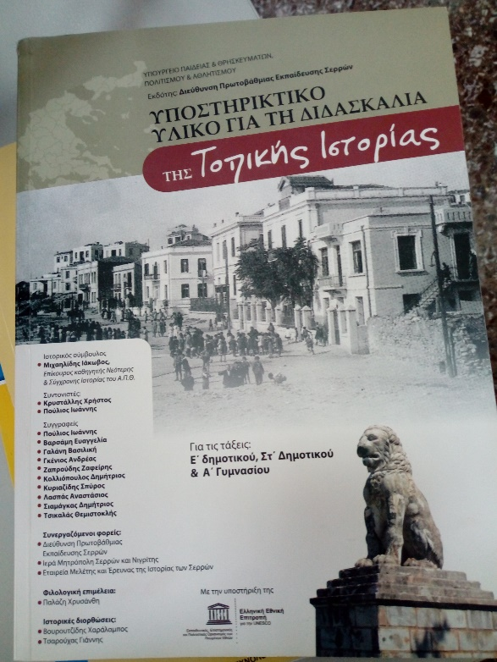
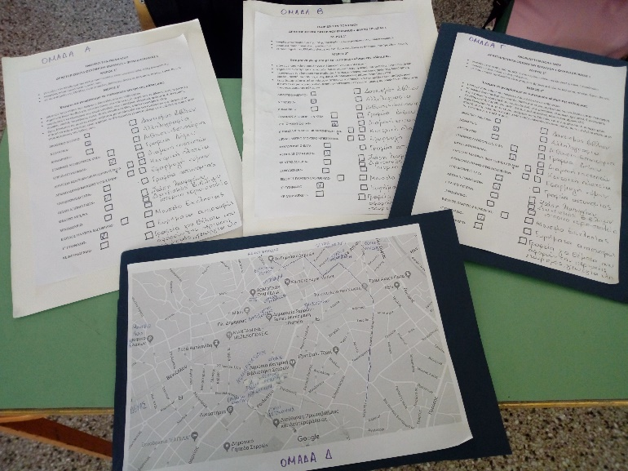

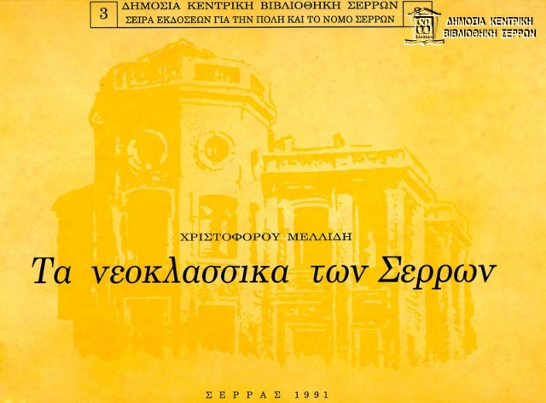

WORKSHEET 2
- guess which building you are looking at
- tick the building on the worksheet and try to guess its use and history
- describe the building’s architecture (Is it old, new? modern, classical? colours, building materials, decoration? storeys, roof, windows? garden, plants? entrance, stairs, special ramp for the disabled? etc.)
- enter the building; is it the first time? who has entered the building before? for what reason? discuss with your team, your teacher and a person who works in the building about its history and use (why is the building useful to the community)
- Match the buildings with their use or what they have inside

COURT HOUSE □ statues, coins, jewels and pottery
PREFECTURE BUILDING □ keeping order and safety in town
TOWN HALL □ mail, letters, parcels, cards, stamps
BUS STATION □ one kind of means of transport
POLICE STATION □ justice and law
PUBLIC CENTRAL LIBRARY OF SERRES □ offices and services of the area
BEZESTENI ARCHEOLOGICAL MUSEUM □ a place to borrow and read books
POST OFFICE □ mayor and town council
ARMY CLUB AND RESTAURANT □ accommodation

MUNICIPAL THEATRE “ASTERIA” □ etc.

HOTEL □
“ELEFTHERIAS” SQUARE (FREEDOM SQUARE) □
HISTORICAL 1ST HIGH SCHOOL □
CHURCH MUSEUM □
OLD CATHEDRAL □
HISTORICAL THEATRE “ORPHEAS” □
CINEMA “KRONION” □
NATIONAL BANK □
AGRICULTURAL BANK □
BANK OF GREECE □
WORK CENTRE □
TRADE & BUSINESS CENTRE □
NEW CATHEDRAL/MITROPOLIS □
CATHEDRAL RESIDENCE □
TELECOMMUNICATIONS BUILDING □
VLACHON MUSEUM □
SARAKATSANI MUSEUM □
CULTURAL CENTRE □
TZINTZIRLI MOSQUE □
ELECTRICITY BUILDING WITH WALL PAINTING □
FOOTBALL STADIUM □
OLD CHURCH “JOHN THE BAPTIST” □
“AHMET PASHA” MOSQUE □
WATER COMPANY BUILDING □
ACROPOLIS & BYZANTINE TOWER □
HOSPITAL □
UNIVERSITY CAMPUS □
TRAIN STATION □

- Scheduled visits to buildings of our community :
1st week of October- Prefecture building
2nd week of October-University campus
3rd week of October-Court house
4th week of October-Municipal library
November: Town hall and Mayor’s office
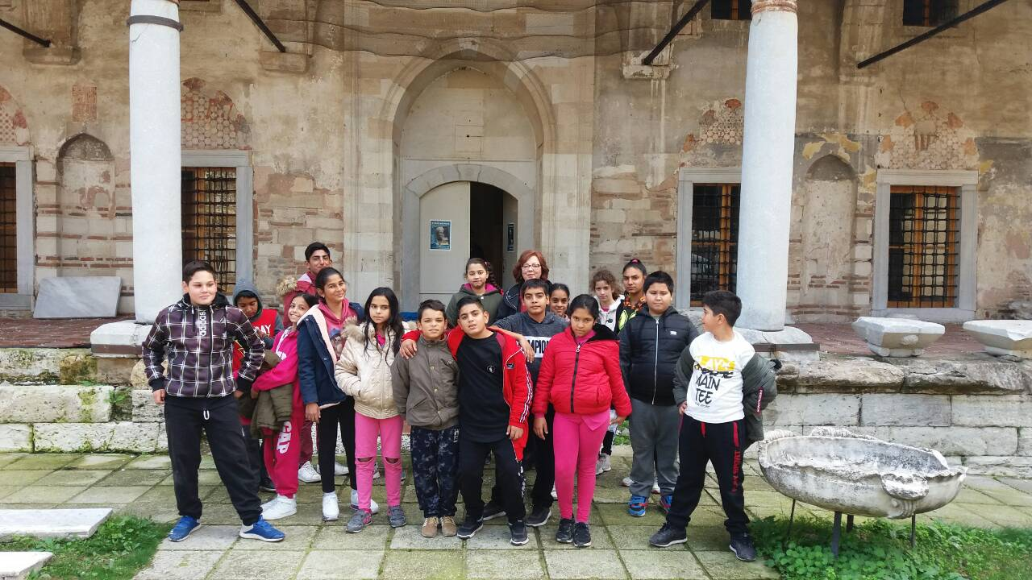
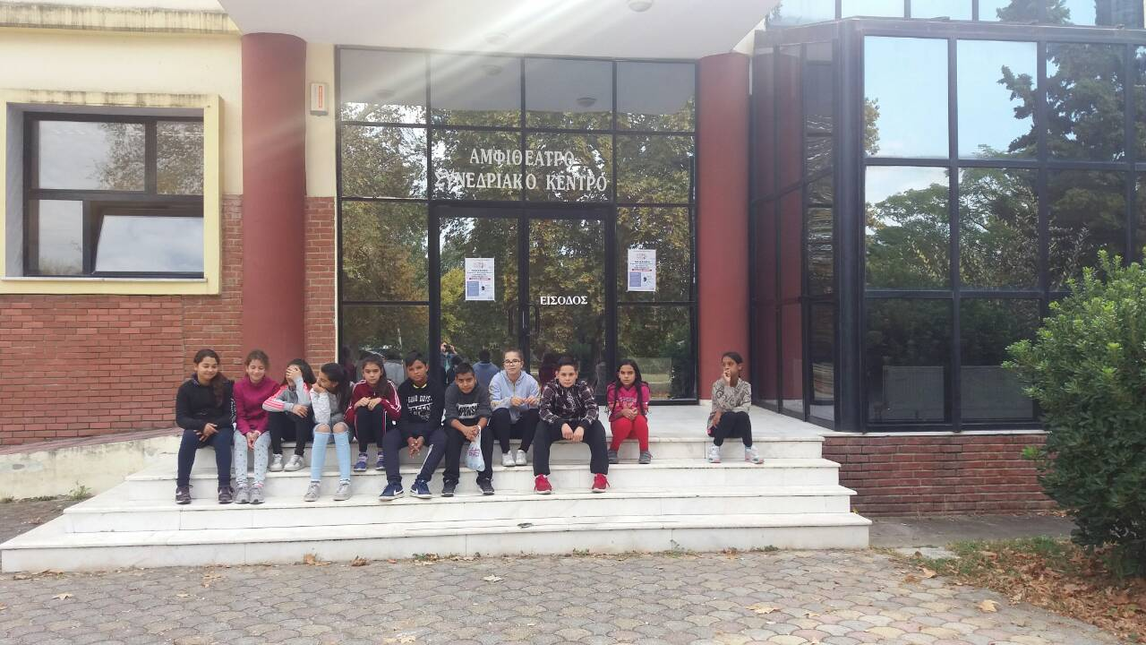
Bezesteni Archeological Museum and Tzintzirli Mosque
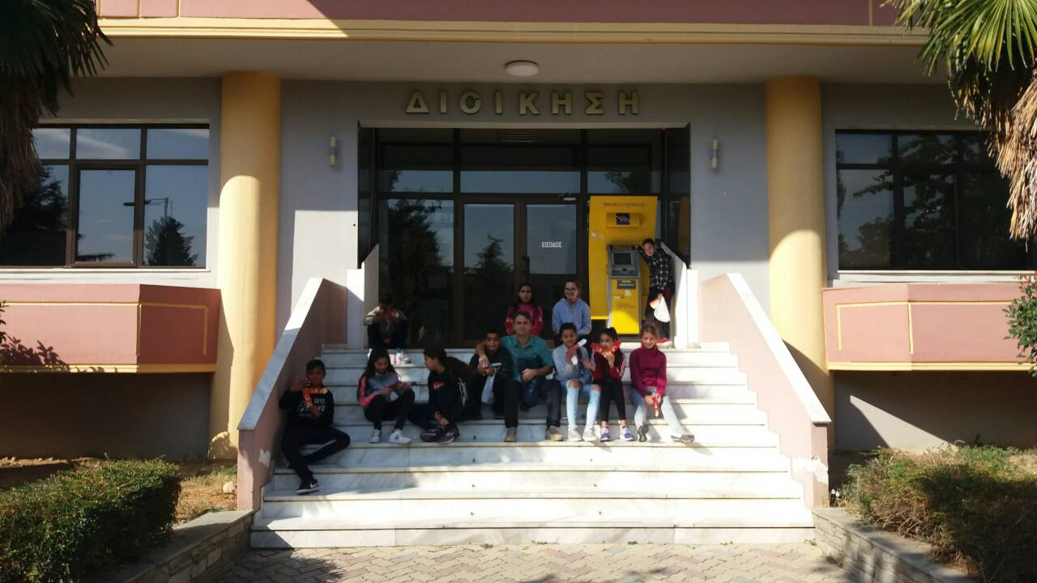
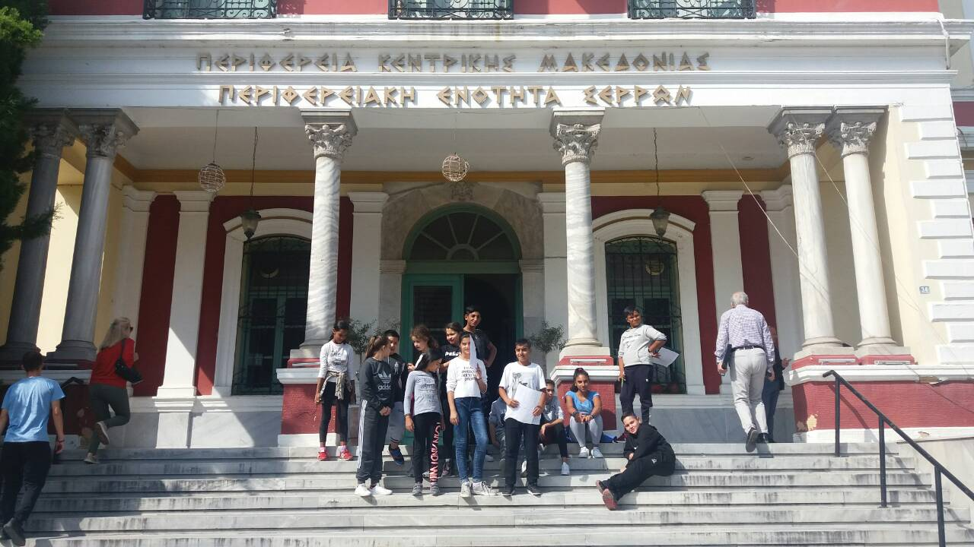

3rd PART-IN THE CLASSROOM-WORKSHEET 3
- What is your first impression from your walk in your town?
_________________________________________________________________________________
- Work in groups and write down 3 positive and 3 negative things you noticed in your town ____________________________________________________________________________________________________________________________________________________________________________________________________________________________________________________________________________________________________________________________________
- Are there more old or modern buildings in our town? Why? _______________________________________________________________________________________________________________________________________________________________________________________________________________Are they built from the same materials? _________________________________________________________________________________ _____________________________________________________ Which buildings do you like more? _________________________________________________________________________________ What have you learnt about the neoclassical buildings and houses? ____________________________________________________________________________________________________________________________________________________________________________________________________________________________________________________________________________________________________________________________________

EXTRA CREATIVE ARTISTIC ACTIVITY FOR OLDER CLASSES
Let’s draw buildings in Serres with the help of our Art teacher!!

- How many museums are there in our town and what can we see in them? ____________________________________________________________________________________________________________________________________________________________________________________________________________________________________________________________________________________________________________________________________
4th PART-HISTORY OF THE TOWN-WORKSHEET 4
- Do you know when the history of the town starts? ____________________________________________________________________________________________________________________________________________________________
- Can you see signs, buildings and sites in the town that reveal its history? ______________________________________________________________________________ ________________________________________________________________________________________________________________________________________________________________________________________________________________________________________________________________________________________________________________________
- Were there difficult periods for our town and its people?(wars, natural disasters, enemies, lack of freedom, refugees etc.) ________________________________________________________ ______________________________________________________________________________________________________________________________________________________________________________________________________________________________________________________________________________________________________________________________________________________________________________________________________
- What pleasant event do we celebrate on the 29th of June in Serres? Which terrible memory is connected to that day? ______________________________________________________________________________
____________________________________________________________________________________________________________________________________________________________
- How many times were there refugees in our town? ______________________________________________________________________________
______________________________________________________________________________________________________________________________________________________________________________________________________________________________________________________________________________________________________________________________________________________________________________________________________
- Do you know traditional products in our town? What would you suggest to a tourist to see, do, taste and take as a souvenir in Serres? ______________________________________________________________________________________________________________________________________________________________________________________________________________________________________________________________________________________________________________________________________________________________________________________________________
- We listen to traditional music, sing a traditional song and dance a traditional dance from our town.
________________________________________________________________________________________________________________________________________________________________________________________________________________________________________________________________________________________________________________________

- Form 4 groups. Find information about people who were born and/or lived in our town and choose four who changed the history of our town and/or were active citizens in terms of their offer to the community, freedom, education, democracy etc.

- Do you know the history of your school?
__________________________________________________________________________________________________________________________________________________________________________________________________________________________________________

EXTRA CREATIVE/ARTISTIC ACTIVITY FOR MIDDLE CLASSES
Draw your school !!!

EXTRA CREATIVE/ARTISTIC ACTIVITY FOR YOUNGER CLASSES
Choose and draw animals which live in our area!!!!!

