Active citizenship
Learning about dialogue

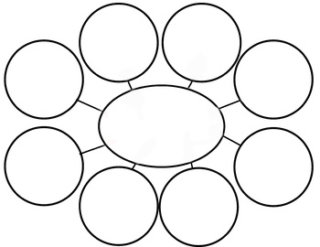
MoTheW²
Dialogue means…
Name: _______________________________________
Grade: _____ ………
2017 - 2018
The conditions of a “good” dialogue …
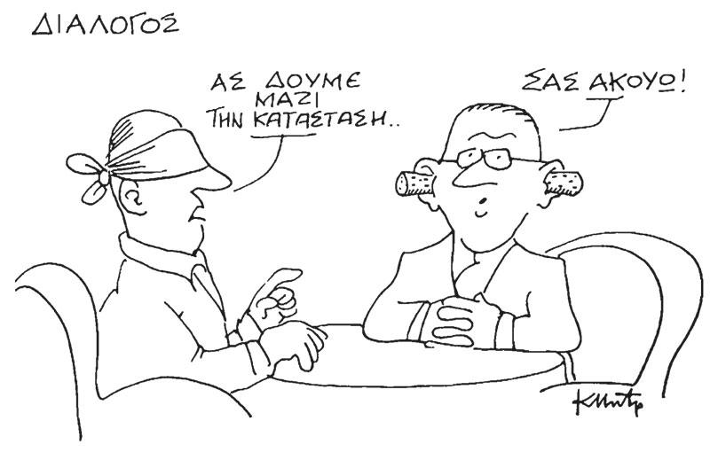
Ok, I am listening.
Let’s look at the situation together.
Dialogue

Γίνομαι ενεργός πολίτης/μαθητής…

Look at the above cartoon and comment on the
effectiveness of the dialogue:
_____________________________________________________________________________________________________________________________________________________________________________________________________________________________________________________________________________________________________________________________________________________________________________________________________________________________________________________________________________________________________________________________________________________________________________________________________________________________________________________________

Three hens and a peacock
(Source: https://www.youtube.com/watch?v=zyTSU58qP-0)
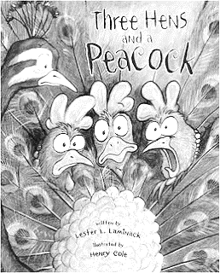
Listen to the story: «Three hens and a peacock»
Are there any dialogues in the story?
________________________________

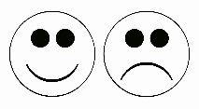
1. Think about the discussions between the hens
- Do they listen or respect the different opinion?
- Do they reach a conclusion accepted by all?

2. How should the dialogue between the hens and the peacock be? Create the dialogue between them:

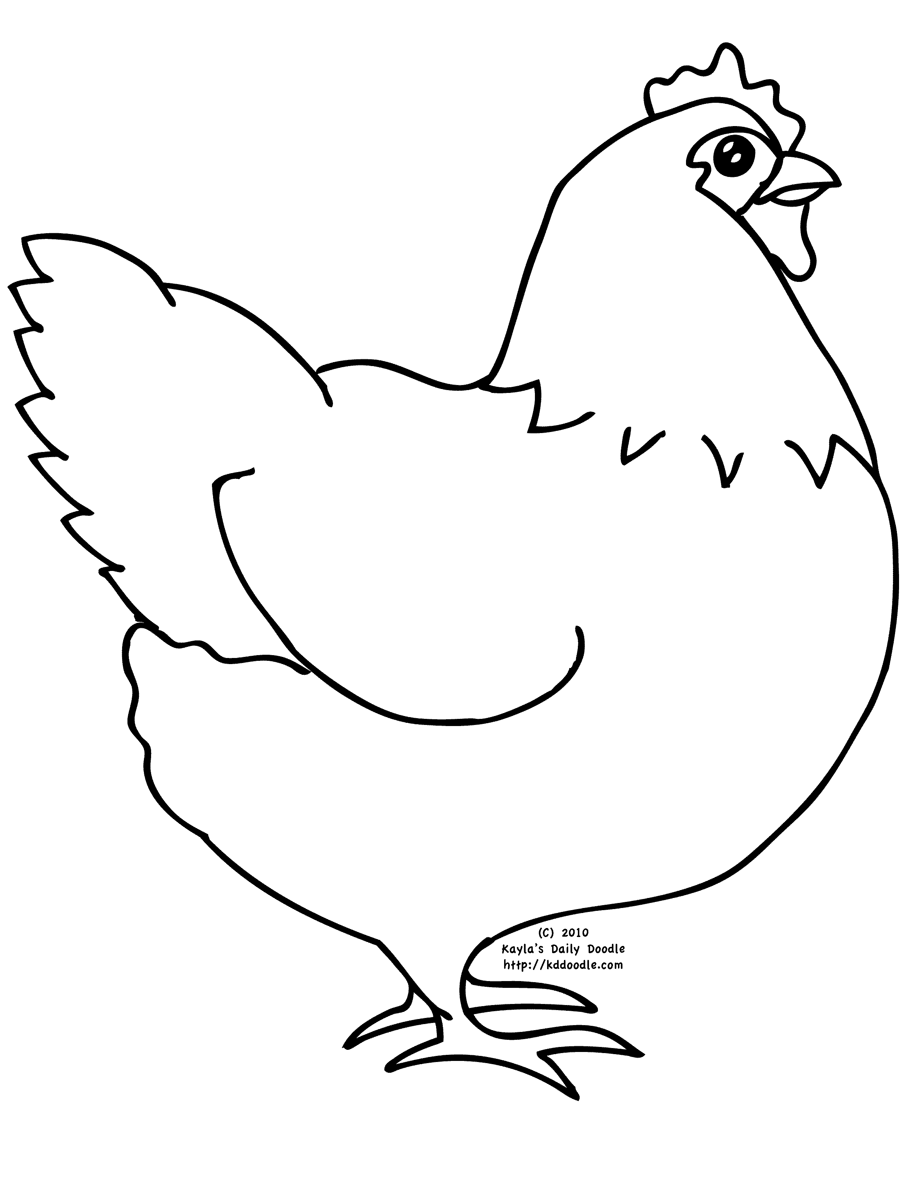
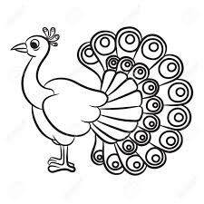

The Recipe of an effective dialogue!
Ingredients:
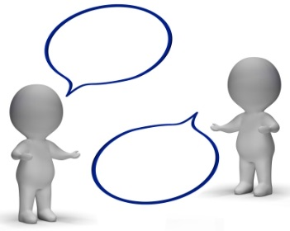
________________________________________________________________________________________________________________________________________________________________________________________________________________________________________________________________________________________________________________________

Procedure:
________________________________________________________________________________________________________________________________________________________________________________________________________________________________________________________________________________________________________________________________________________________________________________________________________________________________________________________________________________________________________________________
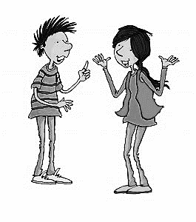
Useful phrases in dialogue:
I think/I believe that… It seems to me that…
According to me/In my point of view… What do you mean?
Could you explain that to me again? I have a question about...
What do you think? Do you agree?
I have noticed that… I have learned/heard that…
As I was reading that, I thought… I don’t agree with you because…
I have a different answer… I understand what you are saying
I agree with… because…. I know what you mean…
My idea is based on ….’s idea. We/I decided t…
I/we came to the conclusion…. I suppose that…
My team is/I am looking at this in a different way… So you are saying that…
I/we had a different approach… In other words…
This is an interesting idea… My thoughts are…

Script: George forgot to bring his rubber at school so he politely asked his friend Anna if he could borrow hers. Anna gave her rubber to George but he forgot to give it back to her. So the next day, Anna opened his pencil case to take her rubber without asking George. When George saw her, he got angry and the two children started an argument.
With your classmate try to picture the scene and write down how the dialogue between George and Anna should be. The above phrases will help you create the dialogue. Then present it with your classmate to the rest of the class!
_________________________________________________________________________________________________________________________________________________________________________________________________________________________________________________________________________________________________________________________________________________________________________________________________________________________________________________________________________________________________________________________________________________________________________________________________________________________________________________________________________________________________________________________________________________________________________________________________________________________________________________________________________________________

How would you improved this dialogue?
From the novel «Matilda», from Roald Dahl

(Dialogue between Matilda and her father)
Harry: Any packages come today?
Matilda: [shakes her head] Mm-mm.
Harry: [noticing her books] Where did all this come from?
Matilda: The library.
Harry: The library? You've never set foot in a library; you're only four years old.
Matilda: Six-and-a-half.
Harry: You're four!
Matilda: Six-and-a-half!
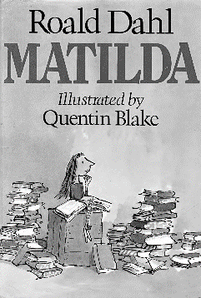
Harry: If you were six-and-a-half, you'd be in school already!
Matilda: I want to be in school. I told you I was supposed to start school
in September. You wouldn't listen.
Harry: Get up! Get up! Get out of here! Give me that book!
(He throws the book aside)

________________________________________________________________________________________________________________________________________________________________________________________________________________________________________________________________________________________________________________________________________________________________________________________________________________________________________________________________________________________________________________________________________________________________________________________________________________________________________________

