“Mirror, Mirror on The Wall”

OUR CRITICAL FRIEND
SHORT BIOGRAFY
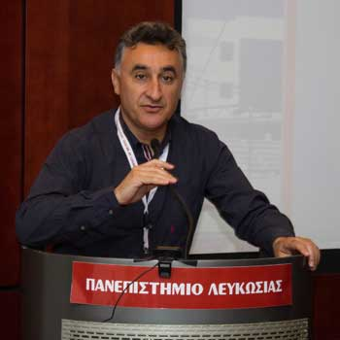

Panayiotis Angelides is professor and the dean of the school of education at the University of Nicosia, Cyprus. Previously he served as an elementary school teacher.
His research interests are focused on finding links between inclusive education, teacher development and school improvement.
A particular feature of this research is to develop collaborative approaches that have a direct and immediate impact on teachers’ practice. He is an experienced researcher with involvement in many local and international projects.
His latest book is entitled Pedagogies of inclusion.

