curriculum vitae

Personal Data

Name: …………………………
Address: …………………………

………………………...

Phone: ………………………...
e-Mail: ..……………………….
Date of Birth: …………………………
Parents: …………………………

Carrer (school and kindergarten)

since 201… Primary School Astrid Lindgren; Schkopau

class: ………….

20…. bis 20…. ………………………………………………

……………….. ………………………………………………

……………….. ………………………………………………

special skills (foreign languages, Talents, special needs)
…………………………….………………………………………………
…………………………………………………………………………….
…………………………………………………………………………….
…………………………………………………………………………….

Statement (PLEASE CHECK AND UNDERLINE THE APPLICANT AND ALL PERSONNEL SUPERIORS)
□ I would like to participate in the student exchange.
□ My parents (or legal guardians) allow participation in student exchanges.
□ My parents are aware that travel and accommodation costs are covered by the PAD of the
European Union. In terms of budgeting, after the budget has been exhausted, a proportionate
amount of funding through pocket money could become necessary.

__________________________ ________________________________________________________
signature applicant signature of all parents

Motivation Letter for the Exchange (answered the questions according to your personality. do you need more space? use the back. ;-)
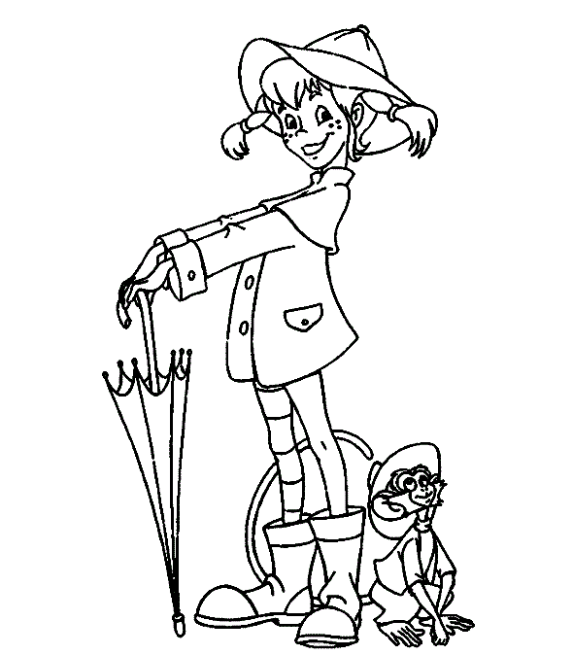

Why I am the right travel guide for Pippi? (future ambitions, skills, cooperation readiness…)
………………………………………………………………………………………………………………………...……………………………………………………………………………………………………………………………………………………………………………………………………………………………………………………………………………………………………………………………………………………………………

What profit you expected for you from the exchange?
………………………………………………………………………………………………………………………………………………………………………………………………………………………………………………………………………………………………………………………………………………………………………………………………………………………………………………………………………………………………

What gain the other childreen have through you?
………………………………………………………………………………………………………………………………………………………………………………………………………………………………………………………………………………………………………………………………………………………………………………………………………………………………………………………………………………………………

How were your experience with the project M²OtheW?
………………………………………………………………………………………………………………………………………………………………………………………………………………………………………………………………………………………………………………………………………………………………………………………………………………………………………………………………………………………………

Do you have new ideas that you or should take together in the project?
………………………………………………………………………………………………………………………………………………………………………………………………………………………………………………………………………………………………………………………………………………………………………………………………………………………………………………………………………………………………

Could you find a pen pal? (Who and Where?)
………………………………………………………………………………………………………………………………………………………………………………………………………………………………………………………………………………………………………………………………………………………………………………………………………………………………………………………………………………………………

Please attach proofs, will be considered in the application according to the emphasis

