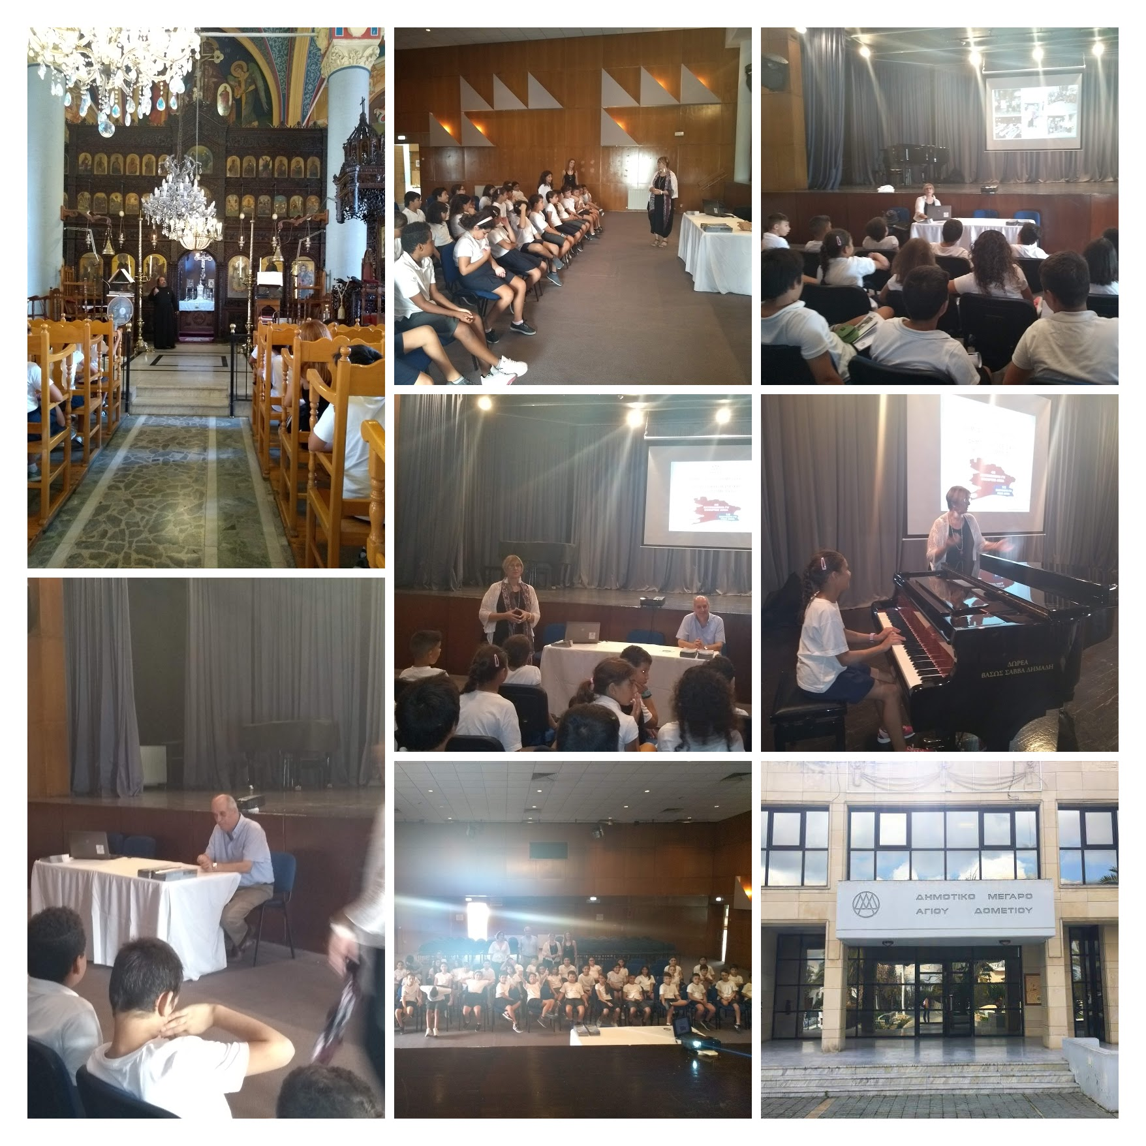

**Visit to the Town Hall and the church of St George**

**Meeting with the mayor of Ayios Dometios**