Minorities in Greece
In Greece, the only officially recognised minority (in accordance with the bilateral treaties that have been signed) is the religious Muslim minority of Thrace and the country is largely ethnically homogeneous.
The Muslim minority in Thrace mainly consists of Turks, Pomaks (both mainly inhabiting Western Thrace), and also Romani, found particularly in central and Northern Greece. Other recognized minority groups are the Armenians numbering approximately 35,000, and the Jews(Sephardim and Romaniotes) numbering approximately 5,500.
Following the Peace Treaty of Lausanne of 1923, many Muslim Roma moved to Turkey in the subsequent population exchange between Turkey and Greece
Roma(ni) in Greece
Nevertheless, there is another large “cultural minority” living in Greece, the Romani or Roma. They don’t consider themselves as minority, they declare Greek identity, speak Greek, and follow most of the customs and traditions of the area they live in. They are mostly merchants in open markets or in touristic places and craftsmen.
The Roma population in Greece reaches approximately 250,000-300,000 according to ELSTAT (the Greek Statistics Institute).
Roma(ni) in the municipality of Serres
This population amounts to approximately 3,000 people. The vast majority of these reside permanently in the town throughout the year in 4 Roma neighbourhoods/settlements, Alibecyoe-Tzabazika, Xilina, Petrina.
Synthesis of student population in 2nd Primary School of Serres
The 2nd primary school of Serres hosts the vast majority of these students. It has 170 students registered in 10 classes, 99% of which are from the Roma settlements, but only 100 have regular attendance. We observe very high rates of early drop out from school and our first primary long-term objective is the gradual reduction of this phenomenon.

Issues to take into consideration
Several parents are seasonally occupied in the field of tourism and this is a problem because students migrate to other primary schools inside Greece before the end of the school year and return to our school in early autumn.
The specific school has become a ghetto because of the composition of the student population. Although it is situated in a densely populated area, it cannot absorb non-Roma students. The Roma residents have been isolated by the local society, since they all live in settlements outside the main urban area. In the same way, the local society has isolated the Roma children indirectly because they do not want to enrol their children in the particular school. There is also a large part of Roma families who don’t want to enrol their children in the particular school either(about one fifth of student population), believing that they will have higher quality of education and better chances of success and progress in other bordering schools (stereotype beliefs, prejudices, social exclusion on both sides).
So, our second long-term objective is to convince social community and opinion that the quality of education offered in our school is high and invite and host more students from the area who are not Roma. Constant actions towards this objective are done in cooperation with the School Advisor on Pedagogic Issues and the Office of Primary Education.

New challenges (2017-2018)
For the last 2 years, there is an organised camp with refugees from the war in Syria. The refugee camp is situated nearby the Roma neighbourhoods. The camp hosts 70 students who have attended Greek language courses this year and they will be divided in groups and included in the morning schedule of the closest to their camp schools in the year 2018-19. One of these schools will be the 2nd elementary school of Serres in accordance with the original planning. We will have the main minority of Roma and a smaller one of the Syrian (about 10 students).
Therefore, it is now understood that our work at our will be even more complex and demanding, and we will have to face new challenges. Our second objective is to improve the quality of education provided in the school and the practices of inclusion and active citizenship implemented through and because of the Erasmus+ project, so that students from the main urban area of the city (non-Roma pupils) enrol. The challenge of coexistence, inclusion and cooperation of all these groups is our long-term objective. The final profit will be multiple for everyone, students, teachers and community.

The Roma people of Greece-Some facts
Arrival into the Balkans
The history of Romani in Greece goes back over 600 years to the 15th century. The name Gypsy sometimes used for the Romani people was first given to them by the Greeks who supposed they were Egyptian in origin.
Origin
The Romani people of Greece (Greek: Ρόμα) are called Arlije/Erlides (Greek: Ερλίδη), Tsiganoi or Athigganoi (Greek: Τσιγγάνοι) or the more derogatory term Gyftoi (Greek: Γυφτοί), (Gypsies).
The Romani people originate from Northern India, presumably from the north western Indian states Rajasthan and Punjab. Linguistic evidence has shown that roots of Romani language lie in India: the language has grammatical characteristics of Indian languages and shares with them a big part of the basic lexicon, for example, body parts or daily routines. The language is exclusively oral and our students don’t speak it, since it is not taught to them and since Roma populations mostly speak the language of the country they live in.
Religion
The majority of the Greek Roma are Orthodox Christian and have taken a Greek identity (language, names) while a small part of them, the Muslim Roma concentrated in Thrace have adopted Turkish identities.
They number 200,000 according to the Greek government. According to the National Commission for Human Rights that number is closer to 250,000 and according to the Greek Helsinki Watch group to 300,000. Due to their nomadic nature, they are not concentrated in a specific geographical area, but are dispersed all over the country, with a large concentration in the bigger cities, mainly in Athens and Thessalonica. There are notable centres of Romani life in Greece like Agia Varvara in Athens, which has a very successful Romani community, or Ano Liosia in Athens and Dendropotamos in Thessaloniki, where conditions are bad with problems of drugs, stealing etc.
Romani largely maintain their own customs and traditions but have also adopted many Greek habits, too-especially religious. Although a large number of Romani has adopted a sedentary and urban way of living, there are still settlements with tents or metal huts (paragges) in some areas. The nomads at the settlements (Gyftomahalas, Gyftika) often differentiate themselves from the rest of the population.
As a result of neglect by the state, their narrow-minded attitude towards education and the weddings between them at very early age( especially girls-even from 10 years old) among other factors, the Romani communities in Greece face several problems including high instances of child labour and abuse, low school attendance, discrimination and drug trafficking. The most serious issue is the housing problem since many Romani in Greece still live in tents, on properties they do not own without electricity and running water, making them subject to eviction. In the past decade these issues have received wider attention and some state funding.
Music and dance
Roma in Greece are known for the zurna and davul or tarabouka (common in Romani music) and their dance (tsifteteli) especially for women
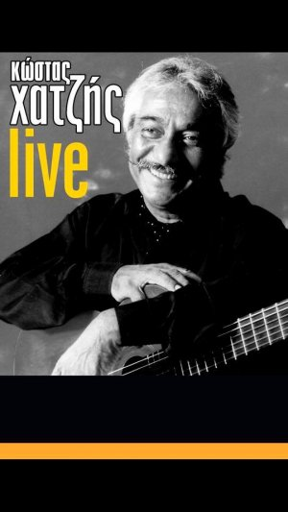
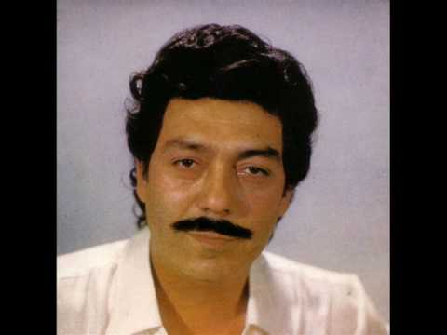
Famous Greek Roma
- Manolis Angelopoulos, singer

- Kostas Hatzis ,singer and musician
- Irini Merkouri ,singer

- Christos Patsatzoglou, Greek international football player

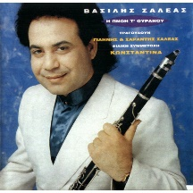
- Vassilis Saleas, clarinettist

- Eleni Vitali, singer and composer
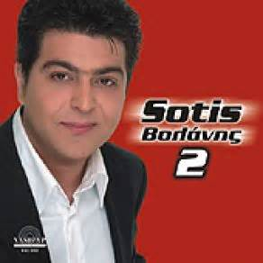
- Sotis Volanis, singer

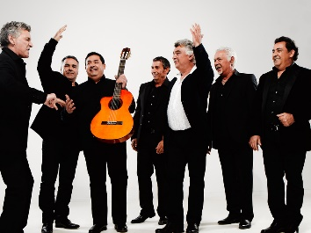
Famous Roma in Europe
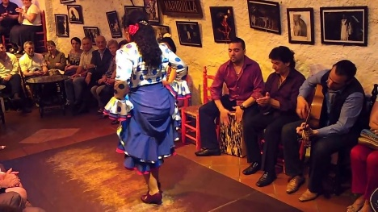
Gypsy Kings (Volare)
Andalousian Flamenco dancers
Web addresses of interesting videos (in Greek) about the life, customs and problems of Roma in Greece and Europe
https://www.telesurtv.net/english/analysis/International-Roma-Day-6-Facts-About-Europes-Largest-Minority-20160407-0035.html 8th of April International Day of Roma article in English
http://www.penna.gr/reportage/8829-i-zoi-ton-roma-stin-ellada Life of the Roma in Greece article ( in Greek)
https://www.youtube.com/watch?v=e21zRMliLKw Roma/Tsigganiko fairytale-A variation of Cinderella (in Greek)
https://www.youtube.com/watch?v=xxMJRHLgZFo A documentary about the life of the Roma in Greece in many settlements around Greece, called “I was born Roma”. It starts with the history of their origin, arrival in Europe and culture. It touches many sensitive issues like their jobs in the past(fortune-tellers, roving musicians and entertainers, beggars) and nowadays (mainly merchants in bazaars), the bad conditions of their neighbourhoods, the absence of help from Greek governments, the early school drop-out and marriage for girls, their exclusion from schools, traditions like their weddings and music. Unemployment, poverty, lack of education, prejudices, social exclusion, drug trafficking, bad conditions of living, lack of facilities in their settlements (a cultural centre, a playground, sport courts etc.) are some of the serious problems intensified after the economic crisis.

https://www.youtube.com/watch?v=BCYWPBz0HPg Active program "Fundamental rights and citizenship/2007--2013 with the title" I AM ROMA, Changing Mindsets. " The program aims to raise awareness of the local community on issues of discrimination and attempting to clear various stereotypes of Roma in general and in particular Roma children. The program is funded by the European Union. It’s the story of little Roma girl, Amalia, and how she was finally accepted by her non-Roma classmates who decided to go to her birthday party.
https://www.youtube.com/watch?v=WYZMkPjUlOQ A Greek TV show: the Roma customs about getting engaged and married at an early age

https://www.youtube.com/watch?v=klJwDkhx9xI Roma song JASTAR AMENGE DUR- (Come with me far away)
https://www.youtube.com/watch?v=KwQ-uxNUrE0 Roma traditional song – “Gypsies song-Balamo” Roma people call the people of the white race “Balamo”

