Content
Kurzbeschreibung Material: 1
Förderziele: 1
Zielgruppen + Einsatzmöglichkeiten: 2
Bildbeispiel: 3
Quellen: 4

Level-specific differentiation

Short description Material:

- Plan as an overview on the board
- 3 (or more) level-differentiated groups here for first-grade students: animal pictures
- each pupil receives animal image according to his level of learning (little cards for the student's table)
- Images (title page) of workbooks, books or worksheets
- additional material in boxes below the board

Objectives of the promotion

- creating different levels of learning in a lesson
- each student learns according to his level of learning, learning pace
- increase the independence of the students (organization, implementation and control of the learning process / learning outcome)
- creation of a motivating learning situation (success for every student)

Target groups + applications:

Material | grade 1-4 | Pupils with special needs | Own experience
"Level-specific differentiation" | - pupils receive a symbol (here: penguin) symbol represents a learning level (here: lowest learning level)  - students recognize on chalkboard / plan which tasks they should solve (good overview, structure)  - the solutions are also on board (possibility of self-control)  - during the study period, students can also receive other symbols, depending on whether they have changed to another level of learning  - more time spent by the teacher enables better observation and support of the learning process (difficulties can be identified and repeated in the following hours) | Special need "learning":  - Students learn according to their level of learning without receiving an official rating (performance levels are not obvious at first glance)  - Teacher has more time during planned work to turn to students with special needs  - for students with intellectual disabilities, materials and symbols can be adjusted very well | - motivating for the students as they can achieve individual success  - for class 1, the animal symbols are very appealing  - it is easy to differentiate the materials according to level / competence-oriented Extend or delete tasks

Image example:

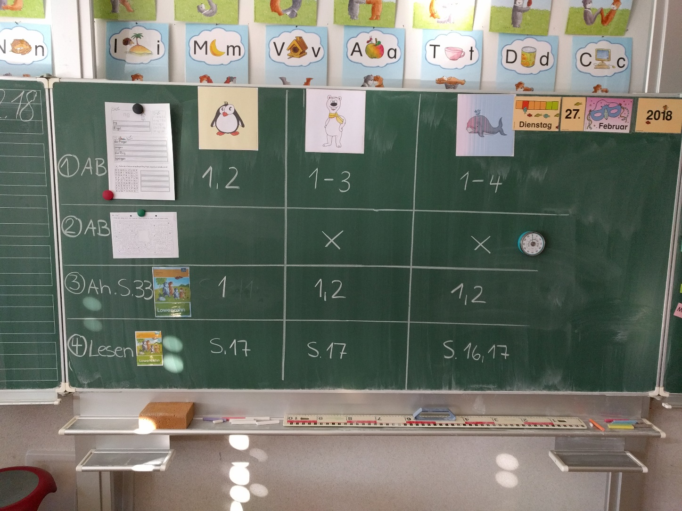

Sources:

- Idea and realization by Lisa Herzig "Primary school Otto-Lilienthal"
- Photo: V. Kühn

