My community
AYIOS DOMETIOS
Name: __________________________________
Class: _____________
Ayios Dometios ||| Elementary School
School Year 2018-19

Can you write down the 6 cities of Cyprus?
Can you also point out where is Ayios Dometios?
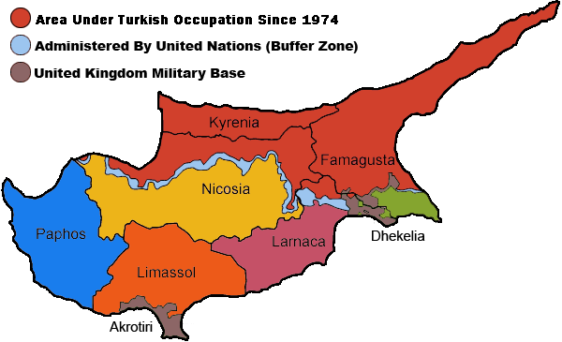

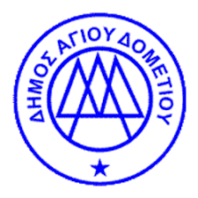
Important information about my community…
- My community’s name is ________________________. It’s located in ______________________. Nicosia is the only ________________ capital in Europe.

- Since turkish invasion in 1974, 4/5 of our community is under turkish _______________________.
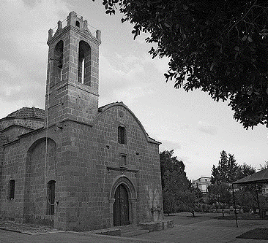
- Ayios Dometios has three churches: The church of __________________________________, the saint who gave his name to our community, the church of ___________________________ and the church of ______________________________.

- Ayios Dometios has ___________ elementary schools, ________ public kindergartens and one _________________________.

- The mayor of our community is __________________________.

- If you visit Ayios Dometios, you can see… ________________________________________________________________________________________________________________________________________________________________________________________________________________________________________________
Studying my community
Let’s walk around our community and write down what we see.

______________________________________________________________________________________________________________________________________________________________________________________________________________________________________________________________________________________________________________________________________________________________________________________________________________________________________________________________________________________________________________________________________________________________________________________________________________________________________________________________________________________________________________________________________________________________________________________________________________________________________________

Προβλήματα που εντοπίζω:

Let’s paint something we saw in our walk:

A visit to the town hall of our community
Meeting and discussing with the mayor
Let’s paint our town hall!

What did I learn from our visit to the town hall;
______________________________________________________________________________________________________________________________________________________________________________________________________________________________________________________________________________________________________________________________________________________________________________________________________________________________________________________________________________________________________________________________________________________________________________________________________________________________________________________________

