Minorities, Finland

There are many groups of minorities in Finland. The population of Finland is little over 5 500 000.
The Saame people are the only officiall ethnical minority population of Finland. Saame people inhabited the grounds of Finland before Finnish people. Nowadays 8000 Saame people live in Lapland of Finland, the rest of them (about 60 000) live in the Lapland of Russia, Norway and Sweden.

Finland´s second biggest minority group is the Swedish people. There is about 300 000 people in Finland whose mother language is Sweden.

The Tatarian people moved to Finland about 200 years ago. They established the first Finnish muslim church. Nowadays there are about 40 000 muslims living in Finland.

The Roman people came to Finland in the 15th century. There are over 10 000 romans living in Finland. There is no teaching in the Roman language in Finland, but you can study the roman language and culture in Finnish schools.

The first Jewish people came to Finland from Sweden during the 17th century. Nowadays there is less than 2000 Jewish people living in Finland. They have an own hospital, kindergarden and school.

The ”Inkeri” Finns are people who are moving back to Finland from the areas that Finland once lost to former Soviet union during the war. They can move to Finland if at least the other parent is Finnish or both grandparents are Finnish. Since 1990 about 25 000 people have moved to Finland from the area of former Soviet Union. The is still 15 000 in line waiting for their turn to be able to move to Finland and the goverment has decided not to accept any new people to the waiting list.

In addition to the groups Finland has received immigrants e.g. from Vietnam, Chile, Somalia, Thailand, Balkan area ja many European countries. Many refugees have also moved to Finland. In 2017 there was about 249 500 foreigners of 180 different nationalities living in Finland, which is 2,4% of the total population.

The table below shows the biggest groups of foreign nationalities that have moved to Finland.

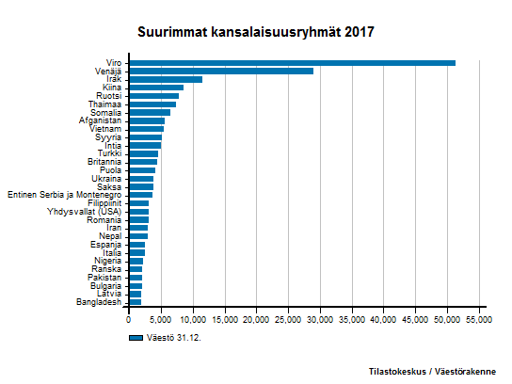

Minorities in Oulu

Oulu has over 200 000 inhabitants. 5 235 persons, which is 2,6% of the population, are of foreign origin. Most of the immigrants in Oulu are from Asian and Ocenian countries.

There is about 360 pupils in the school of Jääli. 2 of them are Dutch, 2 German, 1 Russian, 1 Ugrainian, 1 Estonian and 1 Mid-African origin. These pupils study Finnish as a foreign language and get special Finnish classes taught by a special teacher. There is also 2 Roman pupils studying in the school.

