**Worksheet 2 – Answer key**

And if it were you?

1. Students watch the video “When you don’t exist” (Amnesty International) and answer the questions on the worksheet:

Video: <https://www.youtube.com/watch?v=_OUpsWCvE38>

1. This is a video from a campaign. Watch it carefully and then fill in the table:

|  |  |
| --- | --- |
| Topic of the campaign | **Refugees** |
| Authors of the video | **Amnesty International** |
| Message | **We should put ourselves in refugees’ shoes; the way refugees are often treated is not right; we need to fight prejudice** |
| Strategy used to convey the message | **Inversion of roles; irony; Western Europeans are the refugees – aim of this strategy: to promote empathy** |
| Were you impacted by the video? If so, how? | **(…)** |

1. Pair work: think about these questions for a minute; then, share your answers with a classmate.

* And if it were you? How would you feel if you had to leave your land because of war, starvation, or a natural catastrophe?
* Where would you go to? How? With whom?
* What organizations could help you?

1. Teacher asks students about reasons why people move to another country.

**(to find a better job, better living conditions; war; famine; natural catastrophes; climate change; persecution; …)**

1. In pairs, students try to answer the question: “If you had one hour to pack your bag and flee, what would you take?”.

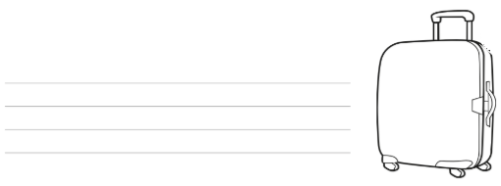

**(mobile phone, documents, money, credit card, family photos; clothes; water and food; …)**

1. Pair work: students look each other in the eyes in silence for 2 minutes. Then, they comment on how they felt.
2. Students watch the video “Look beyond the borders” (Amnesty International) and comment on people’s reactions in the end.

Video: <https://www.youtube.com/watch?v=f7XhrXUoD6U>

1. Students compare the pictures in the worksheet. Then, the teacher asks if they know anything about the article 13 of the Declaration of Human Rights.

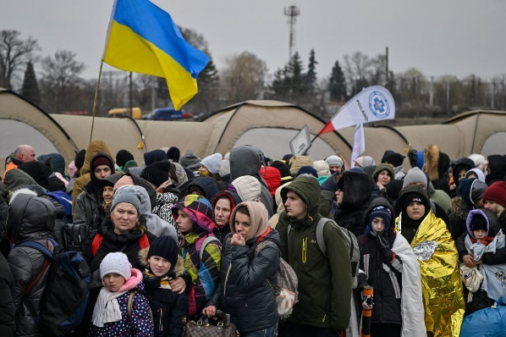

1. 2022

**(differences: black and white vs coloured; old vs modern)**

**(similarities: sad people; people fleeing mainly women and children)**

Universal Declaration of Human Rights



1. Group work: students try to find information for each topic. In the end, they compare the results.
2. What do you know about the 2019 refugee crisis in Europe? Search for information on the web and write down some notes. Then, share the results with the rest of the class.

* Who were these refugees? How old were they? Where did they come from?

**Mainly from Syria, especially women and children**

* Why did they flee their countries? Why did they travel to Europe?

**War and terrorism; in search for security and good living conditions**

* How did they travel? Was it an easy trip? Why?

**In clandestine inflatable boats, which often sank as they were overcrowded**

* What happened when they got to Europe? Where and how were they received?

**They stayed in refugee camps (often for 5 years and more); some were hosted by European countries, but many were refused because of fear of terrorism and xenophobia**

* The public opinion in Europe was divided. What were the arguments of those in favour/against welcoming refugees?

**In favour: they are human beings; they could be us; Human Right no. 13; …**

**Against: the crime rate will rise; refugees are terrorists; …**

* Are there any refugees in your country? If so, where are they? Are they well integrated?

**(…)**

* What are the world’s largest refugee camps? They are the victims of which conflicts?

**65 millions of people and rising – Kenya, Ethiopia, Gaza, Jordania, Tanzania, Pakistan, Southern Sudan**

1. Think together: **(the website of Amnesty International has many ideas)**

* How could governments solve this crisis?
* How can we help?

