Worksheet 2

And if it were you?

- This is a video from a campaign. Watch it carefully and then fill in the table:
https://www.youtube.com/watch?v=_OUpsWCvE38

Topic of the campaign
Authors of the video
Message
Strategy used to convey the message
Were you impacted by the video? If so, how?

- Pair work: think about these questions for a minute; then, share your answers with a classmate.

- And if it were you? How would you feel if you had to leave your land because of war, starvation, or a natural catastrophe?
- Where would you go to? How? With whom?
- What organizations could help you?
- If you had one hour to pack your bag and flee, what would you take?
- Find differences and similarities between the two pictures.

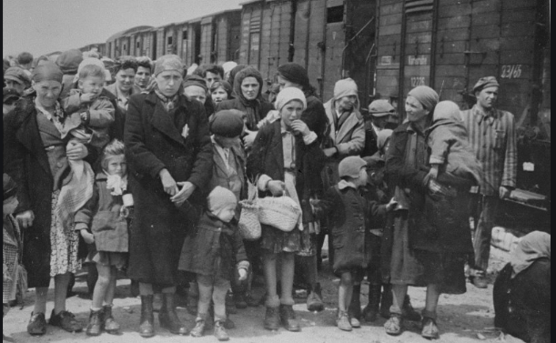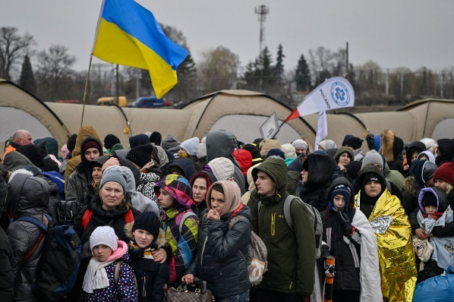

- 2022

- What do you know about the 2019 refugee crisis in Europe? Search for information on the web and write down some notes. Then, share the results with the rest of the class.

- Who were these refugees? How old were they? Where did they come from?
- Why did they flee their countries? Why did they travel to Europe?
- How did they travel? Was it an easy trip? Why?
- What happened when they got to Europe? Where and how were they received?
- The public opinion in Europe was divided. What were the arguments of those in favour/against welcoming refugees?
- Are there any refugees in your country? If so, where are they? Are they well integrated?
- What are the world’s largest refugee camps? They are the victims of which conflicts?

- Think together:
- How could governments solve this crisis?
- How can we help?

