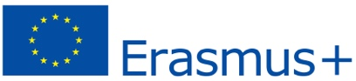

PROJECT WORK SPRING 2022 SWEDEN

Focus
The main focus this this week will be on the migrant situation. This includes topics dealing with racism, xenophobia, discrimination, human rights, social inclusion and the situation with EU-migrants. Of course its also a question concerning whats happening in Ukraine.
------------------------------
Example questions
How are we challenged by migrants or refugees?
- As citizens? What’s our responsibility?
- As societal institutions?
How do we handle different aspects such racism, xenophobia and social inclusion for example
Who are welcome?
Which principles should govern and how? Segregation, integration or assimilation?
-----------------------------------
First
Update yourself on the Swedish, Portuguese and European Union basic policies regarding migration.

Second
Prepare questions to ask the panel Thursday afternoon.
To work with: Make a video and investigate for example one or more of the questions above.
The video could be:
- A documentary
- Something arty
- Interviews
- Presentation
- Discussion/debate
Presentation
Tuesday afternoon

