Julije Knifer
(born in 1924 in Osijek, Croatia, died in 2004 in Paris)

KNOWN AND FAMOUS…..
- one of the most prominent Croatian painters of the 20th century,
- one of the founding members of the 1960s Croatian avant-garde group Gorgona,
- recognised by his geometric form of the meander.

LIFE…
- studied art in Zagreb, Croatia
- in the 70s and 80s lived and worked in Germany
- from the 90s to the end of his life lived and worked in France

STYLE…
- the motif of his winding Meander has become a synonym of the eternal flow of life
- an extreme reduction, an anti-image to be contemplated
- paintings reduced to a rhythmical exchange of black and white, vertical and horizontal surfaces.

CURIOSITY…
- In 2016, Knifer's painting PLS 69 (1969) was sold in an auction in Vienna for €137,000 which the highest price ever paid for a work of Croatian modern art.
- only the works of two painters can be seen on the wall of the private residence of the German chancellors - Picasso and Knifer.

HIS MEANDERS ARE PAINTED …..
- on exterior and interior walls in Zagreb,
- the Catalog hall of a university library in Dijon,
- near Tübingen he painted a 20x30 m large banner

EXHIBITIONS….
- Centre Pompidou, Paris,
- MAMCO in Geneva,
- Museum of Contemporary Art, Sydney,
- the MOMA in New York
- the Tate London,
- National Gallery in Berlin.
MASTERPIECES…

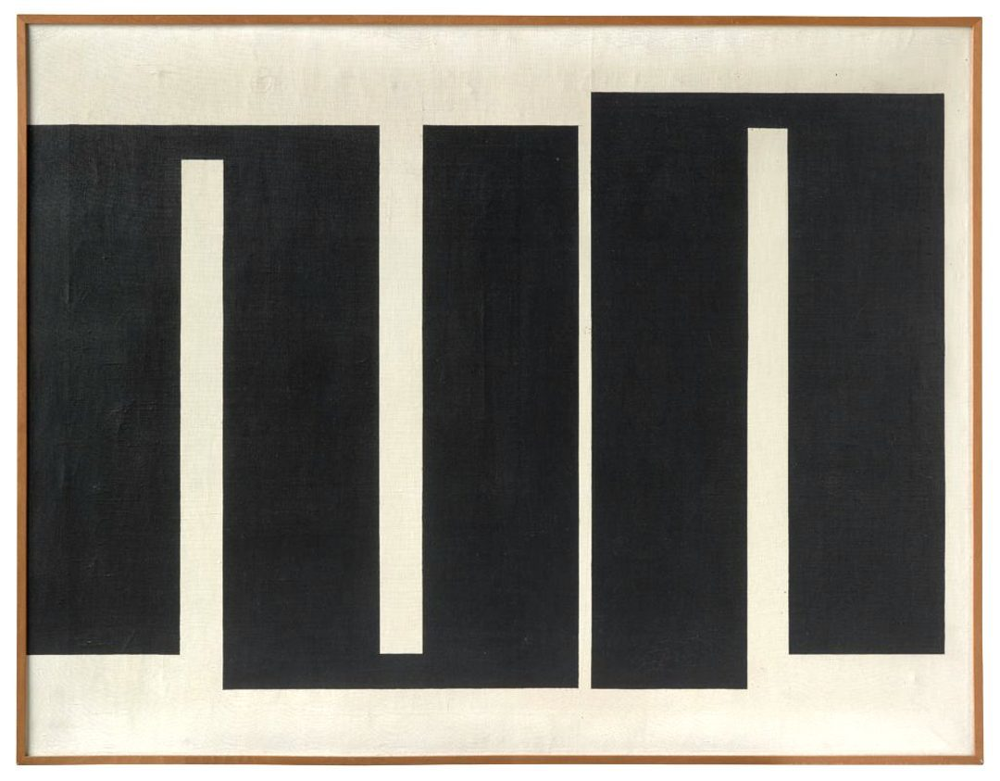
- Composition no. 12

- Meander 15

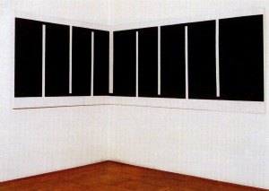
- Meander in the corner
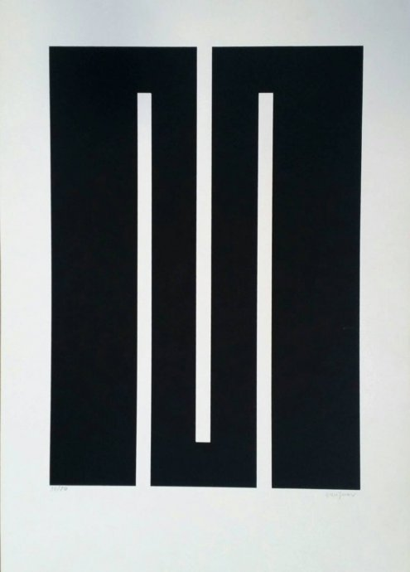
- Meander 4
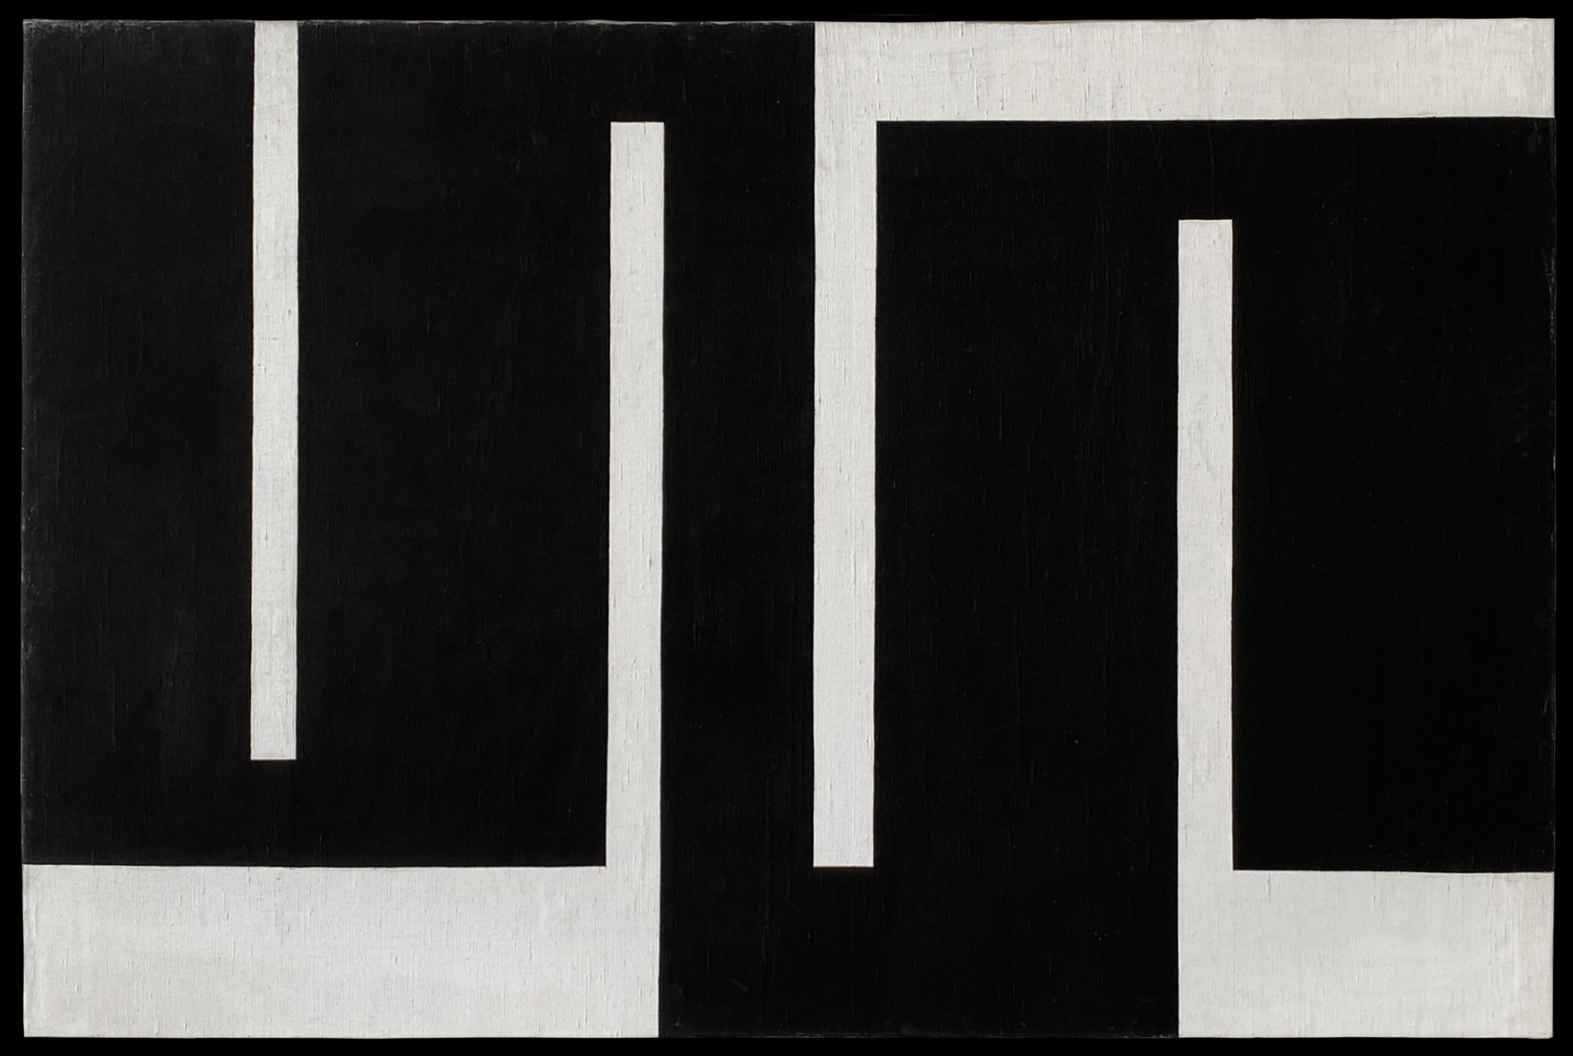
- Meander composition 4

